APPENDIX A

STATEMENT OF WORK

1.0 Project Initiation and Management 10
1.1 Project Planning 10
1.1.1 Project Information Library 10
1.1.2 Project Control Document 11
1.1.3 Project Initiation 12
1.1.4 Project Orientation Materials 15
1.2 Project Monitoring and Status Reporting 16
1.3 Project Closeout 18
1.3.1 Project Closeout 18
2.0 Development 20
2.1 Solution Planning and Design 23
2.1.1 Design and Development Plan 23
2.1.2 Enterprise Software Architecture Document 24
2.2 Engineering Validation Testing 26
2.2.1 Ballot Marking Device 29
2.2.2 Interactive Sample Ballot 54
2.2.3 BMD Manager 64
2.3 Design Validation Testing 73
2.3.1 Ballot Marking Device 75
2.3.2 Interactive Sample Ballot 83
2.3.3 BMD Manager 84
2.4 Regulatory Certification of the VSAP Solution 86
2.4.1 Conduct a Certifications Analysis 86
2.4.2 Obtain California Secretary of State Certification of the VSAP Solution 86
2.4.3 Obtain Other Certifications as Required (Based on a Negotiated Work Order) 88
2.5 Production Validation Testing and Production 90
2.5.1 Ballot Marking Device 92
2.5.2 ISB 97
2.5.3 BMD Manager 98
2.5.4 Integrated System Documentation 98
2.6 Tally System Scanners (Based on a Negotiated Work Order) 100
3.0 Implementation 101
3.1 Develop an Implementation Plan 101
3.2 Analysis of BMD Production Schedule and Strategy 102
3.3 Deliver Production BMDs 103
3.4 Develop System Interface Plan 105
3.5 Develop An End-to-End Security Plan 106
3.5.1 Provide Continuity Plan 109
3.6 Confirm System Interfaces Design and Develop Interfaces 109
3.7 Systems Integration and Coordination 111
3.7.1 Provide Systems Integration Services 111
3.7.2 Provide Coordination Services 112
3.8 Perform Pre-Certification Tests 114
3.9 Develop VSAP Solution Use Procedures 116
3.10 Deploy VSAP Solution (Prior to Full Rollout) 116
3.11 Deploy VSAP Solution to All Sites 118
3.12 Comply with Applicable Elections Code or Regulations After Initial California Secretary of State Certification (Based on a Negotiated Work Order) 119
3.13 Component Hardware Services 119
3.13.1 Provide Repair and Replacement Services 120
3.13.2 Provide Component Recall and Update Services 120
3.13.3 Develop Preventative Maintenance Schedule 121
3.13.4 Conduct Preventative Maintenance on BMDs 122
3.13.5 Track BMD Hardware Lifecycle and Maintain the Bill of Materials 122
3.14 Component Software Services 123
3.15 Sub-Component Services (Third-Party Hardware & Software) 124
3.16 Configuration Management 125
3.16.1 Provide Builds and Releases 125
3.16.2 Test Builds of Contractor In-Scope Components 126
3.16.3 Provide Certification Services for Re-Certification or De Minimis Approval of Releases (Based on a Negotiated Work Order) 130
3.16.4 Provide System Documentation Updates 131
3.17 Training and Knowledge Transfer 131
3.17.1 Develop the Training and Knowledge Transfer Plan 131
3.17.2 Develop Training Materials 133
3.17.3 Provide Training Metrics 134
3.17.4 Provide User Guide Documentation 134
3.18 Provide On-Site Support Services 135
3.19 Provide Help Desk Services 135
3.19.1 Support Tiers 135
3.19.2 Level of Error Severity 136
3.19.3 Support Tiers and Level of Error Severity 136
3.19.4 Provide Contractor In-Scope Component Help Desk Services 138
3.19.5 Provide Contractor In-Scope Component Problem Log Tracking 139
3.20 Provide Service Measurement and Reporting 140
3.21 Implementation Close 141
3.21.1 Criteria for Acceptance of Contractor In-Scope Components 141
3.22 Provide Facility Space (Based on a Negotiated Work Order) 142
4.0 Warranty 144
4.1 Warranty Scope 144
4.1.1 Exceptions to BMD Warranty Services 144
4.2 Warranty Terms 144
4.2.1 Third-Party Warranty Terms 144
4.3 Warranty Initiation 145
4.4 Comply with Applicable Law During Warranty (Based on a Negotiated Work Order) 145
4.5 Provide On-Site Support Services 145
4.6 Other Services to be Provided During Warranty 146
5.0 Maintenance and Support 148
5.1 Maintenance and Support Scope 148
5.1.1 Third-Party Sub-Components 150
5.1.2 Coordination of Other Vendor VSAP Components 150
5.2 M&S Terms 150
5.3 M&S Initiation 150
5.4 Comply with Applicable Election Law During M&S (Based on a Negotiated Work Order) 150
5.5 Provide On-Site Support Services 151
5.6 Other Services to be Provided During M&S 151
5.7 M&S Closeout 152
5.7.1 M&S Closeout Checklist 152
5.7.2 Disposition of County Intellectual Property After M&S 153
5.7.3 System Documentation Updates 154
5.7.4 Transfer of Materials 154
6.0 Additional Services 156
6.1 Provide Additional Goods and Services (Based on a Negotiated Work Order) 156
6.2 Provide Enhancements 156
6.2.1 Provide Enhancement Development (Based on a Negotiated Work Order) 156
6.2.2 Provide Enhancement Certification (Based on a Negotiated Work Order) 157
7.0 Assumptions 158

Appendix A — Statement of Work (SOW)
This Statement of Work (“SOW”) in conjunction with RFP Phase 2: #17-008 captures the County’s expectations regarding the tasks, deliverables and services needed for the Voting Solutions for All People (“VSAP”) implementation and support services. Figure 1 illustrates the overview of the VSAP Solution, which encompasses all components expected to be integrated and certified. Figure 2 depicts the Contractor’s responsibilities for development of the “Contractor In-Scope Components” within the context of the overall VSAP Solution. These figures along with other VSAP Diagrams in this SOW are available to Proposers. Proposers should align with these guidelines. Any deviation shall be addressed in the Proposal with a description as to how it maintains alignment with the County’s requirements.
The following sections capture the activities and deliverables the County expects from the Contractor. This SOW is organized as follows:
- 1.0 Project Initiation and Management
- 2.0 Development
- 3.0 Implementation
- 4.0 Warranty
- 5.0 Maintenance and Support
- 6.0 Additional Services
Section 2.0 of this SOW is structured to follow an iterative process for the Contractor In-Scope Components (see Figure 2). The iterative process is illustrated in Figure 1 below. In addition to software development, the Ballot Marking Device also requires hardware development. Section 2.0 describes the software and hardware development of the BMD at the sub-component level. The BMD sub-components include:
- User Experience / User Interface
- Mechanical (housing, stand, privacy screen and ballot box)
- Application Control System Hardware and Peripherals
- BMD Application Layer
- Application Control System Board Support Package and Firmware
- Ballot Control System Hardware and Peripherals
- Ballot Control System Board Support Package and Firmware
- Paper Handler
- Ballot Printer
- Cases and Carts
Proposers shall be aware that, where applicable, multiple deliverables will be expected for one task and similarly one deliverable will result from multiple tasks. The tasks and associated deliverables within each stage are expected to be refined in the subsequent stage of the iterative process until certification by the California Secretary of State, at which point no modifications to the hardware and software applications shall be made.
- Overview Diagram
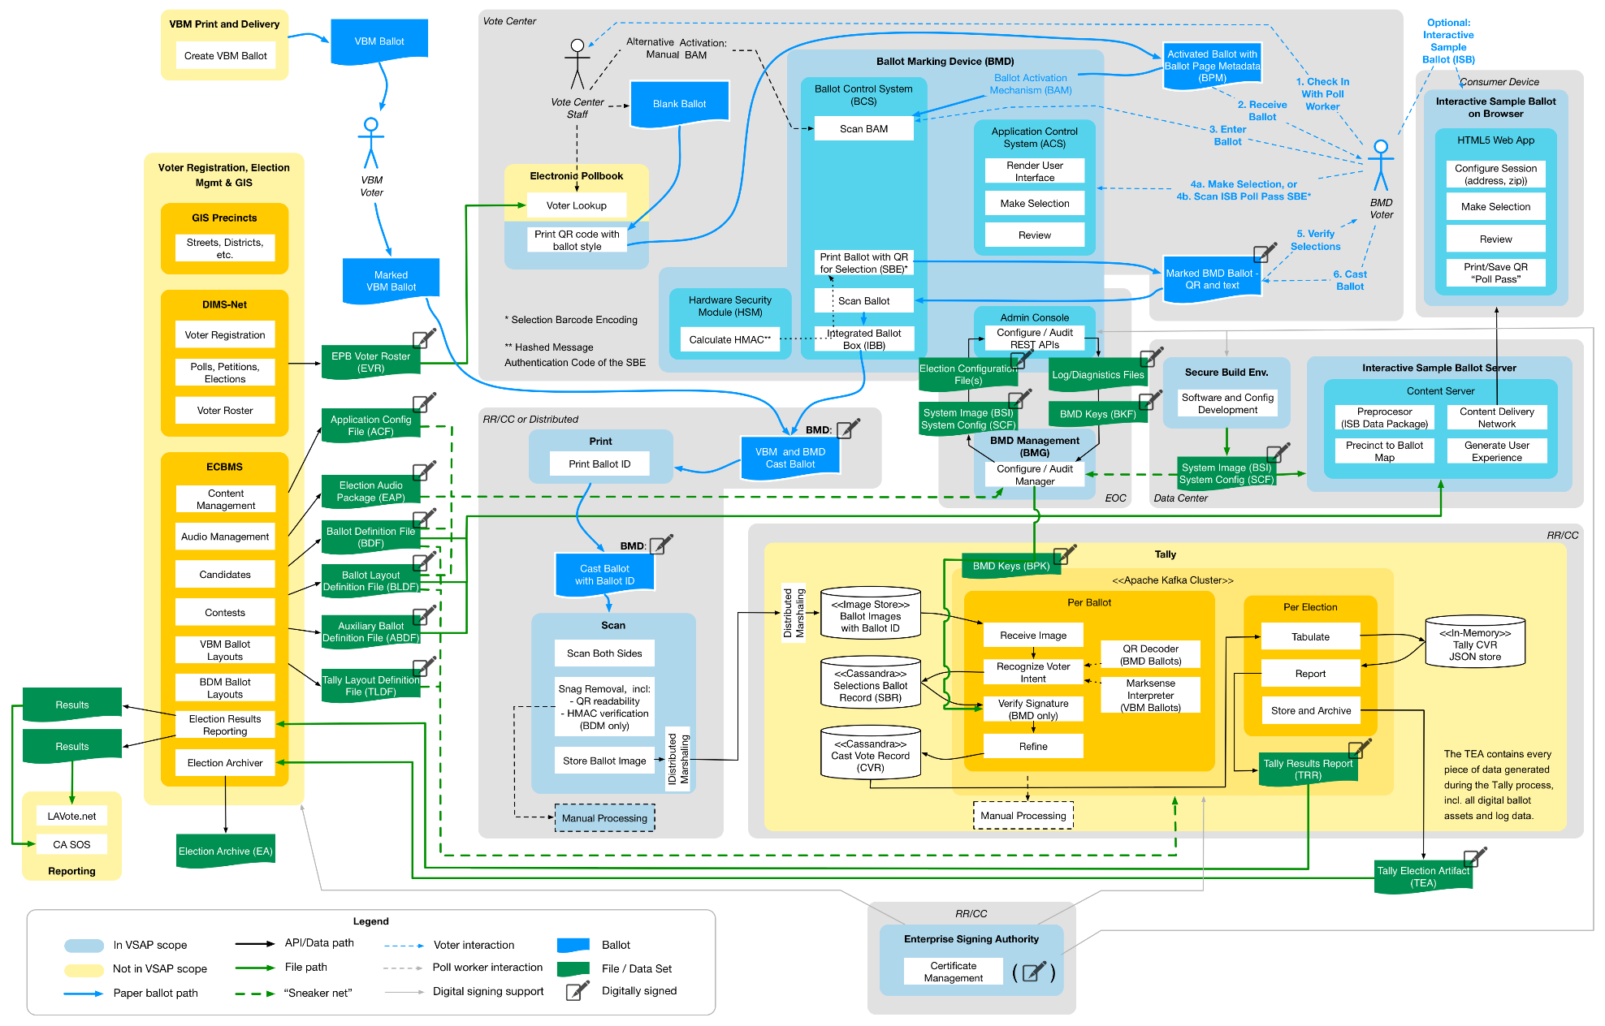

- Overview Diagram with Overlay for Contractor Build & Acquire
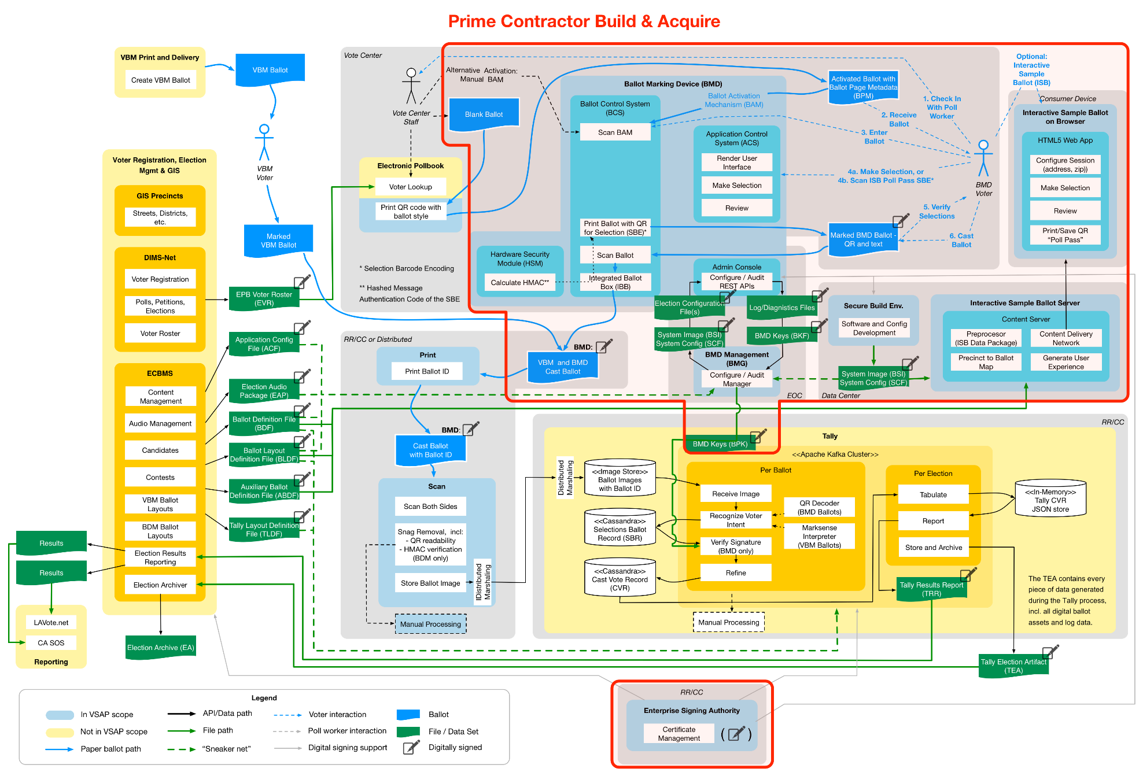
- Iterative Approach to Hardware and Software Development
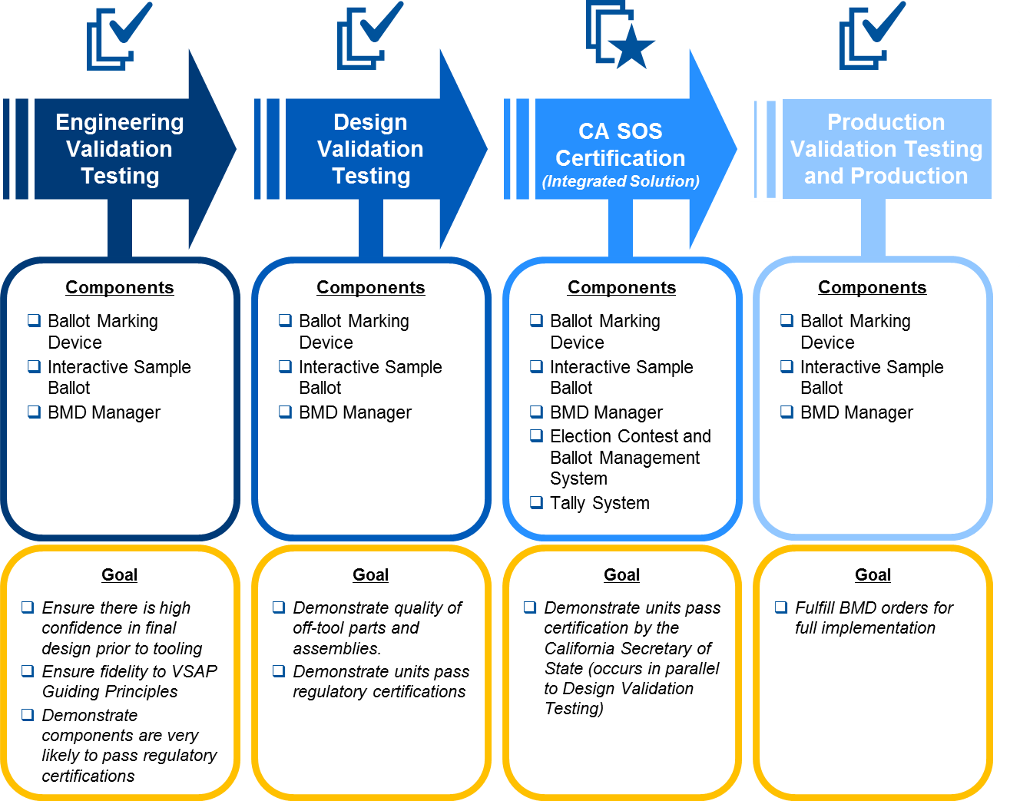

Instructions: The Proposer must complete the response blocks included in the text below to confirm the approach it will take in executing the VSAP implementation and support services. The Proposer must provide direct responses regarding applicable tasks and deliverables without including extraneous content such as marketing language related to broad capabilities.
Do not change any of the text outside the response blocks. Any changes to the language in this SOW outside the response blocks may result in disqualification of the Proposer.
- Project Initiation and Management
During Project initiation activities, the Contractor will develop a Project Control Document (“PCD”), implement required tools and develop artifacts that will establish how the VSAP Project will be managed. The County’s VSAP Program Manager and Project Team will be involved during the development of these deliverables to ensure they are aligned with County standards and provide an effective project management approach.
  - Project Planning
The Contractor must perform the activities required to manage and lead the Project through the entire Project life cycle. During Project initiation and management, the Contractor will establish the processes and tools required to manage and control the Project, in consultation with the County.
    - Project Information Library
The Contractor must develop and maintain a “Project Information Library” in a single online repository used to store, organize, track, control and disseminate all information and items produced through this engagement. The Project Information Library will be used by the Contractor, County staff, other vendors contracted by the County (e.g., Design Stewards) and other key stakeholders.
The Project Information Library must include a file structure with defined access and permissions, including administrator rights for County staff. It also must include a web or portal interface for individuals to remotely view/manage Project information and documentation, and input issues or comments to the Project Team.
The Contractor will store all work products and deliverables in the Project Information Library for the duration of the Project. Work product and deliverables must be uploaded to, and made available through, the Project Information Library to the County after completion of the related Project event or activity. For deliverables, the delivery timing governs the latest by which the deliverables must be uploaded. For any other items, the materials shall be made available to County no more than two weeks after the Project event or activity. At the end of the Project, the Contractor will archive relevant Project artifacts and turn the Project Information Library over to the County in its entirety.
The County is currently using the collaboration software tools Atlassian Confluence® and Microsoft SharePoint® and would prefer to use one of these platforms for the Project Information Library. The Contractor can select any platform for the Project Information Library as long as it is mutually agreed upon by County and the Contractor.
Deliverable 1.1.1 VSAP Project Information Library
Delivery Timing | Submitted for approval no more than 15 calendar days calendar days after Project Commencement Date
Delivery Frequency | Created once, maintained throughout the project
Description | Project Information Library as described in Section 1.1.1 above
PROPOSER RESPONSE TO: Deliverable 1.1.1 VSAP Project Information Library
Will the Proposer complete the deliverables and related tasks as described above?
___ Yes
___ Yes, with modifications
___ No
Explain your approach to completing the deliverables and related tasks as described above:
    - Project Control Document
The Contractor will prepare and submit a Project Control Document that encompasses all activities related to the development, implementation, testing, certification and integration of the VSAP Solution. Activities included in the PCD shall reflect the Project through Maintenance and Support.
The PCD will include:
- Project Schedule — Provides a detailed view of the tasks, milestones and deliverables within the Project and with the overall VSAP Program, including descriptions, durations and activity dependencies. It also includes what resources are to be assigned to each activity (e.g., the County Project Management Team or the Contractor) and responsibilities associated with the resources. Working with the Contractor, the County will determine the needed level of detail for tasks and timeframes. The Project Schedule may be created and maintained in MS Project, or a similar collaborative project software solution
- Project Assumptions — Identifies any assumptions about the Project that significantly affect other aspects of the PCD or the Project
- Scope Management Plan — Outlines the processes required to ensure the VSAP Solution and the Project provide all the services set forth in this SOW, and methods for tracking and managing deviations
- Schedule Management Plan — Captures the process for monitoring variances, planned corrective actions to address schedule variances and the process, roles and responsibilities involved in making changes to the Project Schedule
- Project Change Management Plan — Describes strategy for tracking, reviewing and approving the Project scope and Project schedule
- Risk and Issue Management Plan — Describes the approach to identifying, tracking, communicating and determining mitigation strategies for risks and issues
- Quality Control Plan — Defines a comprehensive Quality Control Plan to be utilized by the Contractor as a self-monitoring tool to ensure the required services are provided as agreed to in the contract. The following elements, at minimum, shall be included:
    - Activities to be monitored to ensure compliance with all contract requirements;
    - Monitoring methods;
    - Frequency of monitoring;
    - Sample forms to be used in monitoring;
    - Title/level and qualifications of personnel performing monitoring functions; and
    - Documentation methods of all monitoring results, including any corrective action taken
- Resource and Staffing Plan — Captures the projected Contractor resources required and the processes for identifying, qualifying, onboarding and replacing Contractor team members
- Deliverables Acceptance Process — Captures the processes, timeframes, templates, roles and responsibilities for completing and approving “Deliverable Expectation Documents,” submitting deliverables for approval and approving deliverables utilizing “Deliverable Acceptance Documents.” All Contractor deliverables are subject to review and comment by the County, and the Contractor may be required to produce revised deliverables prior to County approval, acceptance and payment. The Contractor will perform a walkthrough of a draft version of the deliverable with appropriate County staff and solicit feedback prior to submitting the deliverable for approval
- Project Communication Plan — Details key Project stakeholders and the methods and timeframes for communicating with stakeholders regarding project status, accomplishments, stakeholder impact, etc
- Closure Approach — Captures the activities the Contractor will perform to formally close the Project
Deliverable 1.1.2 Project Control Document
Delivery Timing | Submitted for approval no more than 15 calendar days after Project Commencement Date
Delivery Frequency | Once, with updates throughout the Project as needed
Description | The Contractor shall deliver a Project Control Document as described in Section 1.1.2.

PROPOSER RESPONSE TO: Deliverable 1.1.2 Project Control Document
Will the Proposer complete the deliverables and related tasks as described above?
___ Yes
___ Yes, with modifications
___ No
Explain your approach to completing the deliverables and related tasks as described above:
    - Project Initiation
      - Project Initiation Planning
The Contractor will conduct a meeting within 20 calendar days the Project Commencement Date to introduce County leadership and staff to the services covered by this SOW, including the timelines, dependencies and nature of the work effort that will be required to implement this SOW (“Project Initiation Session”). Other VSAP stakeholders such as members from the County’s Advisory Committees and partner support staff (e.g., Design Stewards, Management Consultants, Tally Solution Developer) may also participate in the Contractor’s Project Initiation Session as determined by the County.
The Contractor will work with the County to prepare for the Project Initiation Session including discussion of the resources (e.g., Design Stewards) and components (e.g., Tally System) that are not explicitly part of this SOW that the Contractor will need to coordinate with, or integrate, in order to successfully complete the VSAP Project. The Contractor and the County will determine how to incorporate those resources or discussion of those resources and components into the Project Initiation Session as needed to achieve the objectives of the session. The Contractor and County will also discuss the resources required to complete the tasks outlined in this SOW including Project participants and key VSAP stakeholders (e.g., VSAP Executive Steering Committee, VSAP Program Management Organization, etc.)
The Contractor will develop the “Project Initiation Session Planning Materials” for the Project Initiation Session in consultation with the County. The Project Initiation Session Planning Materials will include both an agenda and a presentation. The content for the Project Initiation Session will include the following topics:
- Project background and overview reflecting understanding of the VSAP vision and future voter experience
- High-level Project schedule
- Objectives and definitions
- Process (including change control and issue/risk management)
- Roles and responsibilities
- Keys to success (including any possible challenges and anticipated success criteria)
- Next steps
- Questions and answers
- Resources: individuals working on the Project (Contractor and County) and Project tools/systems
Deliverable 1.1.3.1 Project Initiation Session Planning Materials
Delivery Timing | Submitted for approval no more than 20 calendar days after Project Commencement Date
Delivery Frequency | Once
Description | The Contractor shall deliver both of the following materials:  - Agenda for Project Initiation Session  - Project Initiation Session Planning Materials

PROPOSER RESPONSE TO: Deliverable 1.1.3.1 Project Initiation Session Planning Materials
Will the Proposer complete the deliverables and related tasks as described above?
___ Yes
___ Yes, with modifications
___ No
Explain your approach to completing the deliverables and related tasks as described above:
      - Project Initiation Session
The Contractor will conduct a Project Initiation Session with key VSAP Stakeholders using the Project Initiation Planning Materials created under Section 1.1.3.1. The Project Initiation Session will be conducted no later than three (3) weeks after the Project Commencement Date.
During the Project Initiation Session, the Contractor will document input from County stakeholders to be incorporated in the Project Initiation Session Event Summary Report.
The Contractor will develop a draft Project Initiation Session Event Summary Report that includes observations, opportunities and challenges based on the Project Initiation Session, as well as County and Contractor attendance.
Deliverable 1.1.3.2 Project Initiation Session and Event Summary Report
Delivery Timing | Project Initiation Session: Conducted no more than 21 calendar days after Project Commencement Date  Event Summary Report: Submitted for approval no more than 5 calendar days after Project Initiation Session
Delivery Frequency | Once
Description | The Contractor shall deliver the Project Initiation Session described above and prepared for under Section 1.1.3.1 and a Project Initiation Session Event Summary Report including all of the following:  - Attendance sheet/roster of Contractor and County participants in Project Initiation Session  - Project Initiation Session Event Summary Report, including at least:  - Observations, opportunities and challenges  - Any new items identified as part of the event, including tangential items unrelated to the Project Initiation Session objectives  - Any materials used during the Project Initiation Session that were not included in the submission of Deliverable 1.1.3.1.

PROPOSER RESPONSE TO: Deliverable 1.1.3.2 Project Initiation Session and Event Summary Report
Will the Proposer complete the deliverables and related tasks as described above?
___ Yes
___ Yes, with modifications
___ No
Explain your approach to completing the deliverables and related tasks as described above:
    - Project Orientation Materials
The Contractor will prepare “Project Orientation Materials” which will be used by the Contractor and by the County to orient new project team members to the goals, objectives and approach of the VSAP Project.
The Project Orientation Materials will be used for training new project team members (County, Contractor and other County vendors) to become familiar with the Project. This shall include:
- Overview of the Project and background
- Information on how to obtain access to the Project Information Library
- Reference documents (with links)
- Overview of relevant Project processes (e.g., status reporting, risk management)
- Project Team members, roles and responsibilities
These materials shall be updated throughout the Project as necessary

Deliverable 1.1.4 VSAP Project Orientation Materials
Delivery Timing | Submitted for approval no more than 30 calendar days after Project Commencement Date
Delivery Frequency | Once, updated throughout Project as necessary
Description | The Contractor shall deliver Project Orientation Materials as described in Section 1.1.4.

PROPOSER RESPONSE TO: Deliverable 1.1.4 VSAP Project Orientation Materials
Will the Proposer complete the deliverables and related tasks as described above?
___ Yes
___ Yes, with modifications
___ No
Explain your approach to completing the deliverables and related tasks as described above:
  - Project Monitoring and Status Reporting
The Contractor will execute the processes outlined in the PCD (see Section 1.1.2) for the duration of the Project to effectively control and manage the Project in coordination with the VSAP Program Management Organization, the VSAP Executive Steering Committee and other stakeholders (e.g., Advisory Committees, Design Stewards and other consultants).
The Contractor will track the Project status and update applicable portions of the Project Schedule no less than twice per month to reflect the status of the Project against the baseline Project Schedule. In addition, the Contractor will maintain risks and issues logs for the Project a minimum of twice per month, proactively identifying risks and issues to be reviewed with the County Project Management Team.
The Contractor will provide the VSAP Program Manager with written Project Status Reports twice per month and any such other information from time to time, as requested.
The Contractor will schedule and facilitate weekly status meetings with the County Project Management Team to discuss Project progress, issues, resolutions and next steps. The Contractor will prepare and provide an agenda and meeting minutes for each status meeting. In addition, the Contractor will participate in a monthly status meeting with the Executive Steering Committee and, as requested by the County, assist in the preparation of the agenda and minutes for such meeting.
The Project Status Report must capture, at a minimum, the status of the Project including:
- Graphical statuses of scope, schedule and budget (e.g., red, yellow, or green color codes)
- Accomplishments of the last reporting period and objectives for the next reporting period
- Contractor and client responsibilities for the next reporting period
- Actual/projected Project Schedule dates versus baseline Project Schedule milestone dates
- Projected completion dates compared to approved baseline key dates
- Recovery plan for all work activities not tracking to the approved schedule
- Escalated risks, issues (including schedule and budget) and action items
- Key dependencies between efforts and activities, including any other County projects
(if applicable)
- Disposition of logged issues and risks
- Important decisions made and/or upcoming decisions
- Any team member changes, with prior approval from the County
- Comparison of budget to actual costs and estimated cost at completion (or similar forecast of remaining costs)
- Pending scope change requests with appropriate justification
- One-page graphical summary of the Project Schedule status of all major tasks and subtasks
- Status of integration activities of the VSAP Solution
- Status of certification preparation and coordination
- Matrix linking design changes to the VSAP General Voting System Principles
The Issues Log must capture, at minimum:
- Identified issues
- Issue categorization (impact and severity) and prioritization
- Issue remediation actions, timeframes and responsible parties
The Risk Log must capture, at minimum:
- Identified risks
- Risk categorization (impact and severity) and prioritization
- Risk remediation actions, timeframes and responsible parties
Deliverable 1.2 Project Status Report, Issues Log and Risk Log
Delivery Timing | No more than 3 days after each reporting period closes
Delivery Frequency | Semimonthly (twice per month) delivery of Project Status Report  Semimonthly delivery of Risk Log and Issue Log  Weekly Project Status Meetings, including agenda and minutes as follows:  - Agenda: No less than 1 day prior to the status meeting  - Minutes: No more than 3 days after the status meeting  Monthly Status Meetings with the Executive Steering Committee
Description | The Contractor shall conduct weekly status meetings, participate in monthly status meetings with the Executive Steering Committee, create and deliver the Project Status Report twice per month and maintain and deliver the Risk Log and Issue Log twice per month.  After each semimonthly reporting period, the Contractor will deliver all of the following, as described in Section 1.2:  - Status meeting agendas and minutes delivered by the Contractor during the period  - The Project Status Report delivered by the Contractor during the reporting period  - The Risk and Issue Logs showing all items recently closed, addressed or still open at the end of the reporting period

PROPOSER RESPONSE TO: Deliverable 1.2 Project Status Report, Issues Log and Risk Log
Will the Proposer complete the deliverables and related tasks as described above?
___ Yes
___ Yes, with modifications
___ No
Explain your approach to completing the deliverables and related tasks as described above:
  - Project Closeout
    - Project Closeout
Upon completion of implementation and deployment, and prior to the turnover of the VSAP Solution to Warranty Services (as described in Section 4.0), the Contractor will collaborate with the County to develop the Project Closeout Checklist, which is a checklist of all activities required to consider the Project complete. This includes confirming all VSAP Solution documentation is up to date; all deliverables have been completed, approved and archived (and owned by the County); facilitating a lessons-learned process; and related tactical activities (e.g., rolling people off the Project).
The Contractor will conduct a Project Closeout Session to review the Project Closeout Checklist.
Deliverable 1.3.1 Project Closeout
Delivery Timing | Project Closeout Checklist: Approved no less than 30 days prior to commencement of Warranty period  Project Closeout Session: Conducted no less than 30 days prior to commencement of Warranty period
Delivery Frequency | Once
Description | The purpose of this deliverable is to ensure all Project activities and deliverables are complete, and the Project is ready to migrate to the Warranty period. This deliverable will be the completed checklist and confirmation that all Project deliverables have been approved by the County. The Project Closeout Checklist will include, at a minimum:  - Proof that all deliverables are up-to-date and approved as detailed in the Final Acceptance Report (Deliverable 3.21.1)  - Control of all Solution and training documentation has been transferred to the Warranty team  - Lessons learned documented  - Tactical/Administrative activities completed (e.g., returning Project Team members’ badges)  - Ensuring hand-off of source code and build files and confirming receipt by County of all source code and configurations  - All test scripts (unit, component, regression, etc.) have been completed and have been provided to the County  The Contractor shall conduct a Project Closeout Session to review the Project Closeout Checklist.

PROPOSER RESPONSE TO: Deliverable 1.3.1 Project Closeout
Will the Proposer complete the deliverables and related tasks as described above?
___ Yes
___ Yes, with modifications
___ No
Explain your approach to completing the deliverables and related tasks as described above:

- Development
During Development, the Contractor will complete a series of tasks to finalize the Ballot Marking Device hardware and software design, Interactive Sample Ballot (“ISB”) software design and BMD Manager (“BMG”) software design, so that the components meet the requirements for functionality, performance and reliability. For manufacturing of the BMD, development entails an iterative approach at the level of each sub-component to identify issues that need to be addressed with the current “Design Validation Unit” design, conduct a wide variety of testing activities, iteratively modify the design, finalize the production design, update design documents and successfully obtain all required certifications. Software development will follow a similar, iterative approach.
This Section is structured to provide the expected tasks and deliverables at the component level, and further detailed at the sub-component level for the BMD. A high-level overview of this structure is provided in Figure 4 and Figure 5. However, additional tasks and deliverables are expected in addition to those directly related to hardware manufacturing and software development of the Contractor’s In-Scope Components as detailed below.

- Statement of Work Outline for Section 2.0 Development
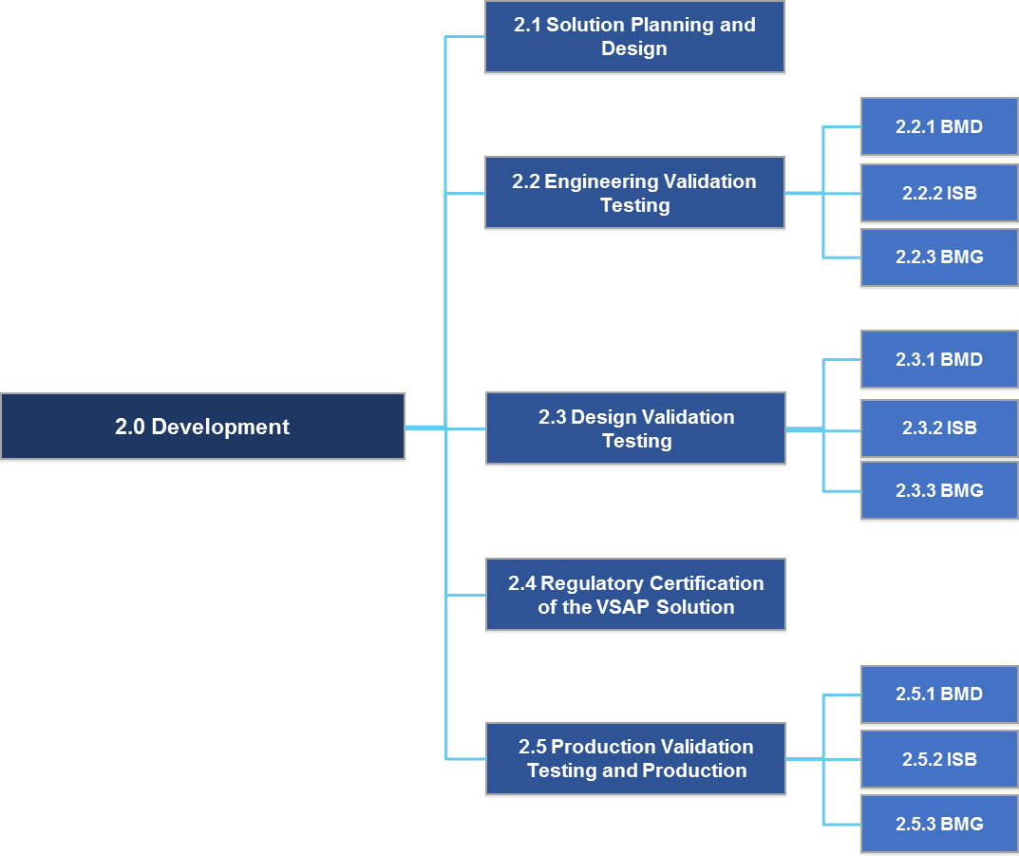
- Statement of Work Outline for Ballot Marking Device Development
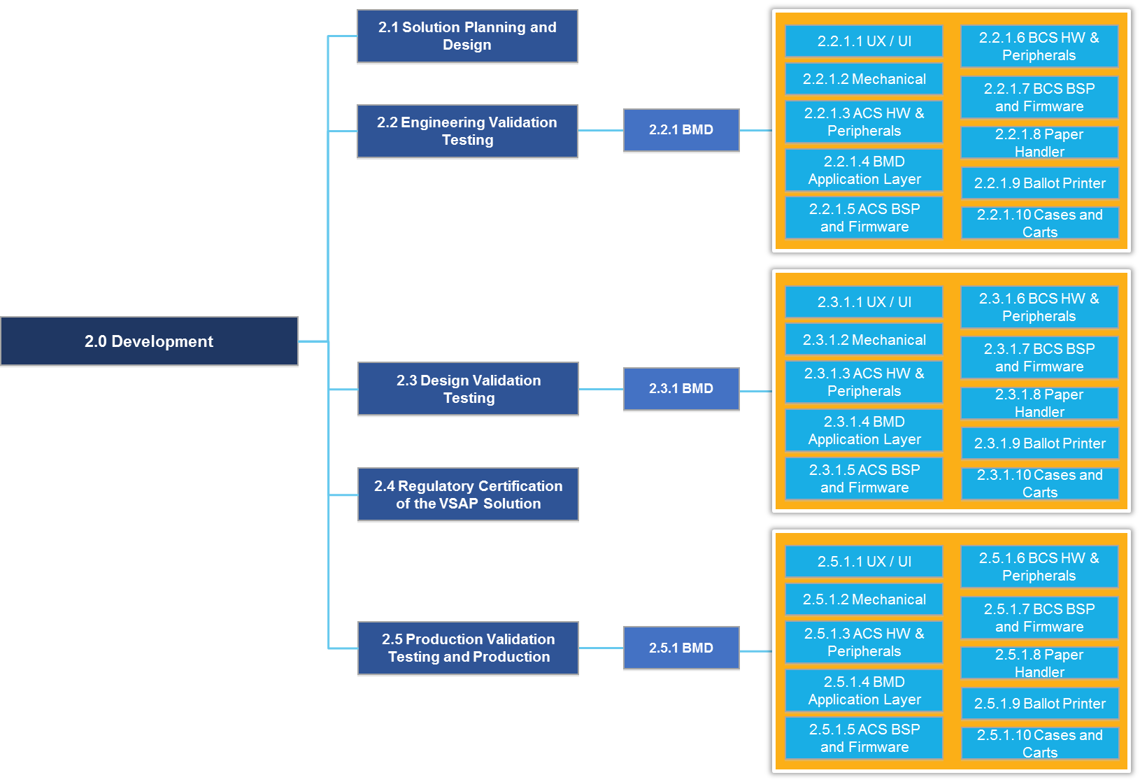

  - Solution Planning and Design
    - Design and Development Plan
Prior to commencing Development activities, the Contractor will develop a Design and Development Plan that will document the Contractor’s approach to design and development of software and hardware, and will capture the Project approach that will ensure the VSAP Project will meet all of the County’s requirements. This must align with the PCD, be based on the VSAP specifications provided by the County and reflect the VSAP branding strategy as defined in collaboration with the County. The Design and Development Plan will capture the approach the Contractor will follow to develop the In-Scope Components including:
- Requirements traceability
- Solution design (where applicable)
- Solution design validation (where applicable)
- Solution build
- Performance targets (for current and anticipated future volumes of transactions, users, languages, ballot styles, districts, contests, candidates, precincts, voting locations, etc. for major Countywide elections)
- Testing (including a test plan for each development phase)
- Release strategy
- Description of the tools to be used to manage the design and development process (e.g., requirements repository and document repository)
- Plan for ensuring the VSAP Solution aligns with the established standards for the VSAP Program (including branding), regulatory certifications and certification of voting systems by the California Secretary of State
To develop the Design and Development Plan, the Contractor will need to:
- Gain a deep understanding of the business processes the VSAP Solution is expected to serve and the corresponding functionality the VSAP Project will provide
- Understand and demonstrate adherence to the VSAP General Voting System Principles (http://vsap.lavote.net/principles/)
- Establish a requirements traceability plan to ensure all requirements are met, including a process for tracking, updating and managing changes to the requirements traceability matrix throughout the life cycle of the Project (including mapping requirements to design documents and test cases)
- Establish the mechanisms for managing the custom software code through development, build and release
- Establish the mechanisms for managing the custom hardware through development, build and release, including a manufacturing strategy
- Establish Contractor’s internal processes to ensure the design is an integrated, coherent VSAP Solution (e.g., internal design reviews)
- Establish the approach to developing technical standards and confirming conformance to the standards
- Establish the approach to implementing generally-accepted secure software design life cycle elements (e.g., static and dynamic testing, memory-safe programming language)
- Identify major technical challenges the Contractor must overcome to implement the VSAP Solution
- Define the tools to be used to manage the design and development process (e.g., requirements code repositories, development environments)
Deliverable 2.1.1 Design and Development Plan
Delivery Timing | Submitted for approval no more than 60 calendar days after Project Commencement Date
Delivery Frequency | Once, updated throughout Project as necessary
Description | The Contractor shall deliver a Design and Development Plan as described in Section 2.1.1.

PROPOSER RESPONSE TO: Deliverable 2.1.1 Design and Development Plan
Will the Proposer complete the deliverables and related tasks as described above?
___ Yes
___ Yes, with modifications
___ No
Explain your approach to completing the deliverables and related tasks as described above:
    - Enterprise Software Architecture Document
Prior to commencing Development activities, the Contractor will develop an Enterprise Software Architecture Document that will capture the overall architecture of the VSAP Solution, including components that are within the Contractor’s scope for implementation and coordination. The goal for the Enterprise Software Architecture Document is to convey the overarching architecture of VSAP, and how it interacts with the broader ecosystem, including:
- A description of the software architecture drivers and their impact
- Description of the major components and their role in the overall solution
- Major interfaces and integration points between the components and the ecosystem
- Description of the ballot flows, for all modalities, from origination to processing
- Description of the data flows that support the voting process
- The security approach, including interfaces, interactions, and defensive mechanisms
- Dependencies on frameworks and abstraction layers
For software components, such as the BMD Application Layer, ISB and BMD Manager, the Contractor shall also develop a Software Architecture Document at a more granular level. The Enterprise Software Architecture Document ties those together, and includes a perspective of the overall VSAP Solution.
To develop the Enterprise Software Architecture Document, the Contractor will:
- Develop a deep understanding of the architecture and design work completed in prior phases
- Identify areas where the prior work requires refinement, such as the security architecture, and elaborate these areas to a comprehensive and consistent architecture perspective
- Describe the conceptual architecture in a set of comprehensive, yet easy to digest models and visualizations that convey the solution to technical and non-technical stakeholders
- Capture the overall software architecture in a set of formal architecture notation that guide the subsequent work at a component level
- Establish the approach to developing technical standards and confirming conformance to the standards
- Define the tools to be used to support the architecture work throughout the project (e.g., requirements code repositories, development environments)
Deliverable 2.1.2 Enterprise Software Architecture Document
Delivery Timing | Submitted for approval no more than 60 calendar days after Project Commencement Date
Delivery Frequency | Once, updated throughout Project as necessary
Description | The Contractor shall deliver a Design and Development Plan as described in Section 2.1.2.

PROPOSER RESPONSE TO: Deliverable 2.1.2 Enterprise Software Architecture Document
Will the Proposer complete the deliverables and related tasks as described above?
___ Yes
___ Yes, with modifications
___ No
Explain your approach to completing the deliverables and related tasks as described above:

  - Engineering Validation Testing
During Engineering Validation Testing (“EVT”), the Contractor will identify the issues related to the design of the Design Validation Units that need to be changed for production. The Contractor will finalize the BMD design so that it meets all requirements for functionality, usability, performance and reliability, including those related to design for manufacturing (“DFM”) and required certifications. EVT may be an iterative process to ensure that the design meets all the requirements prior to moving to Design Validation Testing (“DVT”).
While the BMD tasks are separated at the sub-component level in this Section 2.2, the Contractor will submit fully functional BMD units at the end of the EVT stage to demonstrate that they meet all the requirements and all sub-components are integrated. A high-level summary of the relationship between tasks and deliverables for the BMD is shown in Figure 6.

- Engineering Validation Testing — Ballot Marking Device Tasks and Deliverables (Summary View)
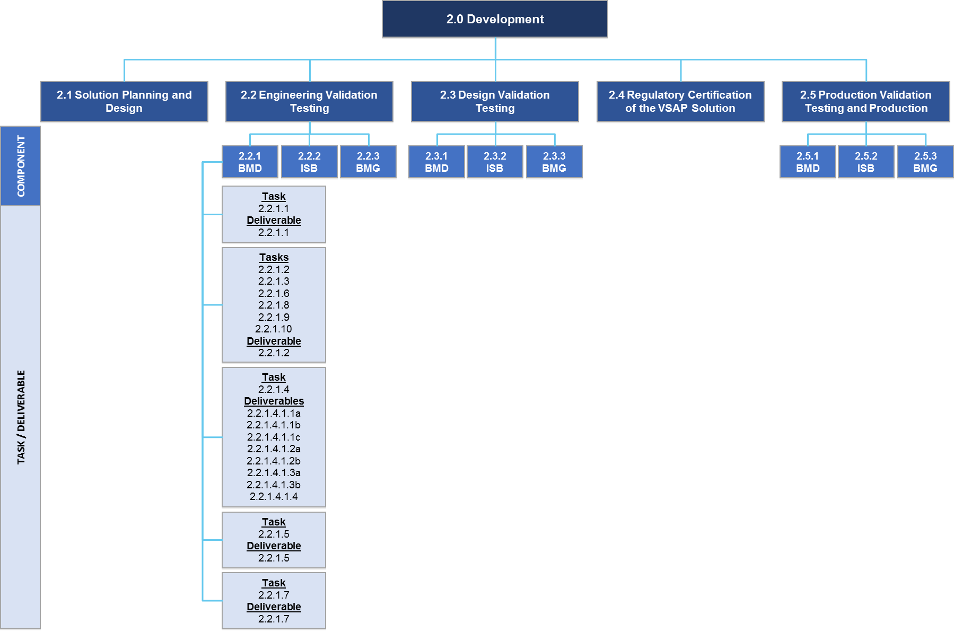

Where applicable, this Section 2.2 is organized as follows:
- Complete: Refers to aspects of the design that have been completed by the County in prior phases. No further work is expected by the Contractor
- To Be Done: Refers to aspects of the design that have not yet been finalized or developed by the County. The Contractor will be expected to complete the design where needed as part of the VSAP Project
- Specification Documents: Links in each section direct Proposers to the County’s specifications for the respective component. Proposers are encouraged, however, to review all accessible County IP. Only individuals who have successfully completed the fingerprint background check and signed the NDA are permitted to access County IP
- Requirements: Links in each section direct Proposers to the County’s requirements for the respective component. Although additional requirements may be developed by the County (e.g., to respond to changes in the Elections Code and regulations) during the solicitation and Project period, the requirements are considered complete. Proposers are expected to understand the requirements as context for the VSAP Solution design and for the associated specification documents. The Contractor must ensure that the VSAP Solution is implemented in a way that meets the requirements and aligns with the overall design intent. The Contractor must use the requirements for developing test cases that will enable the assessment and verification of solution design. The Contractor shall inform the County if any conflicting or unclear requirements are identified as part of the VSAP Project. The County’s Design Steward will assist the County in verifying alignment of final design with design intent
- Expected Tasks: Refers to the expected tasks to be completed by the Contractor based on the work remaining for the respective component. The County is open to Proposers proposing additional or alternative tasks if the Proposer believes those tasks will better meet the County’s objectives
    - Ballot Marking Device
      - User Experience / User Interface
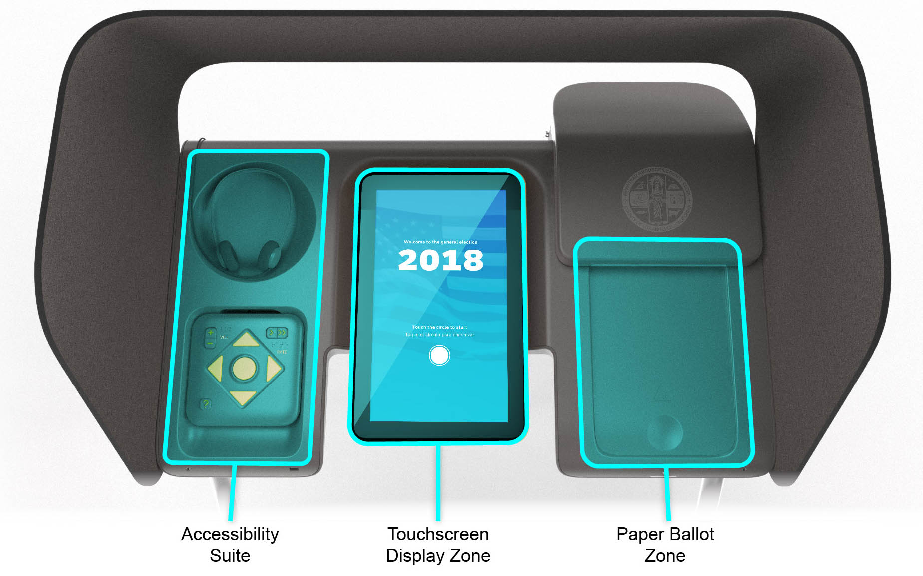
Complete:
- The design of the main user experience (“UX”) is complete and has been prototyped in English, Spanish and Korean. This includes the main voting flows, the help and settings menus and major error cases for both the touchscreen and tactile keypad user interfaces (“UI”), as well as audio. Write-ins has been localized in English QWERTY keyboard only
- The dual-switch interface for accessibility peripherals follows the main touch flow with a special two-button interaction model and device configuration flow, which has been defined
- A flow for using the manual Ballot Activation Mechanism (“BAM”) has been confirmed
and finalized
- High-level requirements for the administrative and diagnostic interfaces
To Be Done:
- Localize the UI for the other supported languages, including adapting the write-in interface as needed, for both touch and keypad interfaces, including audio
- Identify and design for additional edge and error cases
- Demonstrate dual switch interface
- Capture detailed requirements for the administrative and diagnostic interfaces and define UI flow
Specification Documents:
- Location: BMD UX
- Filenames:
    - 3.2 BMD User Interface Design.pdf
    - 3.2 BMD User Interface Flows.pdf
    - 3.2 BMD User Interface Flows.sketch
    - BMD System Sounds.zip
    - BMD Animations.zip
    - BMD Icons.zip
    - Video-Dual Switch.mp4
    - BAM
    - Known Issues and Recommendations
Requirements:
- BMD Requirements
- Legal and Regulatory
Expected Tasks:
- Complete localization of UI, including the write-in interface, for all the supported languages. Note: It shall also be configured to support future language needs. Support languages currently required include:
    - English
    - Chinese (Mandarin, Cantonese)
    - Cambodian/Khmer
    - Korean
    - Spanish
    - Tagalog/Filipino
    - Vietnamese
    - Hindi
    - Japanese
    - Thai
    - Farsi
    - Armenian
    - Russian
- Identify and design remaining edge and error cases
- Evaluate and address Known Issues and Recommendations from the document linked above and incorporate design refinements as required based on mutual agreement with the County and its Design Stewards
- Test across touchscreen, tactile controller and dual-switch interfaces
- Test the Poll Pass (QR code) feature
- Validate the performance to ensure it can support all languages and all ballot styles
- Iterate on above tasks as necessary until design is shown to meet performance requirements
Deliverable 2.2.1.1 Updated BMD User Experience / User Interface Design Assets — EVT
Delivery Timing | Submitted for approval as fully functional BMDs at the end of the EVT stage
Delivery Frequency | Once
Description | The Contractor shall deliver updated design assets based on EVT, including:  - Native design files (i.e., those developed in Sketch)  - UI flows map  - System sound files  - UI animations  - UI icons

PROPOSER RESPONSE TO: Deliverable 2.2.1.1 Ballot Marking Device — User Experience / User Interface Design Assets – EVT
Will the Proposer complete the deliverables and related tasks as described above?
___ Yes
___ Yes, with modifications
___ No
Explain your approach to completing the deliverables and related tasks as described above:
      - Mechanical (housing, stand, privacy screen and ballot box)
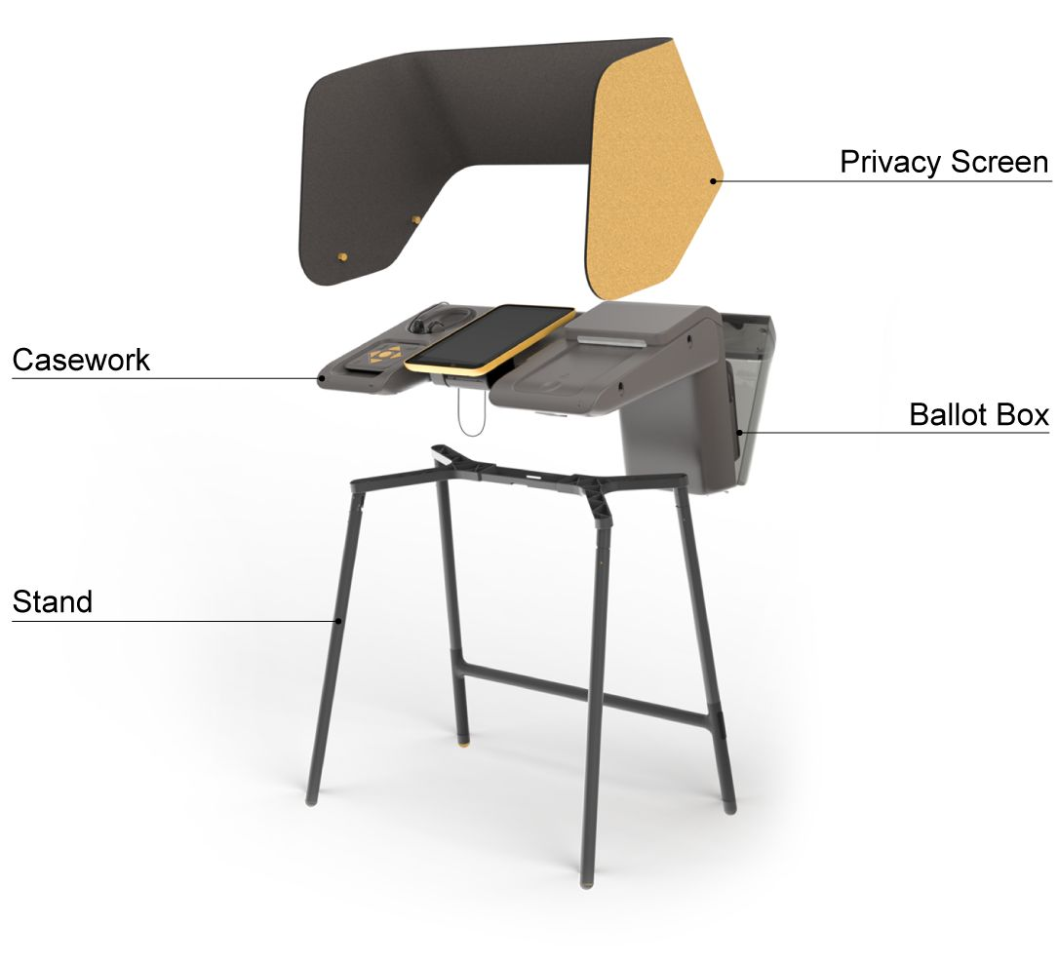
Complete:
- BMD mechanical elements have been designed for manufacturing, with the exception of the paper handler
- Five functional Design Validation Unit prototypes have been built to the final design and have passed a preliminary shock and vibration test
- 3D CAD and engineering drawings for all components are complete
To Be Done:
- Further compliance testing required, which may identify other design issues to be addressed
Specification Documents:
- Location: BMD Hardware
- Filenames:
    - Vox_ID_Deck_2016-06_28.pdf
    - 5.4.2.2.1 Designing & Using the BMD
    - 5.4.2.2.2 Designing & Engineering the External BMD Components
    - 5.4.2.2.3 Designing & Engineering the Internal BMD Components
    - 5.4.2.2.4 Designing & Engineering the BMD’s Paper Handler
    - 5.4.2.3 BMD Manufacturing Release Package
    - 5.4.4 BMD Design Validation Units
    - Known Issues and Recommendations
Requirements:
- BMD Requirements
Expected Tasks:
- Design assembly processes, work instructions and quality assurance suitable for the EVT build
- Evaluate and address Known Issues and Recommendations from the document linked above and incorporate design refinements as required based on mutual agreement with the County and its Design Stewards
- Build test units and test mechanical design against performance requirements. Address issues raised in testing
- Iterate on above tasks as necessary until design is shown to meet performance requirements
Deliverable 2.2.1.2 Engineering Validation Testing and Results for BMD Hardware
Delivery Timing | Submitted for approval as fully functional BMDs at the end of the EVT stage, including completion of expected tasks described in the following sections:  - 2.2.1.2 Mechanical (housing, stand, privacy screen and ballot box)  - 2.2.1.3 Application Control System Hardware and Peripherals  - 2.2.1.6 Ballot Control System Hardware and Peripherals  - 2.2.1.8 Paper Handler  - 2.2.1.9 Ballot Printer  - 2.2.1.10 Cases and Carts
Delivery Frequency | Once
Description | The Contractor shall deliver:  - Assembled EVT test unit BMDs  - Test reports from verification tests  - Documentation of issues raised in testing and design changes made to address them  - Updated “Design & Engineering Specification” documentation, as needed  - Updated manufacturing package(1)  - 3D CAD of parts and assemblies  - Engineering drawings of parts and assemblies  - Bill of Materials  - Electrical engineering computer-aided design for printed circuit board assemblies (where applicable)  ⁽¹⁾Manufacturing package does not apply to 2.2.1.9 Ballot Printer and 2.2.1.10 Cases and Carts, as these products may be commercial off the shelf (COTS) or industrial off the shelf (IOTS).

PROPOSER RESPONSE TO: Deliverable 2.2.1.2 Engineering Validation Testing and Results for BMD Hardware
Will the Proposer complete the deliverables and related tasks as described in the following sections?
2.2.1.2 Mechanical (housing, stand, privacy screen and ballot box)
2.2.1.3 Application Control System Hardware and Peripherals
2.2.1.6 Ballot Control System Hardware and Peripherals
2.2.1.8 Paper Handler
2.2.1.9 Ballot Printer
2.2.1.10 Cases and Carts
___ Yes
___ Yes, with modifications
___ No
Explain your approach to completing the deliverables and related tasks as described in all sections listed above:
      - Application Control System Hardware and Peripherals
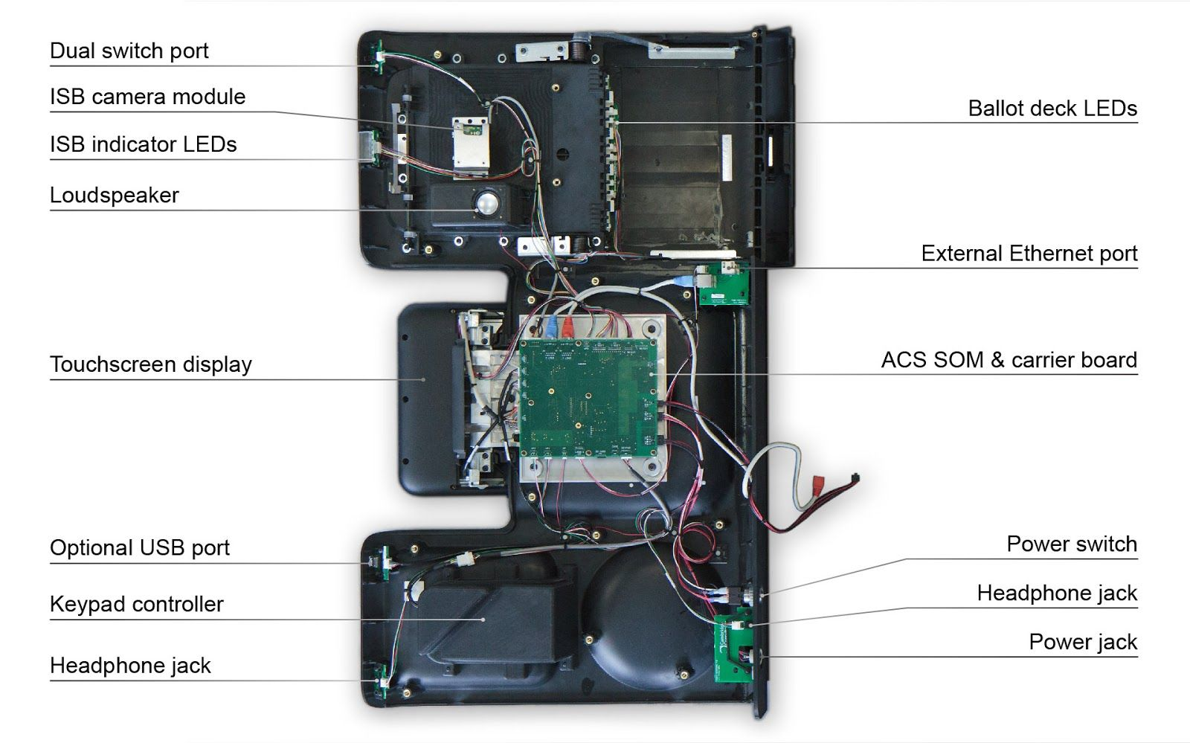
Complete:
- Selection of the IOTS system on module and design of the CPU carrier board complete
- Peripherals and key components, including the main application CPU System On Module (“SOM”), chosen
- Build of five functional Design Validation Unit prototypes to the final design
- Board layout and bill of materials documented
To Be Done:
- Update the selected IOTS SOM
- Evaluate options for secure USB port that meets voting system standards
- Develop to pass Federal Communications Commission (“FCC”) certification testing
- Improve cable and connector robustness, particularly LVDS cable termination
Specification Documents:
- Location: BMD Hardware
- Filenames:
    - Vox_ID_Deck_2016-06_28.pdf
    - 5.4.2.2.1 Designing & Using the BMD
    - 5.4.2.2.2 Designing & Engineering the External BMD Components
    - 5.4.2.2.3 Designing & Engineering the Internal BMD Components
    - 5.4.2.3 BMD Manufacturing Release Package
    - 5.4.4 BMD Design Validation Units
    - Known Issues and Recommendations
Requirements:
- BMD Requirements
Expected Tasks:
- Evaluate and address Known Issues and Recommendations from the document linked above and incorporate design refinements as required based on mutual agreement with the County and its Design Stewards
- Build test units and test electrical design against performance requirements
- Address issues raised in testing
- Iterate on above tasks as necessary until design is shown to meet performance requirements
Expected Deliverable:
This subcomponent is one aspect of the BMD hardware and will be completed at the same time as the other BMD hardware subcomponents in order to deliver an assembled BMD unit. The result of these tasks will be considered to meet deliverable 2.2.1.2 Engineering Validation Testing and Results for BMD Hardware, and shall be submitted upon completion of all expected tasks described in the following sections:
- 2.2.1.2 Mechanical (housing, stand, privacy screen and ballot box)
- 2.2.1.3 Application Control System Hardware and Peripherals
- 2.2.1.6 Ballot Control System Hardware and Peripherals
- 2.2.1.8 Paper Handler
- 2.2.1.9 Ballot Printer
- 2.2.1.10 Cases and Carts
See Section 2.2.1.2 Mechanical (housing, stand, privacy screen and ballot box) for a description of the deliverable and the Proposer’s response.
      - BMD Application Layer
The BMD Application Layer (“Application Layer”) runs the voting application on the BMD, including the user interface and integration with the various hardware components.
The BMD is designed with a two-machine architecture to provide a clear delineation between the user interface components, managed by the Application Control System (“ACS”), and the paper path, managed by the Ballot Control System (“BCS”). The ACS and BCS are integrated through an internal network and communicate through APIs.
- The ACS drives the touchscreen display, keypad controller, QR code scanner, etc.
- The ACS application layer will be based on Android, with strong support of UI tools
- The BCS drives the paper path, including the scanner and printer
- The BCS application layer will be based on Linux, with strong support for device management
The following diagram in Figure 7 illustrates the context of the application layer relative to the other components.
- Application Layer (Context)
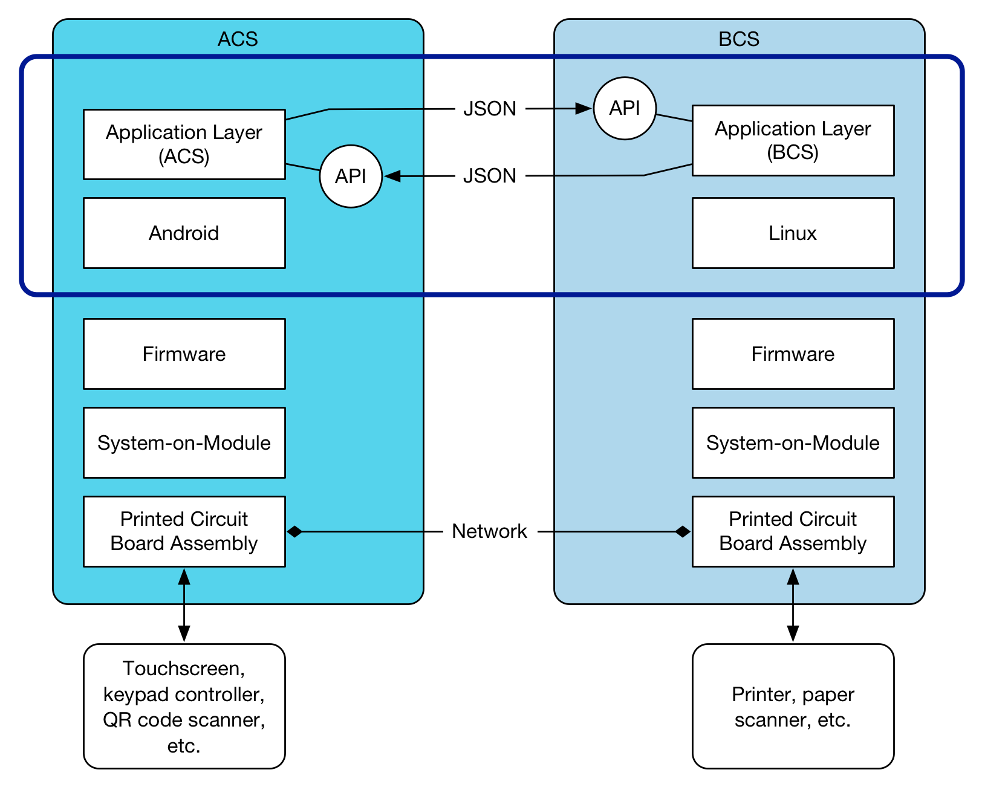
The BMD Application Layer consists of two parts:
- The ACS, which drives the user interface, audio and voting selection; and manages the overall workflow
- The BCS, which drives the paper path, accepts, prints, scans and casts the ballot
ACS and BCS communicate using an API-based integration (“Shuttle API”) over an Ethernet connection.
The ACS application layer consists of:
- The voting application, implementing the user interactions with the BMD
- The BMD deployment management service, which receives and installs system images and BMD election configuration files. The BMD deployment management service is also responsible for deploying software updates to the BCS
It is expected that the API will allow the ACS and BCS to be developed and updated independently, while still maintaining interoperability.
The software development model for the Application Layer follows the hardware manufacturing model from EVT to DVT to Production Validation Testing (“PVT”). The goal is to have a completely working BMD and surrounding VSAP ecosystem by the end of EVT, not just a partial prototype that may undergo substantial changes. Therefore, the software development for the Application Layer must be complete and integrated with the BMD within EVT. Minor changes and refinements may be introduced in DVT and PVT.
        - BMD Application Layer Tasks and Deliverables
The purpose of the application development tasks at this stage of the process is to finalize the selection of the production software stack based on previous recommendations and develop
the first version of the Application Layer, ready for deployment with the BMD hardware at the EVT stage.
          - Develop Software Development Plan and Test Plan
The Software Development Plan and Test Plan drive the specific approach to implement the Application Layer. While the BMD Application Layer shares the overall approach with the software development for the ISB and BMG components, there are likely differences related to the deployment platform of the ACS and BCS SOM components of the BMD.
Deliverable 2.2.1.4.1.1a BMD Application Layer Software Development Plan
Delivery Timing | Submitted for approval prior to software development
Delivery Frequency | Once
Description | This deliverable describes the overall approach to confirming the requirements, refining the design and developing, testing and deploying the solution.  The Application Layer Software Development Plan shall include, at minimum:  - Requirements confirmation  - Requirements management  - Design validation and refinement  - Release and sprint planning, with delivery cadence  - Code versioning  - Build management and continuous integration with deployment to production-class hardware (ACS and BCS SOM runtime environment)  - Defect management and resolution

PROPOSER RESPONSE TO: Deliverable 2.2.1.4.1.1a BMD Application Layer Software Development Plan
Will the Proposer complete the deliverables and related tasks as described above?
___ Yes
___ Yes, with modifications
___ No
Explain your approach to completing the deliverables and related tasks as described above:

Deliverable 2.2.1.4.1.1b BMD Application Layer Test Plan
Delivery Timing | Submitted for approval prior to software development
Delivery Frequency | Once
Description | This deliverable describes the approach to testing the solution under development. The preference is to test as early and often as possible in the life cycle and detect defects when they are relatively easy to fix.  The Application Layer Test Plan shall cover, at minimum:  - Unit Test within classes/low level modules of the code  - System Test within the ACS and BCS  - Integration Test within the BMD  - Security test of all components and integration  - End-to-end functional test within the overall solution, including the BMG  - Load/stress testing  - User Experience testing by community stakeholders of elements that require further design  - User Acceptance Test

PROPOSER RESPONSE TO: Deliverable 2.2.1.4.1.1b BMD Application Layer Test Plan
Will the Proposer complete the deliverables and related tasks as described above?
___ Yes
___ Yes, with modifications
___ No
Explain your approach to completing the deliverables and related tasks as described above:

Deliverable 2.2.1.4.1.1c BMD Application Layer Test Cases — EVT
Delivery Timing | Submitted for approval prior to testing
Delivery Frequency | Once
Description | This deliverable captures all test cases, whether manual or automated. This includes, at minimum:  - Test cases with traceability to requirements and acceptance criteria  - Test suites and dependency chains  - All test data required to execute the test cases  - Test scripts for all automated tests

PROPOSER RESPONSE TO: Deliverable 2.2.1.4.1.1c BMD Application Layer Test Cases – EVT
Will the Proposer complete the deliverables and related tasks as described above?
___ Yes
___ Yes, with modifications
___ No
Explain your approach to completing the deliverables and related tasks as described above:
          - Validate and Refine the Design
Requirements: The requirements for the Application Layer have been defined in Phase 3 (System Design and Engineering) of the VSAP Project. As part of this task, the Contractor shall develop an understanding of the requirements and how they have driven the design documents that are the core input into this Project. The County does not intend to revisit the requirements or to hold requirement validation sessions.
Similarly, Phase 3 (System Design and Engineering) of the VSAP Project also established the software design of the solution, captured in distinct sections of the Software Solution Design Document (“SSDD”), including the design for the Application Layer. The County seeks to capture the next version of the VSAP design into two new document formats:
- Software Architecture Document, which captures the core architecture design
- Software Specifications, capturing the detailed software specifications
These two documents will replace the current SSDD and form the new basis for building and describing the software components.
For the BMD Application Layer, the documents that describe the current version of the design include the documents listed below.
Specification Documents:
- Location: BMD Software & Software Solution Design Document
- Filenames:
    - SSDD — Section 02 — System Connectivity
    - SSDD — Section 03 — System Security
    - SSDD — Section 04 — Ballot Marking Device
    - BMD Software, Section 5.4.3, detailed software design specification documents:
        - Software Architecture Specification
        - Shuttle API Specification
    - 3.2 BMD User Interface Design.pdf
    - 3.2 BMD User Interface Flows.pdf
    - 3.2 BMD User Interface Flows.sketch
    - BMD System Sounds.zip
    - BMD Animations.zip
    - BMD Icons.zip
    - Video-Dual Switch.mp4
Requirements:
- BMD Requirements
Based on review of the requirements, the goal for this task is to identify the potential gaps in the design. The design includes, but is not limited to:
- The User Experience, including detailed screen layout and flow
- The final technology stack, including operating system, frameworks and toolkits
- The interface definitions between the ACS, BCS and components
After identification, all gaps and outstanding open items must be addressed in a functionally complete design. The County expects design artifacts to be generated such as detailed software architecture diagrams, event models and data structures. The County’s expectation is that these artifacts will be generated as maintainable models through widely available tooling.
It is the intention for the design of the Application Layer to be complete at the end of the EVT stage.
Deliverable 2.2.1.4.1.2a BMD Application Layer Software Architecture Document — EVT
Delivery Timing | Upon completion of expected tasks described in this section
Delivery Frequency | Once
Description | The Contractor shall create the Software Architecture Document based on the SSDD that contains several sections that capture detailed software design specifications for the Application Layer, including:  - System Connectivity that describes how the major components of the overall voting solution communicate and exchange data  - System Security that describes the data integrity, confidentiality and availability of the voting system. The BMD, and the software that controls it, is the heart of the voting system and touches on all aspects of system security  - BMD that describes the hardware and software components of the BMD, their interactions and how they will support the voting process. It is a key section of the overall design for the Application Layer

PROPOSER RESPONSE TO: Deliverable 2.2.1.4.1.2a BMD Application Layer Software Architecture Document – EVT
Will the Proposer complete the deliverables and related tasks as described above?
___ Yes
___ Yes, with modifications
___ No
Explain your approach to completing the deliverables and related tasks as described above:

Deliverable 2.2.1.4.1.2b Final BMD Application Layer Software Design Document — EVT
Delivery Timing | Upon completion of expected tasks described in this section
Delivery Frequency | Once
Description | The Contractor shall create the final BMD Application Layer Software Design Document based on the preexisting design specifications that contain several documents that capture detailed software design specifications for the Application Layer, including:  - Software Specification that provides a comprehensive architectural overview of the system and is intended to capture and convey the structure and the architectural decisions that have been made on the system, along with rationale  - Application Detailed Design Specification that provides a detailed description of the BMD Application Layer as described in the Software Architecture Specification document (linked above)  - Shuttle API Specification that defines the interface that allows the ACS and BCS to communicate with each other  While the County emphasizes the development of highly maintainable and transparent code over the creation of documentation, some core artifacts are critical such as:  - Detailed software architecture diagrams  - Event model  - Data structures  - Interface specifications  These artifacts must be in portable, standards-based electronic formats, rather than documents or presentations.

PROPOSER RESPONSE TO: Deliverable 2.2.1.4.1.2b Final BMD Application Layer Software Design Document – EVT
Will the Proposer complete the deliverables and related tasks as described above?
___ Yes
___ Yes, with modifications
___ No
Explain your approach to completing the deliverables and related tasks as described above:
          - Establish the Development Environment
The development environment includes all processes and toolchains to develop and test the Application Layer software, including the software repository, continuous integration and test automation. The County intends to maintain ownership and governance (directly, or through a separate entity) of the software development environment. Changes and optimizations of the environment must be reflected in this deliverable.
Deliverable 2.2.1.4.1.3a BMD Application Layer Software and Deployment — EVT
Delivery Timing | Upon completion of expected tasks described in this section
Delivery Frequency | Once
Description | This deliverable covers all software code, configuration and runtime components to be deployed to the ACS and BCS environment. These include:  - Software repository for each release  - Operating system baseline and configuration  - BMD system configuration and application configuration file

PROPOSER RESPONSE TO: Deliverable 2.2.1.4.1.3a BMD Application Layer Software and Deployment – EVT
Will the Proposer complete the deliverables and related tasks as described above?
___ Yes
___ Yes, with modifications
___ No
Explain your approach to completing the deliverables and related tasks as described above:

Deliverable 2.2.1.4.1.3b BMD Application Layer Software Tooling
Delivery Timing | Upon completion of expected tasks described in this section
Delivery Frequency | Once
Description | This deliverable includes all tooling required to develop and maintain the Application Layer, including:  - Configuration of the Integrated Development Environment (“IDE”)  - Software repository  - Continuous build and integration  - Test automation  - Deployment and release management

PROPOSER RESPONSE TO: Deliverable 2.2.1.4.1.3b BMD Application Layer Software Tooling
Will the Proposer complete the deliverables and related tasks as described above?
___ Yes
___ Yes, with modifications
___ No
Explain your approach to completing the deliverables and related tasks as described above:
          - Develop and Test the Solution
Development and testing should be approached as integrated activities, with testing commencing as early as possible in the development process. The County expects the majority of testing to be automated and repeatable, based on a managed and comprehensive set of test cases that trace back to the requirements.
End-to-end testing is conducted at the project level, not at the component level. However, prior to end-to-end testing of the Application Layer, testing must include deployment and execution on the ACS and BCS SOM hardware. It must not be limited to a simulated environment. The EVT stage is not complete until all components, and the integration between the components, have been fully tested. This includes all hardware, all software and all interfaces.
Deliverable 2.2.1.4.1.4 BMD Application Layer Test Report — EVT
Delivery Timing | Submitted for approval as fully functional BMDs at the end of the EVT stage
Delivery Frequency | Once
Description | This deliverable includes a comprehensive test report that captures the test outcomes at all levels specified in the Test Plan and is a key input to the completeness of this project stage. The County envisions that this deliverable is largely automatically generated as part of the test execution. It includes:  - Test methodology and test tools  - Outcomes of all test levels and test cases  - Indication of the test coverage  - Test trends and “hot spots” of the software that are more prone to defects than others

PROPOSER RESPONSE TO: Deliverable 2.2.1.4.1.4 BMD Application Layer Test Report – EVT
Will the Proposer complete the deliverables and related tasks as described above?
___ Yes
___ Yes, with modifications
___ No
Explain your approach to completing the deliverables and related tasks as described above:
      - Application Control System Board Support Package and Firmware
Complete:
- Temporary Board Support Package built on embedded Linux and off-the-shelf drivers used to build the prototype voting application loaded on the Design Validation Units for demonstration purposes
To Be Done:
- Develop the production Board Support Package and drivers based on the software stack chosen for the UX/UI application layer
Specification Documents:
- Location: BMD Software
- Filename:
    - Software Architecture Specification
    - Software Solution Design Document — Section 04 — Ballot Marking Device
Requirements:
- BMD Requirements
Expected Tasks:
- Review design rationale for proposed OS and finalize selection
- Select, modify, or build Board Support Package for selected OS
- Demonstrate and test functionality on EVT hardware
- Address issues raised in testing
- Iterate on above tasks as necessary until design is shown to meet performance requirements
Deliverable 2.2.1.5 Application Control System Board Support Package Software Image — EVT
Delivery Timing | Submitted for approval as fully functional BMDs at the end of the EVT stage
Delivery Frequency | Once
Description | The Contractor shall deliver:  - ACS Board Support Package software image  - Associated documentation

PROPOSER RESPONSE TO: Deliverable 2.2.1.5 Application Control System Board Support Package Software Image – EVT
Will the Proposer complete the deliverables and related tasks as described above?
___ Yes
___ Yes, with modifications
___ No
Explain your approach to completing the deliverables and related tasks as described above:

      - Ballot Control System Hardware and Peripherals
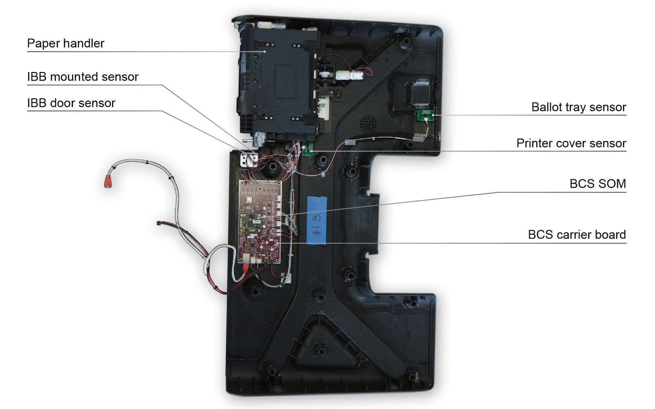
Complete:
- Design of the BCS printed circuit board assemblies is complete
- Five functional design validation unit prototypes of the final design were built
- Board layouts and bill of materials are documented
To Be Done:
- Validate and document that printer driver board and BCS are not affected by final thermal print mechanism specification
- Assess consolidation of printer driver board with BCS
- Validate and document any changes to BCS hardware caused by cost-reduction efforts on the paper handler
- Assess potential changes to BCS to facilitate the BMD passing FCC scan tests
Specification Documents:
- Location: BMD Hardware
- Filenames:
    - Vox_ID_Deck_2016-06_28.pdf
    - 5.4.2.2.1 Designing & Using the BMD
    - 5.4.2.2.2 Designing & Engineering the External BMD Components
    - 5.4.2.2.3 Designing & Engineering the Internal BMD Components
    - 5.4.2.2.4 Designing & Engineering the BMD's Paper Handler
    - 5.4.2.3 BMD Manufacturing Release Package
    - 5.4.4 BMD Design Validation Units
    - Known Issues and Recommendations
Requirements:
- BMD Requirements
Expected Tasks:
- Evaluate and address Known Issues and Recommendations from the document linked above and incorporate design refinements as required based on mutual agreement with the County and its Design Stewards
- Build test units and test electrical hardware design against performance requirements
- Document and resolve issues raised in testing
- Iterate on above tasks as necessary until design is shown to meet performance requirements
Expected Deliverables:
This subcomponent is one aspect of the BMD hardware and will be completed at the same time as the other BMD hardware subcomponents in order to deliver an assembled BMD unit. The result of these tasks will be considered to meet deliverable 2.2.1.2 Engineering Validation Testing and Results for BMD Hardware, and shall be submitted upon completion of all expected tasks described in the following sections:
- 2.2.1.2 Mechanical (housing, stand, privacy screen and ballot box)
- 2.2.1.3 Application Control System Hardware and Peripherals
- 2.2.1.6 Ballot Control System Hardware and Peripherals
- 2.2.1.8 Paper Handler
- 2.2.1.9 Ballot Printer
- 2.2.1.10 Cases and Carts
See Section 2.2.1.2 Mechanical (housing, stand, privacy screen and ballot box) for a description of the deliverable and the Proposer’s response.
      - Ballot Control System Board Support Package and Firmware
Complete:
- Board Support Package and firmware complete
To Be Done:
- Update drivers, as applicable, to meet the final thermal printer paper handler specifications
Specification Documents
- Location: BMD Software
- Filename:
    - Software Architecture Specification
    - BCS Software Design Description
    - BCS Software Detailed Design
    - Software Solution Design Document — Section 04 — Ballot Marking Device
Requirements:
- BMD Requirements
Expected Tasks:
- Update firmware, if needed, to support changes to the paper handler or printer
- Demonstrate and test functionality on EVT hardware
- Address issues raised in testing
- Iterate on above tasks as necessary until design is shown to meet performance requirements
Expected Deliverables:
- BCS BSP software image
- Related documentation
Deliverable 2.2.1.7 Ballot Control System Board Support Package Software Image — EVT
Delivery Timing | Submitted for approval as fully functional BMDs at the end of the EVT stage
Delivery Frequency | Once
Description | The Contractor shall deliver:  - BCS Board Support Package software image  - Related documentation

PROPOSER RESPONSE TO: Deliverable 2.2.1.7 Ballot Control System Board Support Package Software Image – EVT
Will the Proposer complete the deliverables and related tasks as described above?
___ Yes
___ Yes, with modifications
___ No
Explain your approach to completing the deliverables and related tasks as described above:
      - Paper Handler
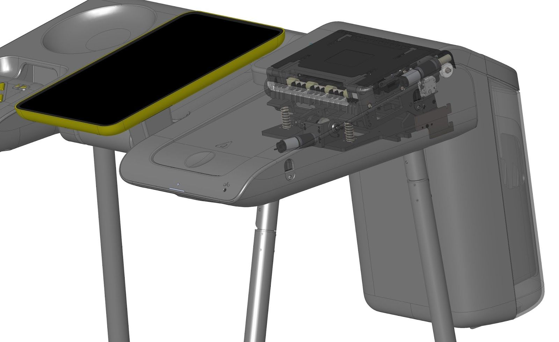
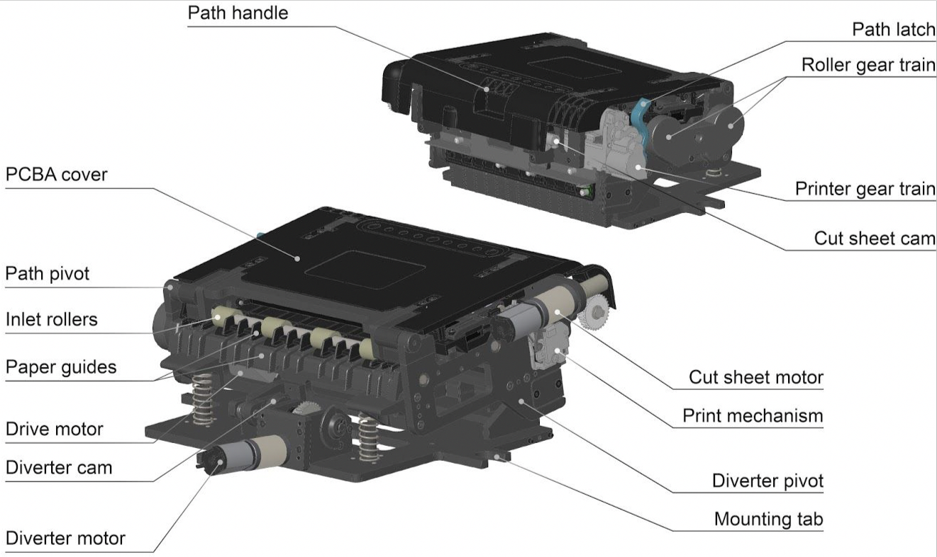
Complete:
- Functional design demonstrated and specified with manufacturing methods suitable for low-volume production
To Be Done:
- Complete full production engineering for the paper handler
- Refine the paper handler design for higher volume production techniques and processes, including evaluating and documenting potential for cost reduction (e.g., by adjusting the design of the metal parts to be more net shaped, instead of being an assembly of machined components fastened with screws)
- Refine and document design as print mechanism is finalized
Specification Documents:
- Location: BMD Hardware
- File Names:
    - Vox_ID_Deck_2016-06_28.pdf
    - 5.4.2.2.1 Designing & Using the BMD
    - 5.4.2.2.2 Designing & Engineering the External BMD Components
    - 5.4.2.2.3 Designing & Engineering the Internal BMD Components
    - 5.4.2.2.4 Designing & Engineering the BMD's Paper Handler
    - 5.4.2.3 BMD Manufacturing Release Package
    - 5.4.4 BMD Design Validation Units
    - Known Issues and Recommendations
Requirements:
- BMD Requirements
Expected Tasks:
- Evaluate and address Known Issues and Recommendations from the document linked above and incorporate design refinements as required based on mutual agreement with the County and its Design Stewards
- Build test units and test mechanical design against performance requirements
- Address issues raised in testing
- Iterate on above tasks as necessary until design is shown to meet performance requirements
Expected Deliverables:
This subcomponent is one aspect of the BMD hardware and will be completed at the same time as the other BMD hardware subcomponents in order to deliver an assembled BMD unit. The result of these tasks will be considered to meet deliverable 2.2.1.2 Engineering Validation Testing and Results for BMD Hardware, and shall be submitted upon completion of all expected tasks described in the following sections:
- 2.2.1.2 Mechanical (housing, stand, privacy screen and ballot box)
- 2.2.1.3 Application Control System Hardware and Peripherals
- 2.2.1.6 Ballot Control System Hardware and Peripherals
- 2.2.1.8 Paper Handler
- 2.2.1.9 Ballot Printer
- 2.2.1.10 Cases and Carts
See Section 2.2.1.2 Mechanical (housing, stand, privacy screen and ballot box) for a description of the deliverable and the Proposer’s response.
      - Ballot Printer
Complete:
- Reference design demonstrated with modified Fujitsu print mechanism
To Be Done:
- Custom develop, or commercially source, a production print mechanism to the specifications set forth in the design documentation.
Specification Documents:
- Location: BMD Hardware
- File Name:
    - 5.4.2.2.4 Designing & Engineering the BMD's Paper Handler
Requirements:
- BMD Requirements
Expected Tasks:
- Design and manufacture printer to specifications
- Build test units and test mechanical design against performance requirements
- Address issues raised in testing
Expected Deliverables:
This subcomponent is one aspect of the BMD hardware and will be completed at the same time as the other BMD hardware subcomponents in order to deliver an assembled BMD unit. The result of these tasks will be considered to meet deliverable 2.2.1.2 Engineering Validation Testing and Results for BMD Hardware, and shall be submitted upon completion of all expected tasks described in the following sections:
- 2.2.1.2 Mechanical (housing, stand, privacy screen and ballot box)
- 2.2.1.3 Application Control System Hardware and Peripherals
- 2.2.1.6 Ballot Control System Hardware and Peripherals
- 2.2.1.8 Paper Handler
- 2.2.1.9 Ballot Printer
- 2.2.1.10 Cases and Carts
See Section 2.2.1.2 Mechanical (housing, stand, privacy screen and ballot box) for a description of the deliverable and the Proposer’s response.
      - Cases and Carts
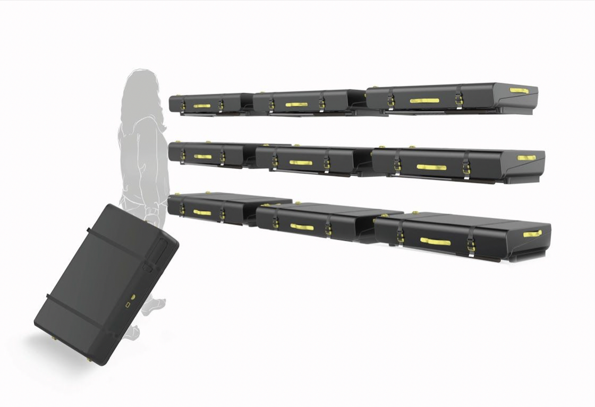
Complete:
- Reference sketch/illustration and high-level requirements
To Be Done:
- Create detailed design, perform functional testing and refine design based on testing
- Collaborate with the County to work with its racking and storage strategy in the Election Operations Center (“EOC”) or other designated facility
Specification Documents:
- Location: BMD Hardware
- File Names:
    - Vox_ID_Deck_2016-06_28.pdf
    - 5.4.2.2.1 Designing & Using the BMD
    - 5.4.2.2.2 Designing & Engineering the External BMD Components
Requirements:
- BMD Requirements
Expected Tasks:
- Design case and cart with consideration for storage at County’s EOC and transportation to/from Vote Centers
- Build test units of the case and cart and test BMDs against applicable performance requirements
- Address issues raised in testing
- Iterate on above tasks as necessary until design is shown to meet performance requirements
Expected Deliverables:
This subcomponent is one aspect of the BMD hardware and will be completed at the same time as the other BMD hardware subcomponents in order to deliver an assembled BMD unit. The result of these tasks will be considered to meet deliverable 2.2.1.2 Engineering Validation Testing and Results for BMD Hardware, and shall be submitted upon completion of all expected tasks described in the following sections:
- 2.2.1.2 Mechanical (housing, stand, privacy screen and ballot box)
- 2.2.1.3 Application Control System Hardware and Peripherals
- 2.2.1.6 Ballot Control System Hardware and Peripherals
- 2.2.1.8 Paper Handler
- 2.2.1.9 Ballot Printer
- 2.2.1.10 Cases and Carts
See Section 2.2.1.2 Mechanical (housing, stand, privacy screen and ballot box) for a description of the deliverable and the Proposer’s response.
    - Interactive Sample Ballot
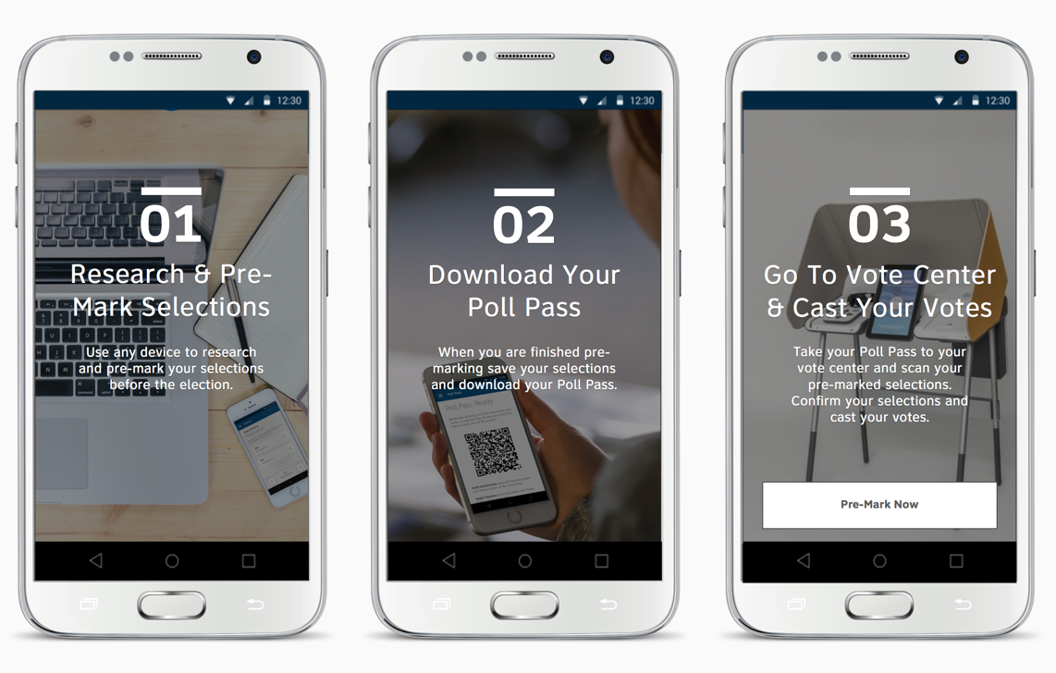
The ISB is a web-based solution that delivers the following services:
- Enables voters to view their sample ballot online in an accessible and responsive format, digitally pre-mark vote selections prior to arriving at the Vote Center and generate a QR code (“Poll Pass”) that may be used to quickly transfer the pre-marked selections when casting a ballot on the BMDs at Vote Centers
- Enables voters with disabilities to privately and securely access, mark and print a Remote Accessible Vote by Mail (“RAVBM”) ballot on their personal devices, which may be returned with their VBM packet
- Enables military and overseas voters to vote and print an electronic Uniformed and Overseas Citizens Absentee Voting Act (“UOCAVA”) ballot and a privacy waiver signature form, which may be signed and faxed in
Both the RAVBM ballot and the UOCAVA ballot will be similar to the BMD Ballot in that the voter’s selections will be encoded in a QR code as well as printed in human-readable text for auditability purposes. The Poll Pass is not considered a ballot and only contains pre-marked selections in the QR code to streamline the BMD voting experience.
The following diagram in Figure 8 illustrates the context of the ISB used to generate a Poll Pass in the BMD-centric voting path. The initial steps in the diagram are different for ISB voters, but then the paths converge and ISB voters complete the process on the BMD. Similarly, Figure 9 illustrates the context by which voters use and submit an RAVBM or UOCAVA ballot.

- Interactive Sample Ballot Voting Path
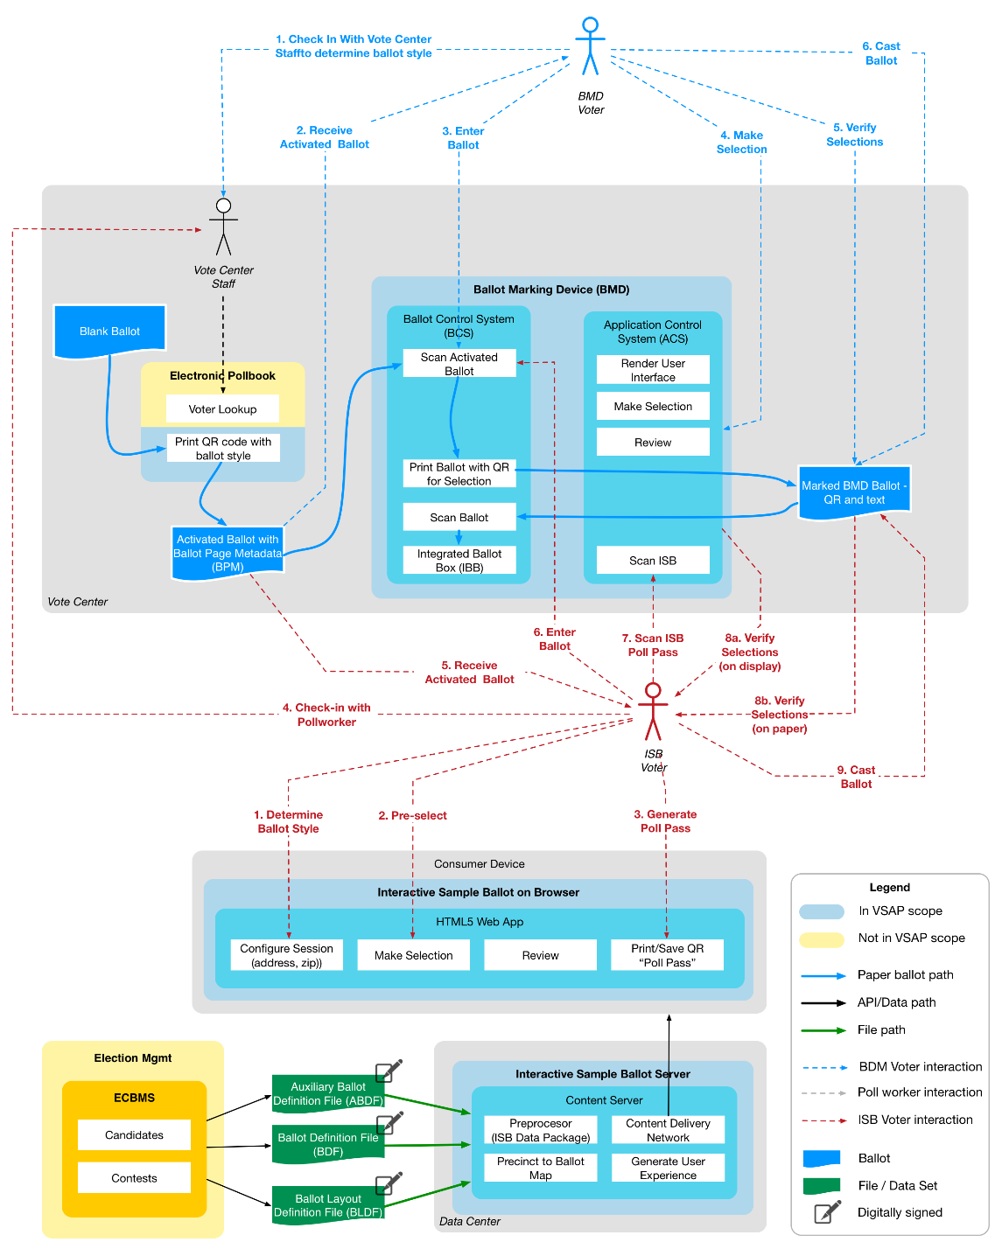
- RAVBM and UOCAVA Voting Path
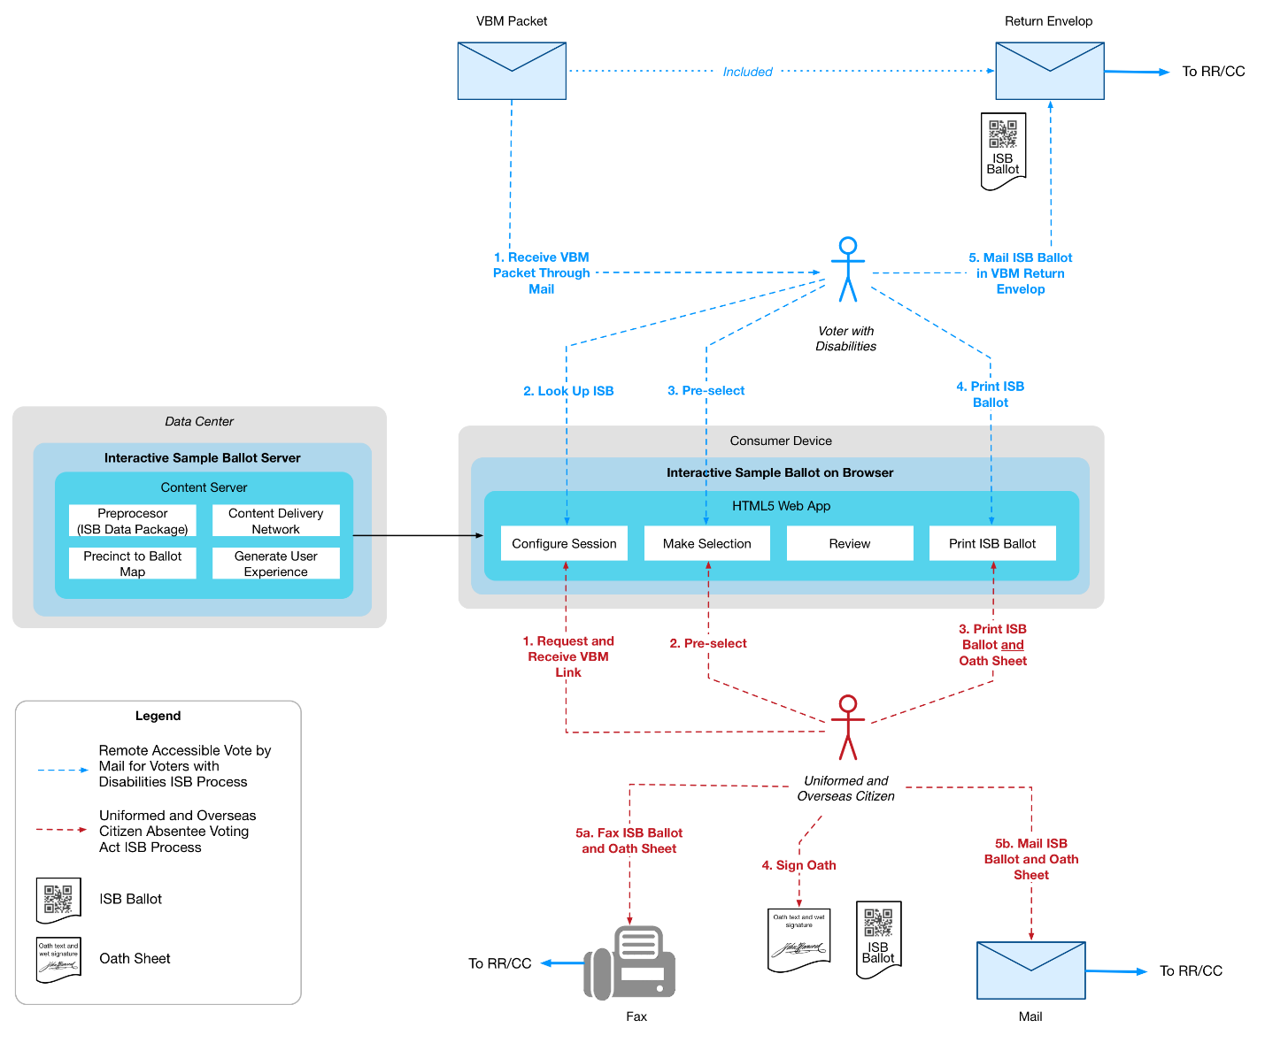

The ISB solution consists of:
- A search interface with Department databases to retrieve the correct ballot style given the user’s voter information or address
- A content server, running on commodity hardware. It is configured with two (2) file types generated from the Election Contest and Ballot Management System (“ECBMS”): a Ballot Definition File and an Auxiliary Ballot Definition File. These files help to present the correct ballot style for the voter, which is generated as a self-contained UX to be executed within an HTML5 browser environment, requiring no server interaction and storing no personally identifiable information
- A responsive web application designed to be fully functional in both a desktop and mobile browser environments, capable of running the self-contained HTML5 application to guide the user through the pre-selection process and generate a Poll Pass, a RAVBM Ballot or a UOCAVA Ballot
The development of the ISB application and the BMD application layer should be coordinated to maintain a consistent user experience. The ACS will contain functionality to read the QR code on the Poll Pass.
Because of the need to integrate with the BMD as a complete solution at the EVT milestone, the ISB application must be functionally complete at that time. Minor changes and refinements may be introduced in DVT. Notwithstanding anything to the contrary in this document, the ISB must be compliant with the current laws and regulations related to remote accessible vote by mail.
      - Expected ISB Tasks and Deliverables
The purpose of the application development tasks at this stage of the process is to finalize the selection of the production software stack based on previous recommendations and develop the first version of the ISB content server and HTML5 application, ready for integration with the BMD hardware at the EVT stage.
        - Develop Software Development Plan and Test Plan
The Software Development Plan and Test Plan drive the specific approach to implement the ISB solution. While it shares the overall approach with the software development for the Application Layer components, there are likely differences since the deployment platform is a content server and client browser environment.
Deliverable 2.2.2a ISB Software Development Plan
Delivery Timing | Upon completion of expected tasks described in this section
Delivery Frequency | Once
Description | This deliverable describes the overall approach to confirming the requirements; refining the design; and developing, testing and deploying the solution.  The ISB Software Development Plan shall include, at minimum:  - Requirements confirmation  - Requirements management  - Design validation and refinement  - Release and sprint planning, with delivery cadence  - Code versioning  - Build management and continuous integration and testing with deployment to production-class hardware (content server) and target desktop and mobile browser environments  - Defect management

PROPOSER RESPONSE TO: Deliverable 2.2.2a ISB Software Development Plan
Will the Proposer complete the deliverables and related tasks as described above?
___ Yes
___ Yes, with modifications
___ No
Explain your approach to completing the deliverables and related tasks as described above:

Deliverable 2.2.2b ISB Test Plan
Delivery Timing | Upon completion of expected tasks described in this section
Delivery Frequency | Once
Description | This deliverable describes the approach to testing the ISB solution under development. The preference is to test as early and often as possible in the life cycle and detect defects when they are relatively easy to fix.  The ISB Test Plan shall cover, at minimum:  - Unit Test within classes/low level modules of the code  - System Test within the ISB server and browser-based components  - Integration Test within the BMD  - End-to-end functional test within the overall solution, including loading ECBMS configuration files  - Security test of all components and integration  - Load/Stress testing at the server level  - User Experience testing by community stakeholders  - User Acceptance Test  - Security testing

PROPOSER RESPONSE TO: Deliverable 2.2.2b ISB Test Plan
Will the Proposer complete the deliverables and related tasks as described above?
___ Yes
___ Yes, with modifications
___ No
Explain your approach to completing the deliverables and related tasks as described above:

Deliverable 2.2.2c ISB Test Cases — EVT
Delivery Timing | Upon completion of expected tasks described in this section
Delivery Frequency | Once
Description | This deliverable captures all test cases, whether manual or automated. This includes, at minimum:  - Test cases with traceability to requirements and acceptance criteria  - Test suites and dependency chains  - All test data required to execute the test cases  - Test scripts for all automated tests

PROPOSER RESPONSE TO: Deliverable 2.2.2c ISB Test Cases – EVT
Will the Proposer complete the deliverables and related tasks as described above?
___ Yes
___ Yes, with modifications
___ No
Explain your approach to completing the deliverables and related tasks as described above:
        - Validate and Refine the Design
Requirements: The Contractor shall develop an understanding of the ISB requirements and how they have driven the design and requirement documents that are the core input of this Project. The County does not intend to revisit the requirements or to hold requirement validation sessions.
Similarly, Phase 3 (System Design and Engineering) of the VSAP Project also established a preliminary software design of the ISB solution, captured in distinct sections of the SSDD. To further expand upon the requirements gathered in Phase 3 and to add RAVBM and UOCAVA support within the ISB requirements, a Software Requirements Specification was completed for the ISB.
The software design is captured in the following documents (see the related deliverables for the document description).
Specification Documents:
- Location: Interactive Sample Ballot
- File Names:
    - SSDD — Section 02 — System Connectivity
    - SSDD — Section 03 — System Security
    - SSDD — Section 07 — Interactive Sample Ballot (for reference for design refinement, utilize the Software Requirements Specification for final requirements)
    - Section 4 Interactive Sample Ballot, detailed design documents:
        - Interactive Sample Ballot (ISB) Design Deck
        - ISB Sketch File
        - Printed Poll Pass Native File
    - ISB RAVBM Ballot Sample
    - ISB UOCAVA Ballot Sample
    - Known Issues and Recommendations
Requirements:
- ISB Requirements
- Interactive Sample Ballot Software Requirements Specification
The goal for this task is to identify the potential gaps in the design, based on review of the requirements. The design includes, but is not limited to:
- UX, including detailed screen layout and flow, and compatibility with desktop screen readers and mobile accessibility modes (note: this compatibility is not reflected in the demo website)
- The final technology stack, including operating system, frameworks and toolkits for the content server
- The development of a self-contained HTML5 browser application
After identification, all gaps and outstanding open items must be addressed in a functionally complete design. Since the UX of the ISB is a critical success factor, the design must be user-tested prior to starting significant development effort. The County expects design artifacts to be generated such as detailed software architecture diagrams, event models and data structures. The County’s expectation is that these artifacts will be generated as maintainable models through widely available tooling.
It is the intention for the design of the ISB to be complete at the end of the EVT stage. While subsequent stages may introduce changes, the goal of software development in EVT is a functionally and technically complete solution.
Deliverable 2.2.2d ISB Software Architecture Document — EVT
Delivery Timing | Upon completion of expected tasks described in this section
Delivery Frequency | Once
Description | The Contractor shall create the Software Architecture Document based on the Software Requirements Specification and SSDD documentation that contain several sections that capture detailed software design specifications for the ISB, including:  - System connectivity that describes how the major components of the overall voting solution exchange data.  - System security that describes the data integrity, confidentiality and availability of the voting system.  - ISB that describes the flow, user experience, components, design considerations, security considerations, interfaces and the software stack. It is a key section of the overall design for the ISB.

PROPOSER RESPONSE TO: Deliverable 2.2.2d ISB Software Architecture Document – EVT
Will the Proposer complete the deliverables and related tasks as described above?
___ Yes
___ Yes, with modifications
___ No
Explain your approach to completing the deliverables and related tasks as described above:

Deliverable 2.2.2e Final ISB Software Design Document — EVT
Delivery Timing | Upon completion of expected tasks described in this section
Delivery Frequency | Once
Description | The Contractor shall create the final ISB Software Design Document based on the pre-existing ISB Software Requirement Specification and Phase 3 System Design and Engineering design artifacts.  Due to requirement changes since the Phase 3 design documentation was created, this deliverable is meant to create design documentation that reflects all changes included in the ISB Software Requirements Specification, and any gap analysis the selected Contractor performs for this phase of the project.  While the County emphasizes the development of highly maintainable and transparent code over the creation of documentation, some core artifacts are critical such as:  - Detailed software architecture diagrams  - Interaction between the server and browser environment  - Data structures  - Interface and configuration specifications  These artifacts must be in portable, standards-based electronic formats, rather than documents or presentations.

PROPOSER RESPONSE TO: Deliverable 2.2.2e Final ISB Software Design Document – EVT
Will the Proposer complete the deliverables and related tasks as described above?
___ Yes
___ Yes, with modifications
___ No
Explain your approach to completing the deliverables and related tasks as described above:
        - Establish the Development Environment
The development environment includes all processes and toolchains to develop and test the ISB software, including the software repository, continuous integration and test automation. It is the County’s intention to transition the ongoing development to the County or a separate entity following the Project completion. Changes and optimizations of the environment must be reflected in this deliverable.
Deliverable 2.2.2f ISB Software and Deployment — EVT
Delivery Timing | Upon completion of expected tasks described in this section
Delivery Frequency | Once
Description | This deliverable covers all software code, configuration and runtime components to be deployed to the server and browser environment. These include:  - Software repository for each release  - Operating system baseline and configuration  - ISB System Configuration  - Documentation for all software code

PROPOSER RESPONSE TO: Deliverable 2.2.2f ISB Software and Deployment – EVT
Will the Proposer complete the deliverables and related tasks as described above?
___ Yes
___ Yes, with modifications
___ No
Explain your approach to completing the deliverables and related tasks as described above:

Deliverable 2.2.2g ISB Software Tooling
Delivery Timing | Upon completion of expected tasks described in this section
Delivery Frequency | Once
Description | This deliverable includes all tooling required to develop and maintain the ISB, including:  - Configuration of the IDE  - Software repository  - Continuous build and integration  - Test automation  - Deployment management

PROPOSER RESPONSE TO: Deliverable 2.2.2g ISB Software Tooling
Will the Proposer complete the deliverables and related tasks as described above?
___ Yes
___ Yes, with modifications
___ No
Explain your approach to completing the deliverables and related tasks as described above:

        - Develop and Test the Solution
Development and testing should be approached as integrated activities, with testing commencing as early as possible in an iterative development process. The County expects the majority of testing to be automated and repeatable, based on a managed and comprehensive set of test cases that trace back to the requirements.
End-to-end testing is conducted at the project level, not at the component level. Testing must include scanning of the Poll Pass QR code on the BMD QR code scanner.
Deliverable 2.2.2h ISB Test Report — EVT
Delivery Timing | Upon completion of expected tasks described in this section
Delivery Frequency | Once
Description | This deliverable covers a comprehensive test report that captures the test outcomes at all levels, and is a key input to the completeness of this stage. The County envisions that this deliverable is largely automatically generated as part of the test execution. It includes:  - Test methodology and test tools  - Outcomes of all test levels and test cases  - Indication of the test coverage  - Test trends and “hot spots” of the software that are more prone to defects than others

PROPOSER RESPONSE TO: Deliverable 2.2.2h ISB Test Report – EVT
Will the Proposer complete the deliverables and related tasks as described above?
___ Yes
___ Yes, with modifications
___ No
Explain your approach to completing the deliverables and related tasks as described above:

    - BMD Manager
The BMG is the mechanism to deploy the Application Layer onto the BMD hardware and configure BMDs for elections. The BMG is a critical tool for carrying out certain administrative functions on BMDs at a large scale without requiring direct physical access. Activities such as securing units for elections and maintaining and repairing BMD hardware will require physical contact with individual BMD units.
BMDs will always be configured with all necessary election data prior to transportation to Vote Centers, where they operate in stand-alone fashion, not connected to any networks. Between elections, while housed at the EOC, BMDs are placed in a rack that allows the units to be accessed through a hardwired, isolated and secure network by the BMG for administration of one-to-many devices simultaneously.
Administrative tasks include:
- Running diagnostics of the hardware, Application Layer software and peripherals
- Loading system images, including the operating system for the ACS and BCS
- Loading BMD configurations with election-specific data and settings
- Obtain the serial number and hardware cryptographic key for BMDs used in an election
- Exporting aggregated BMD logs
The following diagram in Figure 10 illustrates the context of the BMG in the VSAP architecture.
- BMD Manager in the Context of the VSAP Architecture
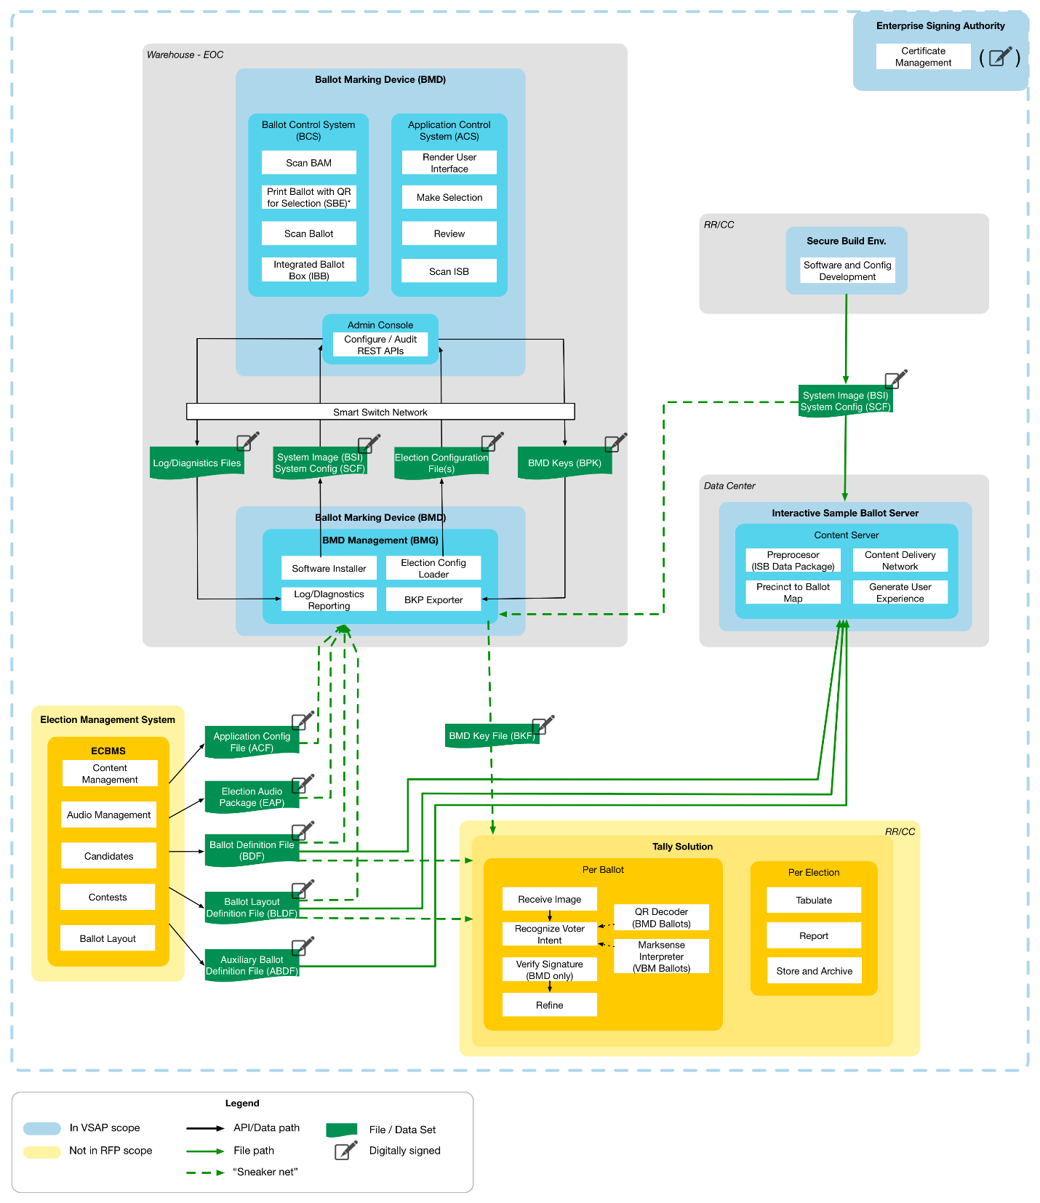
The core Application Layer code, including the entire ACS and BCS software stack, is provided from the secure build environment as a BMD System Image and System Configuration File. There is no need to update these prior to each election. The change rate of BCS software is anticipated to be low, and the ACS may see changes to improve efficiency or add functional capability.
The Application Layer is configurable with election data provided by the following interface files that are created by the ECBMS with a defined interface specification:
- Application Configuration File
- Ballot Definition File
- Ballot Layout Definition File
- Election Audio Package
For security reasons, there is no network connection between the BMG beyond the racked BMDs. Therefore, the configuration file (including the system images) are loaded within the BMG through a manual and audited process. Note that the Ballot Definition File and Auxiliary Ballot Definition File also configure the ISB, which must maintain a consistent user experience with the BMD, while the Ballot Definition File also configures Tally, which tabulates the ballots.
The BMG only operates from the controlled EOC environment. It would not be used at any Vote Center.
The BMG software must be able to interoperate with multiple versions of the BMD Application Layer.
Because of the need to configure the BMDs as a complete solution at EVT stage, the BMG solution must be functionally complete at the EVT stage as well. Minor changes and refinements may be introduced in DVT and PVT.
      - Expected BMD Manager Tasks and Deliverables
The purpose of the application development tasks at this stage of the process is to select the production software stack based on previous recommendations and develop the first version of the BMG software, ready for integration with the BMD hardware at the EVT stage.
        - Develop Software Development Plan and Test Plan
The Software Development Plan and Test Plan drive the specific approach to implement the BMG solution. While it shares the overall approach with the software development for the BMD Application Layer and ISB components, there are some key differences since the BMG is a technical solution to be used by administrators, not the public.
Deliverable 2.2.3a BMG Software Development Plan
Delivery Timing | Upon completion of expected tasks described in this section
Delivery Frequency | Once
Description | This deliverable describes the overall approach to confirming the requirements, refining the design and developing, testing and deploying the solution.  The BMG Software Development Plan shall include, at minimum:  - Requirements confirmation  - Requirements management  - Design validation and refinement  - Release and sprint planning, with delivery cadence  - Code versioning  - Build management and continuous integration with deployment environment  - Defect management

PROPOSER RESPONSE TO: Deliverable 2.2.3a BMG Software Development Plan
Will the Proposer complete the deliverables and related tasks as described above?
___ Yes
___ Yes, with modifications
___ No
Explain your approach to completing the deliverables and related tasks as described above:

Deliverable 2.2.3b BMG Test Plan
Delivery Timing | Upon completion of expected tasks described in this section
Delivery Frequency | Once
Description | This deliverable describes the approach to testing the solution under development. The preference is to test as early and often as possible in the life cycle and detect defects when they are relatively easy to fix.  The BMG Test Plan shall cover, at minimum:  - Unit Test within classes/low level modules of the code  - System Test within the Application Configuration File components  - Integration Test within the BMD  - End-to-end functional test within the overall solution, including loading ECBMS configuration files  - Load/stress testing (of volumes of transactions, users and locations) at the server level  - Security test of all components and integration, including all BMD interfaces accessed by the BMG  - User Acceptance Test

PROPOSER RESPONSE TO: Deliverable 2.2.3b BMG Test Plan
Will the Proposer complete the deliverables and related tasks as described above?
___ Yes
___ Yes, with modifications
___ No
Explain your approach to completing the deliverables and related tasks as described above:

Deliverable 2.2.3c BMG Test Cases — EVT
Delivery Timing | Upon completion of expected tasks described in this section
Delivery Frequency | Once
Description | This deliverable captures all test cases, whether manual or automated. This includes, at minimum:  - Test cases with traceability to requirements and acceptance criteria  - Test suites and dependency chains  - All test data required to execute the test cases  - Test scripts for all automated tests

PROPOSER RESPONSE TO: Deliverable 2.2.3c BMG Test Cases – EVT
Will the Proposer complete the deliverables and related tasks as described above?
___ Yes
___ Yes, with modifications
___ No
Explain your approach to completing the deliverables and related tasks as described above:
        - Validate and Refine the Design
Requirements: The requirements for the BMG have been defined in Phase 3 (System Design and Engineering) of the VSAP Project. As part of this task, the Contractor shall develop an understanding of the requirements and how they have driven the design documents that are the core input into this Project. The County does not intend to revisit the requirements or to hold requirement validation sessions.
Similarly, Phase 3 (System Design and Engineering) of the VSAP Project also established the software design of the solution, captured in distinct sections of the SSDD. They are captured in the following documents (see the related deliverables for the document description).
Specification Documents:
- Location: BMD Manager (BMG)
- File Names:
    - SSDD — Section 02 — System Connectivity
    - SSDD — Section 03 — System Security
    - SSDD — Section 05 — BMD Manager
Requirements:
- BMG Requirements
The goal for this task is to identify the potential gaps in the design, based on review of the requirements. The design includes, but is not limited to:
- The administrative processes, including detailed sequencing
- The final technology stack, including operating system, frameworks and toolkits
- The security model, including file signing and key verification
- The ACS APIs to support communication between BMG and BMD
After identification, all gaps and outstanding open items must be addressed in a functionally complete design. The County expects design artifacts to be generated such as detailed software architecture diagrams, event models and data structures. The County’s expectation is that these artifacts will be generated as maintainable models through widely available tooling.
It is the intention for the design of the BMG to be complete at the end of the EVT stage. While subsequent stages may introduce changes, the goal of software development in EVT is a functionally and technically complete solution.
Deliverable 2.2.3d BMG Software Architecture Document — EVT
Delivery Timing | Upon completion of expected tasks described in this section
Delivery Frequency | Once
Description | The Contractor shall create the Software Architecture Document based on the SSDD that contains several sections that capture detailed software design specifications for the BMG, these include:  - System Connectivity that describes how the major components of the overall voting solution exchange data  - System Security that describes the data integrity, confidentiality and availability of the voting system. The BMD, and the software that controls it, is the heart of the voting system and touches on all aspects of system security  - BMG that describes the device management, administration, internal components, security considerations and interfaces of the BMG

PROPOSER RESPONSE TO: Deliverable 2.2.3d BMG Software Architecture Document – EVT
Will the Proposer complete the deliverables and related tasks as described above?
___ Yes
___ Yes, with modifications
___ No
Explain your approach to completing the deliverables and related tasks as described above:

Deliverable 2.2.3e Final BMG Software Design Document — EVT
Delivery Timing | Upon completion of expected tasks described in this section
Delivery Frequency | Once
Description | The Contractor shall create the final BMG Software Design Document based on the preexisting design specifications that contain several documents that capture detailed software design specifications for the BMG.  While the County emphasizes the development of highly maintainable and transparent code over the creation of documentation, some core artifacts are critical such as:  - Detailed software architecture diagrams  - Interaction between the server and browser environment  - Data structures  - Interface and configuration specifications  These artifacts must be in portable, standards-based electronic formats, rather than documents or presentations

PROPOSER RESPONSE TO: Deliverable 2.2.3e Final BMG Software Design Document – EVT
Will the Proposer complete the deliverables and related tasks as described above?
___ Yes
___ Yes, with modifications
___ No
Explain your approach to completing the deliverables and related tasks as described above:
        - Establish the Development Environment
The development environment includes all processes and toolchains to develop and test the BMG software, including the software repository, continuous integration and test automation. It is the County’s intention to transition the ongoing development to the County or a separate entity following the Project completion. Changes and optimizations of the environment must be reflected in this deliverable.
Deliverable 2.2.3f BMG Software and Deployment — EVT
Delivery Timing | Upon completion of expected tasks described in this section
Delivery Frequency | Once
Description | This deliverable covers all software code, configuration and runtime components to be deployed to the server and browser environment. These include:  - Software repository for each release  - Operating system baseline and configuration  - BMG system configuration

PROPOSER RESPONSE TO: 2.2.3f BMG Software and Deployment – EVT
Will the Proposer complete the deliverables and related tasks as described above?
___ Yes
___ Yes, with modifications
___ No
Explain your approach to completing the deliverables and related tasks as described above:

Deliverable 2.2.3g BMG Software Tooling
Delivery Timing | Upon completion of expected tasks described in this section
Delivery Frequency | Once
Description | This deliverable includes all tooling required to develop and maintain the BMG software, including:  - Configuration of the IDE  - Software repository  - Continuous build and integration  - Test automation  - Deployment management

PROPOSER RESPONSE TO: Deliverable 2.2.3g BMG Software Tooling
Will the Proposer complete the deliverables and related tasks as described above?
___ Yes
___ Yes, with modifications
___ No
Explain your approach to completing the deliverables and related tasks as described above:
        - Develop and Test the Solution
Development and test should be approached as integrated activities, with testing commencing as early as possible in the development process. The County expects the majority of testing to be automated and repeatable, based on a managed and comprehensive set of test cases that trace back to the requirements.
End-to-end testing is conducted at the project level, not at the component level. However, prior to end-to-end testing of the BMG, testing must include deployment of the BMD software and configuration with a sample BMD.
Deliverable 2.2.3h BMG Test Report — EVT
Delivery Timing | Upon completion of expected tasks described in this section
Delivery Frequency | Once
Description | This deliverable covers a comprehensive test report that captures the test outcomes at all levels, and is a key input to the completeness of this project stage. T he County envisions that this deliverable is largely automatically generated as part of the test execution. It includes:  - Test methodology and test tools  - Outcomes of all test levels and test cases  - Indication of the test coverage  - Test trends and “hot spots” of the software that are more prone to defects than others

PROPOSER RESPONSE TO: Deliverable 2.2.3h BMG Test Report – EVT
Will the Proposer complete the deliverables and related tasks as described above?
___ Yes
___ Yes, with modifications
___ No
Explain your approach to completing the deliverables and related tasks as described above:

  - Design Validation Testing
During DVT, the Contractor will verify that the off-tool design passes all functional tests. The Contractor will qualify the hard tool for every part in the assembly, gain confidence in all corrective actions for any issue that causes unacceptable quality of parts and assemblies and build sufficient sub-assemblies and assemblies to test for qualification (meets regulatory requirements) and reliability (meets use requirements). Furthermore, the Contractor will refine the BMD, ISB and BMG software applications based on BMD hardware changes, BMD Application Layer changes or user experience enhancements since EVT.
Note: Regulatory testing and certification is described in Section 2.4 Regulatory Certification of the VSAP Solution.
While the BMD hardware tasks are separated at the sub-component level in this Section 2.3, the Contractor will submit fully functional BMD units at the end of the DVT stage to demonstrate that they meet all the requirements and all sub-components are integrated. A high-level summary of the relationship between tasks and deliverables for the BMD is shown in Figure 11.

- Design Validation Testing — Ballot Marking Device Tasks and Deliverables (Summary View)
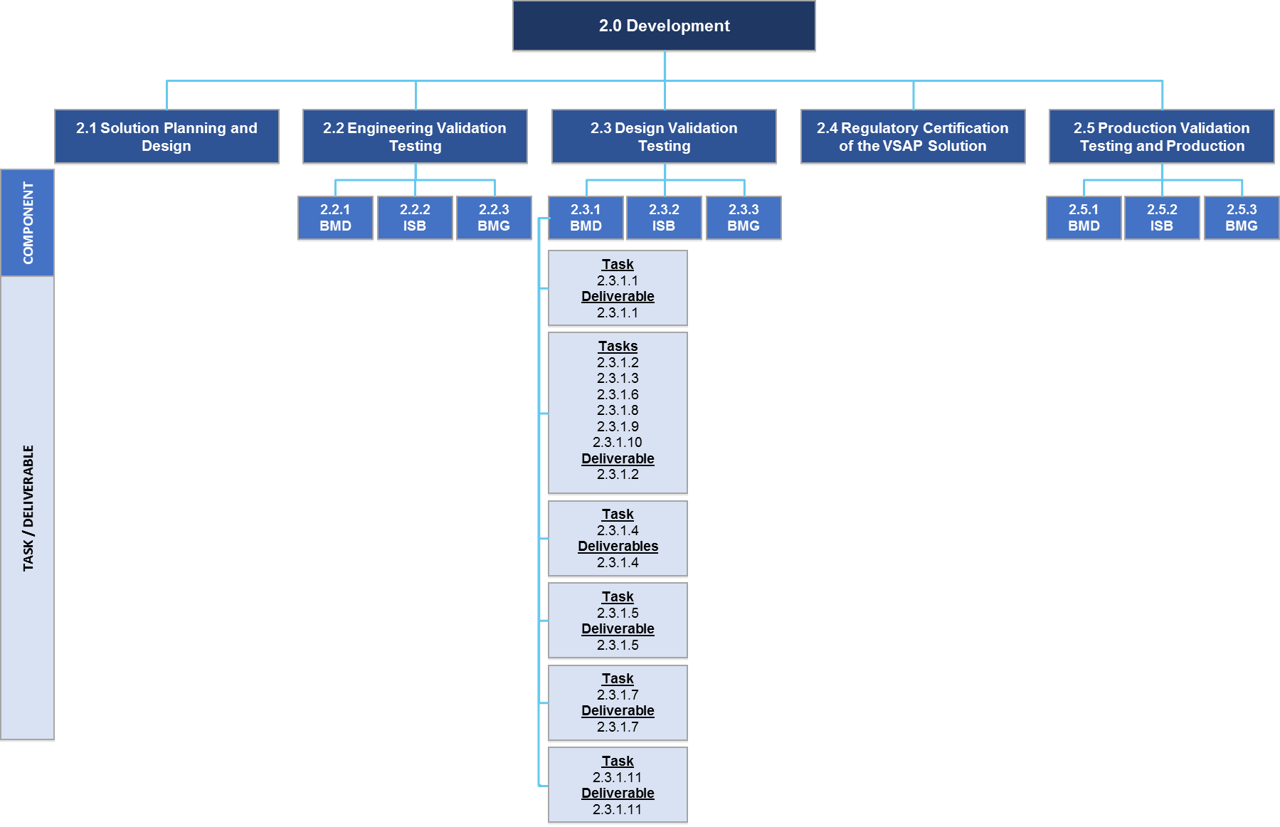

    - Ballot Marking Device
      - User Experience / User Interface
Expected Tasks:
- Review results of DVT testing
- Support User Interface change requests, if needed
Deliverable 2.3.1.1 Updated BMD User Experience / User Interface Design Assets — DVT
Delivery Timing | Submitted for approval as fully functional BMDs at the end of the DVT stage
Delivery Frequency | Once
Description | The Contractor shall deliver:  - Updated design assets based on DVT, including:  - Native design files (i.e., those developed in Sketch)  - UI flows map  - System sound files  - User Interface animations  - User Interface icons

PROPOSER RESPONSE TO: Deliverable 2.3.1.1 Updated BMD User Experience / User Interface Design Assets – DVT
Will the Proposer complete the deliverables and related tasks as described above?
___ Yes
___ Yes, with modifications
___ No
Explain your approach to completing the deliverables and related tasks as described above:
      - Mechanical (housing, stand, privacy screen and ballot box)
Expected Tasks:
- Design and build mass production tooling
- Design assembly processes, work instructions and quality assurance suitable for low-volume production
- Qualify hard tooling for each component
- Build and test DVT units against performance requirements
- Test for regulatory certifications (Underwriter’s Laboratory), FCC, etc.)
- Address issues raised in testing
Deliverable 2.3.1.2 Design Validation Testing and Results for BMD Hardware
Delivery Timing | Submitted for approval as fully functional BMDs at the end of the DVT stage, including completion of expected tasks described in the following sections:  - 2.3.1.2 Mechanical (housing, stand, privacy screen and ballot box)  - 2.3.1.3 Application Control System Hardware and Peripherals  - 2.3.1.6 Ballot Control System Hardware and Peripherals  - 2.3.1.8 Paper Handler  - 2.3.1.9 Ballot Printer  - 2.3.1.10 Cases and Carts
Delivery Frequency | Once
Description | The Contractor shall deliver:  - Tooling drawings for tool design approval  - First article inspection reports  - Documentation tracking tooling and assembly issues to resolution  - DVT test units (including case and cart)  - Test reports from validation tests  - Regulatory certifications  - Documentation of issues raised in test and design changes made to address them  - Updated “Design & Engineering Specification” documentation, as needed  - Updated manufacturing package:  - 3D CAD of parts and assemblies  - Engineering drawings of parts and assemblies  - Mechanical Bill of Materials

PROPOSER RESPONSE TO: Deliverable 2.3.1.2 Design Validation Testing and Results for BMD Hardware
Will the Proposer complete the deliverables and related tasks as described above?
___ Yes
___ Yes, with modifications
___ No
Explain your approach to completing the deliverables and related tasks as described above:
      - Application Control System Hardware and Peripherals
Expected Tasks:
- Develop printed circuit board assembly manufacturing process
- Develop in circuit test fixture and protocols
- Develop electronics subassembly and test protocols
- Build and test DVT units against performance requirements
- Test for regulatory certifications (Underwriters Laboratory, FCC, etc.)
- Address issues raised in testing
Expected Deliverables:
This subcomponent is one aspect of the BMD hardware and will be completed at the same time as the other BMD hardware subcomponents in order to deliver an assembled BMD unit. The result of these tasks will be considered to meet deliverable 2.3.1.2 Design Validation Testing and Results for BMD Hardware, and shall be submitted upon completion of all expected tasks described in the following sections:
- 2.3.1.2 Mechanical (housing, stand, privacy screen and ballot box)
- 2.3.1.3 Application Control System Hardware and Peripherals
- 2.3.1.6 Ballot Control System Hardware and Peripherals
- 2.3.1.8 Paper Handler
- 2.3.1.9 Ballot Printer
- 2.3.1.10 Cases and Carts
See Section 2.3.1.2 Mechanical (housing, stand, privacy screen and ballot box) for a description of the deliverable and the Proposer’s response.
      - BMD Application Layer
The Application Layer for the BMD will be functionally complete at the end of the EVT stage. There should be no functional gaps between the requirements, design and developed code. From a software perspective, there should be no difference in scaling from a small number of EVT deployments to a large number of DVT deployments. However, it is possible that, as the BMD hardware completes the DVT stage, changes will be made within the BMD hardware design that affect the software. In addition, there may be refinements to the BMD user experience based on further testing.
Any BMD changes or user experience requirements must go through an accelerated software development life cycle process for implementation. The process is expected to leverage all previously established development approach, test plans and tooling.
        - BMD Application Layer Tasks and Deliverables
The purpose of the application development tasks at this stage of the process is to refine the Application Layer based on BMD hardware changes or user experience refinements and deploy the Application Layer to the BMD hardware at the DVT stage.
          - Capture Changes and Refine the Design
The design for the Application Layer has been defined in the EVT stage and captured in the BMD Application Layer Software Architecture Document and Software Specifications.
The goal for this task is to capture any changes to the design and refine the deliverables from the EVT stage, to be brought forward to the DVT stage.
          - Develop and Test the Refined Solution
The goal for this task is to develop the code needed to implement the refined design and retest the solution. Additional test cases likely will be required to be developed by the Contractor.
Similar to the EVT, end-to-end testing is conducted at the project level, not at the component level, but testing should include deployment to the changed BMD hardware.
Deliverable 2.3.1.4 BMD Application Layer — DVT Update Package
Delivery Timing | Submitted for approval as fully functional BMDs at the end of the DVT stage
Delivery Frequency | Once
Description | The Contractor shall update the following deliverables created during the EVT as needed:  - Deliverable 2.2.1.4.1.1c: BMD Application Layer Test Cases — EVT  - Deliverable 2.2.1.4.1.2a: BMD Application Layer Software Architecture Document — EVT  - Deliverable 2.2.1.4.1.2b: BMD Application Layer Software Specifications — EVT  - Deliverable 2.2.1.4.1.3a: BMD Application Layer Software and Deployment — EVT  - Deliverable 2.2.1.4.1.4: BMD Application Layer Test Report — EVT (An update to this item is mandatory, even if no changes occurred in any of the above deliverables, to ensure full regression testing.)

PROPOSER RESPONSE TO: Deliverable 2.3.1.4 BMD Application Layer - DVT Update Package
Will the Proposer complete the deliverables and related tasks as described above?
___ Yes
___ Yes, with modifications
___ No
Explain your approach to completing the deliverables and related tasks as described above:
      - Application Control System Board Support Package and Firmware
Expected Tasks:
- Modify board support package, if necessary
- Demonstrate and test functionality on DVT hardware
- Address issues raised in testing
Deliverable 2.3.1.5 Application Control System Board Support Package Software Image — DVT
Delivery Timing | Submitted for approval as fully functional BMDs at the end of the DVT stage
Delivery Frequency | Once
Description | The Contractor shall deliver:  - ACS Board Support Package software image updated for DVT  - Associated documentation

PROPOSER RESPONSE TO: Deliverable 2.3.1.5 Application Control System Board Support Package Software Image - DVT
Will the Proposer complete the deliverables and related tasks as described above?
___ Yes
___ Yes, with modifications
___ No
Explain your approach to completing the deliverables and related tasks as described above:
      - Ballot Control System (BCS) Hardware and Peripherals
Expected Tasks:
- Develop printed circuit board assembly manufacturing process
- Develop in circuit test fixture and protocols
- Develop electronics subassembly and test protocols
- Build and test DVT units against performance requirements
- Test for regulatory certifications (Underwriters Laboratory, FCC, etc.)
- Address issues raised in testing
Expected Deliverables:
This subcomponent is one aspect of the BMD hardware and will be completed at the same time as the other BMD hardware subcomponents in order to deliver an assembled BMD unit. The result of these tasks will be considered to meet deliverable 2.3.1.2 Design Validation Testing and Results for BMD Hardware, and shall be submitted upon completion of all expected tasks described in the following sections:
- 2.3.1.2 Mechanical (housing, stand, privacy screen and ballot box)
- 2.3.1.3 Application Control System Hardware and Peripherals
- 2.3.1.6 Ballot Control System Hardware and Peripherals
- 2.3.1.8 Paper Handler
- 2.3.1.9 Ballot Printer
- 2.3.1.10 Cases and Carts
See Section 2.3.1.2 Mechanical (housing, stand, privacy screen and ballot box) for a description of the deliverable and the Proposer’s response.
      - Ballot Control System Board Support Package and Firmware
Expected Tasks:
- Update firmware, if needed, to support changes to the paper handler or printer
- Demonstrate and test functionality on DVT hardware
- Address issues raised in testing
Deliverable 2.3.1.7 Ballot Control System Board Support Package Software Image — DVT
Delivery Timing | Submitted for approval as fully functional BMDs at the end of the DVT stage
Delivery Frequency | Once
Description | The Contractor shall deliver:  - BCS Board Support Package software image updated for DVT  - Related documentation

PROPOSER RESPONSE TO: Deliverable 2.3.1.7 Ballot Control System (BCS) Board Support Package (BSP) Software Image - DVT
Will the Proposer complete the deliverables and related tasks as described above?
___ Yes
___ Yes, with modifications
___ No
Explain your approach to completing the deliverables and related tasks as described above:
      - Paper Handler
Expected Tasks:
- Design and build mass production tooling, if needed
- Qualify hard tooling for each component
- Build and test DVT units against performance requirements
- Test for regulatory certifications (Underwriters Laboratory, FCC, etc.)
- Address issues raised in testing
Expected Deliverables:
This subcomponent is one aspect of the BMD hardware and will be completed at the same time as the other BMD hardware subcomponents in order to deliver an assembled BMD unit. The result of these tasks will be considered to meet deliverable 2.3.1.2 Design Validation Testing and Results for BMD Hardware, and shall be submitted upon completion of all expected tasks described in the following sections:
- 2.3.1.2 Mechanical (housing, stand, privacy screen and ballot box)
- 2.3.1.3 Application Control System Hardware and Peripherals
- 2.3.1.6 Ballot Control System Hardware and Peripherals
- 2.3.1.8 Paper Handler
- 2.3.1.9 Ballot Printer
- 2.3.1.10 Cases and Carts
See Section 2.3.1.2 Mechanical (housing, stand, privacy screen and ballot box) for a description of the deliverable and the Proposer’s response.
      - Ballot Printer
Expected Tasks:
- Build units for DVT testing
Expected Deliverables:
This subcomponent is one aspect of the BMD hardware and will be completed at the same time as the other BMD hardware subcomponents in order to deliver an assembled BMD unit. The result of these tasks will be considered to meet deliverable 2.3.1.2 Design Validation Testing and Results for BMD Hardware, and shall be submitted upon completion of all expected tasks described in the following sections:
- 2.3.1.2 Mechanical (housing, stand, privacy screen and ballot box)
- 2.3.1.3 Application Control System Hardware and Peripherals
- 2.3.1.6 Ballot Control System Hardware and Peripherals
- 2.3.1.8 Paper Handler
- 2.3.1.9 Ballot Printer
- 2.3.1.10 Cases and Carts
See Section 2.3.1.2 Mechanical (housing, stand, privacy screen and ballot box) for a description of the deliverable and the Proposer’s response.
      - Cases and Carts
Expected Tasks:
- Build cases and carts for use in DVT testing
Expected Deliverables:
This subcomponent is one aspect of the BMD hardware and will be completed at the same time as the other BMD hardware subcomponents in order to deliver an assembled BMD unit. The result of these tasks will be considered to meet deliverable 2.3.1.2 Design Validation Testing and Results for BMD Hardware, and shall be submitted upon completion of all expected tasks described in the following sections:
- 2.3.1.2 Mechanical (housing, stand, privacy screen and ballot box)
- 2.3.1.3 Application Control System Hardware and Peripherals
- 2.3.1.6 Ballot Control System Hardware and Peripherals
- 2.3.1.8 Paper Handler
- 2.3.1.9 Ballot Printer
- 2.3.1.10 Cases and Carts
See Section 2.3.1.2 Mechanical (housing, stand, privacy screen and ballot box) for a description of the deliverable and the Proposer’s response.
      - Hardware Tooling
Expected Tasks:
- Produce final hard tooling for each sub-component
Deliverable 2.3.1.11 Hardware Tooling — DVT
Delivery Timing | Submitted for ownership by the County at the end of the DVT stage
Delivery Frequency | Once
Description | The Contractor shall finalize the hard tooling for each sub-component such that the BMD passes all required tests and certifications.

PROPOSER RESPONSE TO: Deliverable 2.3.1.11 Hardware Tooling - DVT
Will the Proposer complete the deliverables and related tasks as described above?
___ Yes
___ Yes, with modifications
___ No
Explain your approach to completing the deliverables and related tasks as described above:
    - Interactive Sample Ballot
The ISB software will be functionally complete at the end of the EVT stage. There should be no functional gaps between the requirements, design and developed code. However, it is possible that, as the BMD Application Layer completes the DVT stage, changes will be made that affect the ISB software. In addition, there may be refinements to the ISB user experience based on further testing.
Any ISB changes or user experience requirements must go through an accelerated software development life cycle process for implementation. The process is expected to leverage all previously established development approach, test plans and tooling.
      - Expected ISB Tasks and Deliverables
The purpose of the application development tasks at this stage of the process is to refine the ISB based on Application Layer changes or user experience refinements and deploy the ISB to the server and client devices at the DVT stage.
        - Capture Changes and Refine the Design
The design for the ISB has been defined in the EVT stage and captured in the ISB Software Architecture Document and Software Specifications.
The goal for this task is to capture any changes to the design and refine the deliverables from the EVT stage, to be brought forward to the DVT stage.
        - Develop and Test the Refined Solution
The goal for this task is to develop the code needed to implement the refined design and retest the solution. Additional test cases are likely required.
Similar to the EVT, end-to-end testing is conducted at the project level, not at the component level, but testing should include deployment to ISB server and mobile test devices.
Deliverable 2.3.2 ISB — DVT Update Package
Delivery Timing | Upon completion of expected tasks described in this section
Delivery Frequency | Once
Description | The Contractor shall update the following deliverables created during the EVT as needed:  - Deliverable 2.2.2c: ISB Test Cases  - Deliverable 2.2.2d: ISB Software Architecture Document  - Deliverable 2.2.2e: ISB Software Specifications  - Deliverable 2.2.2f: ISB Software and Deployment  - Deliverable 2.2.2h: ISB Test Report (An update to this item is mandatory, even if no changes occurred in any of the above deliverables, to ensure full regression testing.)

PROPOSER RESPONSE TO: Deliverable 2.3.2 ISB – DVT Update Package
Will the Proposer complete the deliverables and related tasks as described above?
___ Yes
___ Yes, with modifications
___ No
Explain your approach to completing the deliverables and related tasks as described above:
    - BMD Manager
The BMD Manager (BMG) software will be functionally complete at the end of the EVT stage; there should be no functional gaps between the requirements, design and developed code. However, it is possible that, as the BMD Application Layer completes the DVT stage, changes will be made that affect the BMG software. In addition, there may be refinements to the BMG user experience based on further testing.
Any BMG changes or user experience requirements must go through an accelerated software development life cycle process for implementation. The process is expected to leverage all previously established development approaches, test plans and tooling.
      - Expected BMD Manager Tasks and Deliverables
The purpose of the application development tasks at this stage of the process is to refine the BMG based on BMD hardware, Application Layer, or BMG user experience changes, and make the BMG ready for integration with the BMD hardware at the DVT stage.
        - Capture Changes and Refine the Design
The design for the BMG has been defined in the EVT stage and captured in the ISB Software Architecture Document and Software Specifications.
The goal for this task is to capture any changes to the design and refine the deliverables from the EVT stage, to be brought forward to the DVT stage.
        - Develop and Test the Refined Solution
The goal for this task is to develop the code needed to implement the refined design and retest the solution. Additional test cases are likely required.
Similar to the EVT, end-to-end testing is conducted at the project level, not at the component level, but testing should include deployment to BMG server and BMD hardware.
Deliverable 2.3.3 BMD Manager
Delivery Timing | Upon completion of expected tasks described in this section
Delivery Frequency | Once
Description | The Contractor shall update the following deliverables created during the EVT as needed:  - Deliverable 2.2.3c: BMG Test Cases  - Deliverable 2.2.3d: BMG Software Architecture Document  - Deliverable 2.2.3e: BMG Software Specifications  - Deliverable 2.2.3f: BMG Software and Deployment  - Deliverable 2.2.3h: BMG Test Report (An update to this item is mandatory, even if no changes occurred in any of the above deliverables, to ensure full regression testing.)

PROPOSER RESPONSE TO: Deliverable 2.3.3 BMD Manager
Will the Proposer complete the deliverables and related tasks as described above?
___ Yes
___ Yes, with modifications
___ No
Explain your approach to completing the deliverables and related tasks as described above:

  - Regulatory Certification of the VSAP Solution
During Regulatory Certification of the VSAP Solution, the Contractor in collaboration with the County will use BMD units assembled from tooled DVT parts, BMD software, BMG and ISB to obtain all necessary regulatory certifications, including California Secretary of State certification.
    - Conduct a Certifications Analysis
The Contractor shall conduct an analysis to identify the types of regulatory certifications that will be required prior to deploying the VSAP Solution for use by the public. Certification by the California Secretary of State is a known requirement and is expected to be included as part of the analysis. The analysis must consider other regulatory/certification bodies, such as the FCC, Underwriters Laboratory and any other bodies that may require certification, approval, or proof of compliance. The analysis must clearly identify the certifications/approvals that are mandatory prior to VSAP Solution deployment, and those that are optional.
Deliverable 2.4.1 Certifications Analysis
Delivery Timing | Submitted for approval no less than 30 calendar days prior to EVT completion
Delivery Frequency | Once
Description | The Contractor shall produce a Certifications Analysis as described in this section.

PROPOSER RESPONSE TO: Deliverable 2.4.1 Certifications Analysis
Will the Proposer complete the deliverables and related tasks as described above?
___ Yes
___ Yes, with modifications
___ No
Explain your approach to completing the deliverables and related tasks as described above:
    - Obtain California Secretary of State Certification of the VSAP Solution
The Contractor shall conduct the process to obtain California Secretary of State certification for all VSAP Solution components as an integrated end-to-end system. This will entail modifying the VSAP Solution as needed during the certification process, including changes to the hardware, firmware, software or third-party software necessary and sufficient to certify the BMD, BMG and ISB components, which are the In-Scope Components of this Project. The ECBMS and Tally components of the VSAP Solution are being developed and modified outside the scope of this Project, but as part of the certification services Statement of Work, the Contractor shall coordinate with the County to identify and direct any changes to those components necessary to achieve integration and certification of the overall VSAP Solution.
Any modifications to the system components must remain aligned with VSAP principles, vision and requirements and approved by the County.
Up until the solution is certified by the California Secretary of State, the Contractor will be required to make changes to the BMD, BMG and ISB components, and to coordinate and direct changes to the ECBMS and Tally components, to ensure overall Solution integration and to comply with all applicable regulations and the Elections Code.
The County shall cover the initial $360,000 of cost towards certification of the VSAP Solution by the California Secretary of State. The County shall deposit these funds directly into the escrow account. Any certification fees beyond this amount that are attributable to Contractor In-Scope Components (and not attributable to out-of-scope system components) shall be paid by the Contractor to the California Secretary of State until the entire VSAP Solution is certified.
The Contractor must understand and follow the certification process and requirements as defined by the California Secretary of State. The process and requirements are described at the websites listed below and as prescribed by the Elections Code and regulations:
- Voting System Certification Regulations (Proposer must comply with these requirements): http://www.sos.ca.gov/administration/regulations/current-regulations/elections/voting-system-certification-regulations/
- Voting Technology (Proposer must comply with these requirements): http://www.sos.ca.gov/elections/voting-systems/
In addition, the U.S. Election Assistance Commission has established voluntary national guidelines that could impact the future of voting systems in the State of California. The Contractor should be aware of these guidelines and consider them for the long-term roadmap of the VSAP Solution. The information provided at the website below is for the Contractor’s awareness:
- Voluntary Voting System Guidelines (for Proposer’s reference): https://www.eac.gov/voting-equipment/voluntary-voting-system-guidelines/
Deliverable 2.4.2a California Secretary of State Certification of the VSAP Solution
Delivery Timing | Certification by the California Secretary of State to be achieved prior to PVT and Production stage
Delivery Frequency | Once
Description | The Contractor shall:  - Obtain California Secretary of State Certification of the end-to-end VSAP Solution complying with all guidelines and requirements set forth by the California Secretary of State as part of the certification process.  - Document issues raised and design changes made to address the issues during the certification process.  - Update all BMD Hardware Design and Engineering Specification documents, BMD Manufacturing Packages, and BMD, BMG and ISB Software Documentation developed during DVT.

PROPOSER RESPONSE TO: Deliverable 2.4.2a California Secretary of State Certification of the VSAP Solution
Will the Proposer complete the deliverables and related tasks as described above?
___ Yes
___ Yes, with modifications
___ No
Explain your approach to completing the deliverables and related tasks as described above:

Deliverable 2.4.2b Voluntary Voting System Guidelines Compliance Report
Delivery Timing | Submitted for approval no more than 15 calendar days after certification by the California Secretary of State
Delivery Frequency | Once
Description | The Contractor shall document and provide a report on the VSAP Solution compliance with the Voluntary Voting System Guidelines.

PROPOSER RESPONSE TO: Deliverable 2.4.2b Voluntary Voting System Guidelines Compliance Report
Will the Proposer complete the deliverables and related tasks as described above?
___ Yes
___ Yes, with modifications
___ No
Explain your approach to completing the deliverables and related tasks as described above:
    - Obtain Other Certifications as Required (Based on a Negotiated Work Order)
Upon completion of Deliverable 2.4.1 Certifications Analysis, the County and Contractor shall discuss the level of effort required for the Contractor to obtain all certifications and/or approvals identified as mandatory or as approved by the County. The County also may require that the Contractor seek and obtain some or all certifications/approvals identified as optional in Deliverable 2.4.1 Certifications Analysis.
For the purposes of the Cost Proposal, the cost associated with this Deliverable shall not be included in the fixed-fee cost proposal. Costs associated with obtaining other mandatory or County-required certifications will be charged to the County through a negotiated work order.
The deliverable will be determined based on a negotiated work order.
PROPOSER RESPONSE TO: Task 2.4.3 Obtain Other Certifications as Required
Will the Proposer complete the task as described above?
___ Yes
___ Yes, with modifications
___ No
Explain your approach to completing the task as described above:

  - Production Validation Testing and Production
During PVT, the Contractor will validate and qualify additional tools needed to support quantities for production manufacturing ramp up, including assembly jigs, test software, serialization and traceability, and will complete other necessary manufacturing-related, but not design-related, tasks. At this stage, the ISB software will be deployed to the server and client devices, and the BMG will be integrated with the BMD hardware.
The Contractor will fulfill BMD orders as defined in Section 3.2 (Analysis of BMD Production Schedule and Strategy). The County does not expect any changes to the software and hardware during PVT to facilitate volume production that would require re-certification or de minimis approval. As such, the Contractor shall anticipate any volume production needs affecting the design during the EVT and DVT stages.
While the BMD hardware tasks are separated at the sub-component level in this Section 2.5, the Contractor will submit fully functional BMD units at the end of the PVT stage to demonstrate that they meet all the requirements and all sub-components are integrated. A high-level summary of the relationship between tasks and deliverables for the BMD is shown in Figure 12
- Production Validation Testing and Production — Ballot Marking Device Tasks and Deliverables (Summary View)
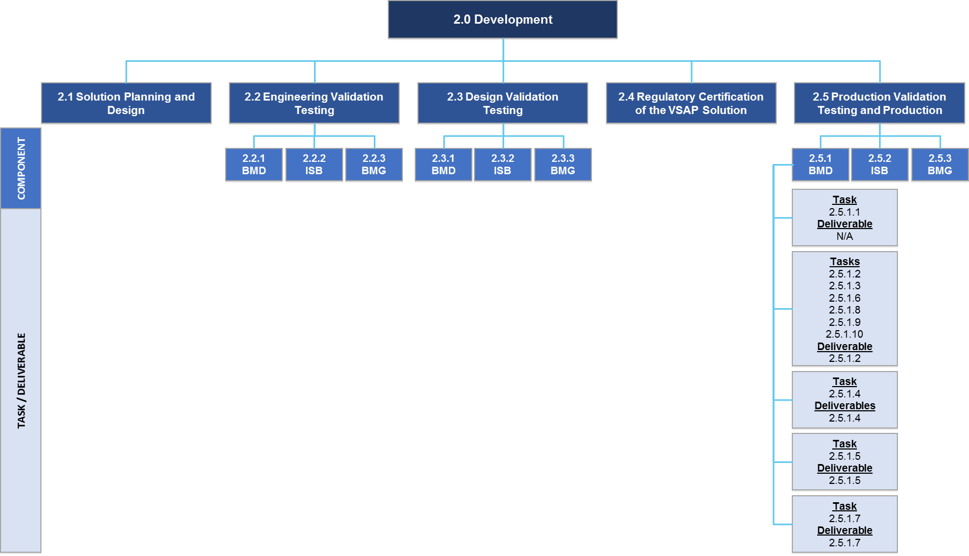

    - Ballot Marking Device
      - User Experience / User Interface
Expected Tasks:
- None expected
Expected Deliverables:
- None expected
      - Mechanical (housing, stand, privacy screen and ballot box)
Expected Tasks:
- Design and build jigs and fixtures needed to support mass production
- Design assembly processes, work instructions and quality assurance
- Build and test PVT units against quality metrics
- Build initial shipment of BMDs
Deliverable 2.5.1.2 Production Validation Testing and Results for BMD Hardware
Delivery Timing | Submitted for approval as fully functional BMDs at the end of the PVT and Production stage, including completion of expected tasks described in the following sections:  - 2.5.1.2 Mechanical (housing, stand, privacy screen and ballot box)  - 2.5.1.3 Application Control System Hardware and Peripherals  - 2.5.1.6 Ballot Control System Hardware and Peripherals  - 2.5.1.8 Paper Handler  - 2.5.1.9 Ballot Printer  - 2.5.1.10 Cases and Carts
Delivery Frequency | Once
Description | The Contractor shall deliver:  - Production BMD units  - Quality reports

PROPOSER RESPONSE TO: Deliverable 2.5.1.2 Production Validation Testing and Results for BMD Hardware
Will the Proposer complete the deliverables and related tasks as described above?
___ Yes
___ Yes, with modifications
___ No
Explain your approach to completing the deliverables and related tasks as described above:
      - Application Control System Hardware and Peripherals
Expected Tasks:
- Design and build jigs and fixtures needed to support mass production
- Design assembly processes, work instructions and quality assurance
- Build initial shipment of BMDs
- Test units against quality metrics
Expected Deliverables:
This subcomponent is one aspect of the BMD hardware and will be completed at the same time as the other BMD hardware subcomponents in order to deliver an assembled BMD unit. The result of these tasks will be considered to meet deliverable 2.5.1.2 Production Validation Testing and Results for BMD Hardware, and shall be submitted upon completion of all expected tasks described in the following sections:
- 2.5.1.2 Mechanical (housing, stand, privacy screen and ballot box)
- 2.5.1.3 Application Control System Hardware and Peripherals
- 2.5.1.6 Ballot Control System Hardware and Peripherals
- 2.5.1.8 Paper Handler
- 2.5.1.9 Ballot Printer
- 2.5.1.10 Cases and Carts
See Section 2.5.1.2 Mechanical (housing, stand, privacy screen and ballot box) for a description of the deliverable and the Proposer’s response.
      - BMD Application Layer
The Application Layer for the BMD will be functionally complete at the end of the EVT stage and further refined at the DVT stage. There should be no functional gaps between the requirements, design and developed code. From a software perspective, there should be no difference in scaling from a small number of DVT deployments to a large number of PVT deployments. At this stage of the process, the Application Layer will be deployed to the BMD hardware.
Deliverable 2.5.1.4 BMD Application Layer — PVT Deployment
Delivery Timing | Submitted for approval as fully functional BMDs at the end of the PVT and Production stage
Delivery Frequency | Once
Description | The Contractor shall confirm the Application Layer has been deployed to the BMD hardware as produced in the PVT stage.

PROPOSER RESPONSE TO: Deliverable 2.5.1.4 BMD Application Layer – PVT Deployment
Will the Proposer complete the deliverables and related tasks as described above?
___ Yes
___ Yes, with modifications
___ No
Explain your approach to completing the deliverables and related tasks as described above:
      - Application Control System Board Support Package and Firmware
Expected Tasks:
- Modify board support package, if necessary
- Demonstrate functionality on PVT hardware
Deliverable 2.5.1.5 Application Control System Board Support Package Software Image — PVT
Delivery Timing | Submitted for approval as fully functional BMDs at the end of the PVT and Production stage
Delivery Frequency | Once
Description | The Contractor shall deliver:  - ACS Board Support Package software image updated for PVT  - Associated documentation

PROPOSER RESPONSE TO: Deliverable 2.5.1.5 Ballot Marking Device — Application Control System Board Support Package Software Image – PVT
Will the Proposer complete the deliverables and related tasks as described above?
___ Yes
___ Yes, with modifications
___ No
Explain your approach to completing the deliverables and related tasks as described above:
      - Ballot Control System Hardware and Peripherals
Expected Tasks:
- Design and build jigs and fixtures needed to support mass production
- Design assembly processes, work instructions and quality assurance
- Build and test PVT units against quality metrics
- Build initial shipment of BMDs
- Characterize the capability of manufacturing processes
Expected Deliverables:
This subcomponent is one aspect of the BMD hardware and will be completed at the same time as the other BMD hardware subcomponents in order to deliver an assembled BMD unit. The result of these tasks will be considered to meet deliverable 2.5.1.2 Production Validation Testing and Results for BMD Hardware, and shall be submitted upon completion of all expected tasks described in the following sections:
- 2.5.1.2 Mechanical (housing, stand, privacy screen and ballot box)
- 2.5.1.3 Application Control System Hardware and Peripherals
- 2.5.1.6 Ballot Control System Hardware and Peripherals
- 2.5.1.8 Paper Handler
- 2.5.1.9 Ballot Printer
- 2.5.1.10 Cases and Carts
See Section 2.5.1.2 Mechanical (housing, stand, privacy screen and ballot box) for a description of the deliverable and the Proposer’s response.
      - Ballot Control System Board Support Package and Firmware
Expected Tasks:
- Modify firmware, if necessary
- Demonstrate functionality on PVT hardware
Deliverable 2.5.1.7 Ballot Control System Board Support Package Software Image — PVT
Delivery Timing | Submitted for approval as fully functional BMDs at the end of the PVT and Production stage
Delivery Frequency | Once
Description | The Contractor shall deliver:  - BCS Board Support Package software image updated for PVT  - Associated documentation

PROPOSER RESPONSE TO: Deliverable 2.5.1.7 Ballot Control System Board Support Package Software Image – PVT
Will the Proposer complete the deliverables and related tasks as described above?
___ Yes
___ Yes, with modifications
___ No
Explain your approach to completing the deliverables and related tasks as described above:
      - Paper Handler
Expected Tasks:
- Design and build jigs and fixtures needed to support mass production
- Design assembly processes, work instructions and quality assurance
- Build and test PVT units against quality metrics
- Build initial shipment of BMDs
- Characterize the capability of manufacturing processes
Expected Deliverables:
This subcomponent is one aspect of the BMD hardware and will be completed at the same time as the other BMD hardware subcomponents in order to deliver an assembled BMD unit. The result of these tasks will be considered to meet deliverable 2.5.1.2 Production Validation Testing and Results for BMD Hardware, and shall be submitted upon completion of all expected tasks described in the following sections:
- 2.5.1.2 Mechanical (housing, stand, privacy screen and ballot box)
- 2.5.1.3 Application Control System Hardware and Peripherals
- 2.5.1.6 Ballot Control System Hardware and Peripherals
- 2.5.1.8 Paper Handler
- 2.5.1.9 Ballot Printer
- 2.5.1.10 Cases and Carts
See Section 2.5.1.2 Mechanical (housing, stand, privacy screen and ballot box) for a description of the deliverable and the Proposer’s response.
      - Ballot Printer
Expected Tasks:
- Build units for PVT testing
- Build initial shipment of BMDs
Expected Deliverables:
This subcomponent is one aspect of the BMD hardware and will be completed at the same time as the other BMD hardware subcomponents in order to deliver an assembled BMD unit. The result of these tasks will be considered to meet deliverable 2.5.1.2 Production Validation Testing and Results for BMD Hardware, and shall be submitted upon completion of all expected tasks described in the following sections:
- 2.5.1.2 Mechanical (housing, stand, privacy screen and ballot box)
- 2.5.1.3 Application Control System Hardware and Peripherals
- 2.5.1.6 Ballot Control System Hardware and Peripherals
- 2.5.1.8 Paper Handler
- 2.5.1.9 Ballot Printer
- 2.5.1.10 Cases and Carts
See Section 2.5.1.2 Mechanical (housing, stand, privacy screen and ballot box) for a description of the deliverable and the Proposer’s response.
      - Cases and Carts
Expected Tasks:
- Build cases and carts for initial shipment of BMDs
Expected Deliverables:
This subcomponent is one aspect of the BMD hardware and will be completed at the same time as the other BMD hardware subcomponents in order to deliver an assembled BMD unit. The result of these tasks will be considered to meet deliverable 2.5.1.2 Production Validation Testing and Results for BMD Hardware, and shall be submitted upon completion of all expected tasks described in the following sections:
- 2.5.1.2 Mechanical (housing, stand, privacy screen and ballot box)
- 2.5.1.3 Application Control System Hardware and Peripherals
- 2.5.1.6 Ballot Control System Hardware and Peripherals
- 2.5.1.8 Paper Handler
- 2.5.1.9 Ballot Printer
- 2.5.1.10 Cases and Carts
See Section 2.5.1.2 Mechanical (housing, stand, privacy screen and ballot box) for a description of the deliverable and the Proposer’s response.
    - ISB
The ISB software will be functionally complete at the end of the EVT stage and refined at the DVT stage. There should be no functional gaps between the requirements, design and developed code. At this stage in the process, the ISB will be deployed to the server and client devices.

Deliverable 2.5.2 ISB — PVT Deployment
Delivery Timing | Upon completion of expected tasks described in this section
Delivery Frequency | Once
Description | The Contractor shall confirm the ISB has been deployed to the server and client devices as produced in the PVT stage.
PROPOSER RESPONSE TO: Deliverable 2.5.2 ISB – PVT Deployment
Will the Proposer complete the deliverables and related tasks as described above?
___ Yes
___ Yes, with modifications
___ No
Explain your approach to completing the deliverables and related tasks as described above:
    - BMD Manager
The BMG software will be functionally complete at the end of the EVT stage and refined at the DVT stage. There should be no functional gaps between the requirements, design and developed code. At this stage of the process, the BMG shall be integrated with the BMD hardware at the PVT stage.
Deliverable 2.5.3 BMD Manager Deployment
Delivery Timing | Upon completion of expected tasks described in this section
Delivery Frequency | Once
Description | The Contractor shall document the integration of the BMG with the BMD hardware at the PVT stage.

PROPOSER RESPONSE TO: Deliverable 2.5.3 BMD Manager Deployment
Will the Proposer complete the deliverables and related tasks as described above?
___ Yes
___ Yes, with modifications
___ No
Explain your approach to completing the deliverables and related tasks as described above:
    - Integrated System Documentation
The Contractor shall create documentation for the VSAP Solution showing how all the components are integrated and interfaced with each other, including applicable dependencies.

Deliverable 2.5.4 Integrated System Documentation
Delivery Timing | Upon completion of expected tasks described in this section
Delivery Frequency | Once
Description | The Contractor shall create documentation for the integrated VSAP Solution as described in the task above.

PROPOSER RESPONSE TO: Deliverable 2.5.4 Integrated System Documentation
Will the Proposer complete the deliverables and related tasks as described above?
___ Yes
___ Yes, with modifications
___ No
Explain your approach to completing the deliverables and related tasks as described above:

  - Tally System Scanners (Based on a Negotiated Work Order)
The County may request that the Contractor procure scanners to be used with the Tally System. In such event, the County will specify the type and number of scanners to be procured. Additionally, the County may request that the Contractor assist with planning and implementing the distributed Tally scanning strategy. The County will provide additional details about the objectives of this effort and the expectations for the Contractor.
The deliverables will be determined based on a negotiated work order.
PROPOSER RESPONSE TO: Task 2.6 Tally System Scanners
Will the Proposer complete the task as described above?
___ Yes
___ Yes, with modifications
___ No
Explain your approach to completing the task as described above:

- Implementation
During Implementation, the Contractor will lead and work collaboratively with County staff to prepare and deploy the VSAP Solution. This includes development of an Implementation Plan, a System Interface Plan, an End-to-End Security Plan, a Training and Knowledge Transfer Plan and other documentation required to prepare for deployment of the VSAP Solution. The Contractor also will provide applicable services to support deployment of the VSAP Solution in Vote Center Test Labs, the 2019 Mock Election, the November 2019 Pilot election, Vote Center Demonstration Centers and Full Rollout (as described in this RFP Phase 2) including systems integration services, coordination services, on-site support services and Help Desk services.
  - Develop an Implementation Plan
The Contractor will develop an Implementation Plan for the BMD, ISB and BMG. The Implementation Plan must be closely coordinated with the County’s overall implementation strategy for VSAP, including other VSAP Program activities not led by the Contractor. The Implementation Plan will need to address, at minimum:
- Vote Center Test Lab Testing 1 (e.g., # of BMDs, etc.)
- Vote Center Test Lab Testing 2 (e.g., # of BMDs, etc.)
- Scope of the 2019 Mock Election (e.g., # of Vote Centers, # of BMDS, etc.)
- Scope of the November 2019 Pilot (e.g., # of Vote Centers, # of BMDs, etc.)
- Scope of Vote Center Demonstration Centers (e.g., # of Vote Centers, # of BMDs, etc.)
- Scope of Full Rollout (e.g., # of Vote Centers, # of BMDs, etc.)
- Manufacturing strategy (e.g., manufacturing activities, timing, production methods, lead times needed, assumptions, etc.)
- Roles and responsibilities during each deployment milestone (e.g., set up, test, transport, deploy and operate)
- Staffing required to set up, test, transport, deploy and operate
- Support model before, during and after the election period
Deliverable 3.1 Implementation Plan
Delivery Timing | Submitted for approval no more than 90 calendar days after Project Commencement Date
Delivery Frequency | Once
Description | The Contractor shall deliver an Implementation Plan as described in Section 3.1.

PROPOSER RESPONSE TO: Deliverable 3.1 Implementation Plan
Will the Proposer complete the deliverables and related tasks as described above?
___ Yes
___ Yes, with modifications
___ No
Explain your approach to completing the deliverables and related tasks as described above:
  - Analysis of BMD Production Schedule and Strategy
The Contractor will be expected to provide BMDs in varying quantities over time throughout the Project. Table 1 and Table 2 highlight the County’s current estimates, which are to be assessed by the Contractor regarding the feasibility and any implications. The Contractor shall provide feedback, lead times and any alternatives (including alternative manufacturing methods and procedures, if necessary) to meet the County’s anticipated dates for Vote Center Test Labs, the 2019 Mock Election, November 2019 Pilot (Local Election), Vote Center Demonstration Centers and full Countywide Rollout for the 2020 election cycle. The County expects to meet each milestone as soon as possible, but no later than dates set forth in Table 1 and Table 2 below. The Contractor shall also include in its BMD Production Schedule and Strategy the number of BMDs needed for EVT, DVT, California Secretary of State Certification as well as PVT and Production stages. Furthermore, the Contractor must account for sufficient delivery timing to allow for County acceptance testing and preparation prior to each anticipated milestone.
- Estimated Quantities and Timing of BMDs — Testing
Deployment Milestone | Timing of Milestone  (no later than) | Estimated Quantity | Certified
Vote Center Test Lab Testing 1 | June 2019 | 10 | No
Vote Center Test Lab Testing 2 | July 2019

- Estimated Quantities and Timing of BMDs — Deployment
Deployment Milestone | Timing of Milestone  (no later than) | Estimated Quantity | Certified
2019 Mock Election | September 2019 | 1,200 | Yes
November 2019 Pilot (Local Elections) | November 5, 2019
Vote Center Demonstration Centers | December 2019
Full Rollout | March 3, 2020 | 31,100 | Yes

Deliverable 3.2 BMD Production Schedule and Strategy
Delivery Timing | Submitted for approval no more than 30 calendar days after Project commences
Delivery Frequency | Once
Description | The Contractor shall deliver a BMD Production Schedule and Strategy that, at minimum, addresses:  - Number of BMDs required at various milestones throughout the Project, including EVT, DVT, Certification as well as PVT and Production stages  - Timeframe by when BMD orders are to be delivered  - Alternative manufacturing methods and procedures, if necessary, to meet the BMD production schedule

PROPOSER RESPONSE TO: Deliverable 3.2 BMD Production Schedule and Strategy
Will the Proposer complete the deliverables and related tasks as described above?
___ Yes
___ Yes, with modifications
___ No
Explain your approach to completing the deliverables and related tasks as described above:
  - Deliver Production BMDs
The Contractor will deliver BMDs per the agreed upon schedule.
Deliverable 3.3 BMDs for Vote Center Test Lab Testing 1 and 2
Delivery Timing | As defined in the BMD Production Schedule and Strategy (see Section 3.2)
Delivery Frequency | Once
Description | The Contractor shall deliver the agreed upon number of BMDs for Vote Center Test Lab Testing 1 and 2.

PROPOSER RESPONSE TO: Deliverable 3.3 BMDs for Vote Center Test Lab Testing 1 and 2
Will the Proposer complete the deliverables and related tasks as described above?
___ Yes
___ Yes, with modifications
___ No
Explain your approach to completing the deliverables and related tasks as described above:

Deliverable 3.3 BMDs for California Secretary of State Certification
Delivery Timing | As defined in the BMD Production Schedule and Strategy (see Section 3.2)
Delivery Frequency | Once
Description | The Contractor shall deliver the agreed upon number of BMDs for testing and ultimate certification by the California Secretary of State.

PROPOSER RESPONSE TO: Deliverable 3.3 BMDs for California Secretary of State Certification
Will the Proposer complete the deliverables and related tasks as described above?
___ Yes
___ Yes, with modifications
___ No
Explain your approach to completing the deliverables and related tasks as described above:

Deliverable 3.3 BMDs for 2019 Mock Election, November 2019 Pilot and Vote Center Demonstration Centers
Delivery Timing | As defined in the BMD Production Schedule and Strategy (see Section 3.2)
Delivery Frequency | Once
Description | The Contractor shall deliver the agreed upon number of BMDs for public use in the 2019 Mock Election, November 2019 Pilot and Vote Center Demonstration Centers.

PROPOSER RESPONSE TO: Deliverable 3.3 BMDs for the 2019 Mock Election, November 2019 Pilot and Vote Center Demonstration Centers
Will the Proposer complete the deliverables and related tasks as described above?
___ Yes
___ Yes, with modifications
___ No
Explain your approach to completing the deliverables and related tasks as described above:

Deliverable 3.3 BMDs for Full Rollout
Delivery Timing | As defined in the BMD Production Schedule and Strategy (see Section 3.2)
Delivery Frequency | Once
Description | The Contractor shall deliver the agreed upon number of BMDs for public use in the Countywide 2020 election cycle (Full Rollout).

PROPOSER RESPONSE TO: Deliverable 3.3 BMDs for Full Rollout
Will the Proposer complete the deliverables and related tasks as described above?
___ Yes
___ Yes, with modifications
___ No
Explain your approach to completing the deliverables and related tasks as described above:
  - Develop System Interface Plan
The System Interface Plan will list and describe the current and target set of interfaces, categorize whether interfaces are inbound or outbound, identify source or destination systems and recommend an appropriate strategy for implementing the interface. Interfaces in this context refers to all system to system interfaces via traditional file exchange, all integration between components requiring software development, all integration between components requiring customized use of APIs, etc. See Figure 10 above for an illustration of the system interfaces for the VSAP Solution.
This strategy should focus on the design, development and testing of the required integration points to be produced and describe the suite of tools required to support that strategy.
Deliverable 3.4 System Interface Plan
Delivery Timing | Submitted for approval no more than 60 calendar days after Project commences
Delivery Frequency | Once
Description | The Contractor shall provide a System Interface Plan that includes, at minimum:  - List of interfaces  - Categorization of interfaces (inbound, outbound)  - Source and destination system/component  - Strategy to complete the interface  - Description of data being exchanged, including security

PROPOSER RESPONSE TO: Deliverable 3.4 System Interface Plan
Will the Proposer complete the deliverables and related tasks as described above?
___ Yes
___ Yes, with modifications
___ No
Explain your approach to completing the deliverables and related tasks as described above:

  - Develop An End-to-End Security Plan
The Contractor will provide an End-to-End Security Plan. It shall include:
Contractor Compliance with California Voting System Standards (“CVSS”) Security Requirements — The Contractor will develop, implement, maintain and use appropriate safeguards as outlined in the CVSS security requirements that reasonably prevent the misuse of information systems and appropriately protect the confidentiality, integrity and availability of information systems.
Subcontractor Compliance with Center for Internet Security Top 20 Critical Security Controls — The Contractor will ensure that any subcontractor or agent, to whom the Contractor provides access, agrees to the same security restrictions and conditions that apply to the Prime Contractor. The Contractor will ensure that any subcontractor or agent, to whom the County provides access to information systems, agrees to implement reasonable and appropriate safeguards that comply with the Center for Internet Security Top 20 Critical Security Controls to ensure the confidentiality, integrity and availability of the information systems.
Supply Chain Risk Management — The Contractor will develop a plan that ensures the security of hardware, firmware and software throughout the manufacturing supply chain.
Threat Modeling and Risk Assessment Processes and Procedures — The Contractor will develop, implement, maintain and use systematic processes and procedures for ensuring continuous monitoring and assessment of emerging threat landscape and to provide situational awareness of systems and their potential vulnerabilities.
Application Development Security Practices — The Contractor will provide policies and practices by which County data as well as County IP is protected during application development tasks.
Security Responsibilities — The Contractor will define security responsibilities of the County and the Contractor to ensure compliance and data security, confidentiality and integrity of systems and data. FIPS Reference: http://csrc.nist.gov/groups/STM/cmvp/documents/140-1/140val-all.htm
User Policies and Procedures to Protect Systems — The Contractor will implement policies and procedures regarding the use of information systems that describe how users are to protect against intrusion, tampering, viruses, etc.
Testing Security Practices — The End-to-End Security Plan will define the specific goals of the security testing, components to be tested, testing methodology, test cases and expected results. The End-to-End Security Plan shall align to the security requirements for certification by the California Secretary of State. The End-to-End Security Plan will further specify acceptance criteria for moving components to production (i.e., define what “election ready” means) and document the roles and responsibilities of the County and the Contractor staff required to conduct the testing.
Contractor Staff Security Training Practices — The Contractor will produce security training requirements for contracted staff and provide security training to contracted staff that access VSAP Project information systems.
Incident Response Plan — The Contractor will have an Incident Response Plan that documents its incident response structure and communication process to customers during a disaster or incident. The Incident Response Plan shall also include lessons learned from incidences to prevent future such incidents. The Contractor will commit to immediately report security incidents that occur to the VSAP Solution to the California Secretary of State as well as any security incidents that may affect any County system to the appropriate County Information Security Officer.
Audit Event Log — The Contractor will ensure that Audit Event Logs are working as designed and are being captured in accordance with County records retention policies, or state and federal requirements (whichever requires that data is retained the longest). The Contractor will also identify a mechanism for maintaining, auditing and analyzing event logs.
Monitoring and Protecting County Data — The Contractor will immediately notify designated County security personnel of any potential breach or risk, including when:
- County data may be at risk
- County data may be at risk of unauthorized disclosure(s)
- County data may have been breached
- County data is subpoenaed through a legal channel
- County data may be inaccessible due to supplier disputes, bankruptcy, or other business and legal scenarios
- County data or copy of County data or any replica, or digital shadow has been intentionally or accidentally copied or moved to a non-U.S. geography or non- County authorized third party
Data Protection for Shipment of BMDs — The Contractor will securely erase data and will document its secure erase process when equipment (i.e., BMDs) needs to be sent back to Contractor or manufacturer for service, upgrades or warranty. Refer to NIST SP 800-88, Guidelines for Media Sanitization — NIST Web Site: https://www.nist.gov/. When equipment with data needs to be shipped, the Contractor will securely ship the equipment taking appropriate precautions to secure the data on the equipment.
Compliance with County Data Security Restrictions — The Plan will include the method by which the Contractor will comply with County Data Security Restrictions, including:
- Restriction on County Data Location — The Contractor will provide information about location of data storage, addressing requirements to keep all data in the United States (including in a disaster scenario)
- Written Approval to Relocate County Data — The Contractor will document how it will assure the County that its data will not be relocated without the County’s written approval
- Restriction on Copying of County Data — The Contractor will not copy any County data obtained while performing services under this Agreement to any media, including hard drives, flash drives, or other electronic device, other than as expressly approved by the County
- Return or Destroy County Data — The Contractor will return or destroy all confidential information received from the County, or created or received by the Contractor on behalf of the County. For any items destroyed, the County will require certification of secure destruction (Department of Defense (“DoD”) standards) along with a list of what was destroyed (model, serial number, content, date of destruction, etc.). If the Contractor determines that returning or destroying the confidential information is infeasible, the Contractor will notify the County in writing of the conditions that make return or destruction infeasible. If the County agrees that return or destruction of confidential information is infeasible, the Contractor will extend the protections of the Contract to such confidential information and limit further uses and disclosures of such confidential information to those purposes that make the return or destruction infeasible, for so long as the Contractor maintains such confidential information. A few references of examples for recommended media destruction practices are listed below:
    - NIST Special Publication 800- 88: http://nvlpubs.nist.gov/nistpubs/SpecialPublications/NIST.SP.800-88r1.pdf
    - FTC Reference: 16 CFR Part 682: https://www.ftc.gov/sites/default/files/documents/federal_register_notices/disposal-consumer-report-information-and-records-16-cfr-part-682/040420disposalofconsumer.pdf
    - Recognized Vendor Association (Vendors that perform destruction): http://www.naidonline.org/nitl/en/certification.html
- County Data Return Format — The Contractor will return all data that is the property of the County in a format specified by the County
Help Desk Level 2 Ticket Security — The Contractor will document how its internal service desk will keep the County’s tickets secure. The County personnel creating service desk tickets with the Contractor must be securely authenticated. For example, when a service request or a service incident request involves a County configuration setting, requests about data, network architecture, manual and automated controls, access control, remote access, or procedures, the data in the request must remain secure. Requesters must always be authenticated through documented agreed upon procedures and controls.
Help Desk Personnel Authentication — The Contractor will guarantee that a current approved caller list and agreed procedures will be on file and referenced by its trained employees and subcontractors that respond to any service/incident requests from the County and others as authorized by the County in writing. As a part of the employee security awareness training, the Contractor’s service staff must be trained and certified (at least annually) on social engineering techniques and the agreed-upon procedures and safeguards. The Contractor will agree to secure and audit the authorized lists and agreed-upon procedures.
Deliverable 3.5 End-to-End Security Plan
Delivery Timing | Submitted for approval prior to commencing EVT
Delivery Frequency | Once
Description | The Contractor shall provide an End-to-End Security Plan as described in the task above.

PROPOSER RESPONSE TO: Deliverable 3.5 End-to-End Security Plan
Will the Proposer complete the deliverables and related tasks as described above?
___ Yes
___ Yes, with modifications
___ No
Explain your approach to completing the deliverables and related tasks as described above:

    - Provide Continuity Plan
The Contractor will work with the County to complete continuity planning, according to CVSS standards. Where CVSS is silent, compliance with NIST security requirements are recommended before moving information systems into a production status.
Deliverable 3.5.1 Continuity Plan
Delivery Timing | Upon completion of expected tasks described in this section
Delivery Frequency | Once
Description | The Contractor shall deliver a Continuity Plan as described in Section 3.5.1.

PROPOSER RESPONSE TO: Deliverable 3.5.1 Continuity Plan
Will the Proposer complete the deliverables and related tasks as described above?
___ Yes
___ Yes, with modifications
___ No
Explain your approach to completing the deliverables and related tasks as described above:
  - Confirm System Interfaces Design and Develop Interfaces
System interfaces and required integrations defined in the SSDD will be implemented, tested, refined and coordinated across the various components. The System Interface Design will describe the source and target systems, the type and layout of data to be interfaced, how and when data will be extracted from source system and loaded into target system.
Interfaces between various components of the VSAP Solution consists of digitally signed data exchanges. By verifying the digital signature of the interface files, such as configuration files, the recipient ensures that the files were created by the trusted source and have not been tampered. This is a key security provision of the overall VSAP Solution. Digital signing, verification and key management is the responsibility of an enterprise signing authority, which is to be established and delivered by the Contractor as part of the VSAP Solution. It will be used by all components that are participants of data exchanges. One of the challenges of key management is that, by design, not all components are network connected. For example, the BMG and Tally operate on separate networks from each other, and from the ECBMS.
The Contractor will develop the System Interface Design to provide detail on the interfaces to be developed including assumptions, dependencies, structure, format, schedule, testing plan and milestones.
Deliverable 3.6a System Interface Design
Delivery Timing | Upon completion of expected tasks described in this section
Delivery Frequency | Once
Description | The Contractor shall deliver the System Interface Design as described in Section 3.6 and complete development of interfaces.

PROPOSER RESPONSE TO: Deliverable 3.6a System Interface Design
Will the Proposer complete the deliverables and related tasks as described above?
___ Yes
___ Yes, with modifications
___ No
Explain your approach to completing the deliverables and related tasks as described above:

Deliverable 3.6b Digital Signing Authority
Delivery Timing | Upon completion of expected tasks described in this section prior to EVT completion
Delivery Frequency | Once
Description | The Contractor shall deliver an enterprise signing authority that can be used by all VSAP components to sign data exchanges such that the contents can be trusted as originating from the intended source, has not been tampered with and is complete. The signing authority must comply with the highest FIPS PUB 180-4 standards. T he signing authority must include mechanisms and processes for secure certificate management, both in network-connected and non-connected scenarios.

PROPOSER RESPONSE TO: Deliverable 3.6b Digital Signing Authority
Will the Proposer complete the deliverables and related tasks as described above?
___ Yes
___ Yes, with modifications
___ No
Explain your approach to completing the deliverables and related tasks as described above:
  - Systems Integration and Coordination
In the role of Systems Integrator, the Contractor shall provide Systems Integration Services and Coordination Services as part of the VSAP Project to ensure seamless integration of all VSAP components and the overall VSAP Solution. The Contractor’s role will change depending on the VSAP component considered. However, it is the County’s expectation that the Contractor will collaborate closely with the County to ensure the delivery of an integrated solution and a tightly coordinated approach across all parties.
As part of the overall Implementation Plan, the Contractor shall develop a strategy and plan to address the requisite Systems Integration Services and Coordination Services that cover the entire VSAP Project life cycle — from development to testing to deployment in pilot, “mock election” and full production stages. The activities and deliverables in this section shall address the execution, monitoring and reporting status of the Systems Integration and Coordination Services as further described below.
    - Provide Systems Integration Services
The Contractor shall provide “Systems Integration Services” to ensure seamless integration of all VSAP components and the overall VSAP Solution. System Integration Services will be applied to all of the functionality, interfaces, integration, security, etc. of the BMD, BMG and ISB. When any functional, security or technology issues arise related to the seamless integration of the BMD, BMG and ISB, the Contractor will ultimately be responsible for resolution and all regression testing of all impacted components.
Deliverable 3.7.1 Report of Systems Integration Activities
Delivery Timing | Submitted no later than the fifth day of each month
Delivery Frequency | Monthly for the duration of full Implementation
Description | The Contractor shall deliver a Report of Systems Integration Activities including, at minimum:  - Integration issues identified  - Issue description  - Parties involved  - Planned resolution activities and timing  - Actual resolution activities and outcome

PROPOSER RESPONSE TO: Deliverable 3.7.1 Report of Systems Integration Activities
Will the Proposer complete the deliverables and related tasks as described above?
___ Yes
___ Yes, with modifications
___ No
Explain your approach to completing the deliverables and related tasks as described above:
    - Provide Coordination Services
The Contractor shall provide “Coordination Services” to ensure a tightly coordinated approach across all parties (County and third-party vendors) responsible for developing or delivering any VSAP component. Coordination Services will be applied to all the interfaces and functionality of all components of the VSAP Solution including ECBMS, Tally System, ePollbook and the thermal printers connected to the ePollbook as illustrated in Figure 13. As part of Coordination Services, the Contractor will identify performance issues related to any component and associated interfaces, identify the party responsible for the component/interface, ensure a resolution is identified, oversee resolution activities and confirm resolution of performance issues. When any issues arise related to any of the VSAP Solution components, the Contractor will be responsible for coordination among third-party vendors and the County and for ensuring that a resolution is achieved, but not for performing changes to components developed by the County (i.e., ECBMS, Tally System) or by a third-party vendor (i.e., ePollbook and thermal printers connected to the ePollbooks) as those parties will be responsible for changes to their components.

- Overview Diagram with Overlay for Contractor Coordination
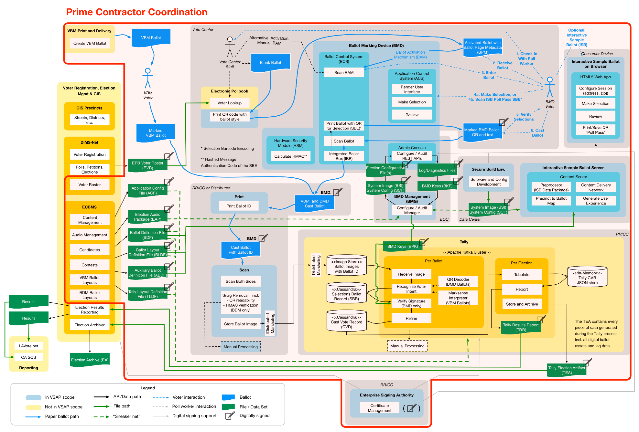

Deliverable 3.7.2 Report of Coordination Activities
Delivery Timing | Submitted no later than the fifth day of each month
Delivery Frequency | Monthly for the duration of full Implementation
Description | The Contractor shall deliver a Report of Coordination Activities including, at minimum:  - Coordination issues identified  - Issue description  - Parties involved and responsible for resolution  - Planned resolution activities and timing as provided by the responsible party  - Actual resolution activities and outcome as confirmed by the Contractor

PROPOSER RESPONSE TO: Deliverable 3.7.2 Report of Coordination Activities
Will the Proposer complete the deliverables and related tasks as described above?
___ Yes
___ Yes, with modifications
___ No
Explain your approach to completing the deliverables and related tasks as described above:
  - Perform Pre-Certification Tests
The Contractor will retain the services of a State-Approved Testing Agency, which is an Independent Testing Authority that is approved by the California Secretary of State to conduct voting system certification tests for the State. The State-Approved Testing Agency will conduct the CVSS required tests during the development of the BMDs, ISB and BMG components until they are very likely to pass the required tests for certification and use in California as components of a voting system (e.g., comply with the CVSS). These tests shall occur during the EVT stage and include:
- Functional testing — Functionality testing will be conducted, depending on the system’s use of specific technologies and configurations, the systems’ capabilities and the outcomes of previous testing
- Usability/accessibility/privacy testing — This will test the fully integrated VSAP Solution including internal and external system interfaces, usability (including volume testing), accessibility and security
- Hardware testing — This will evaluate the ability of the system hardware to withstand exposure to the various environmental conditions, storage, maintenance and transportation
- Software testing — This will evaluate programming completeness, consistency, correctness, modifiability, structure and traceability, along with modularity and construction
- Telecommunications testing — This will test for the transmission of certain data including, but not limited to, voter authentication and ballot definition
- Security testing — This will consist of, but is not limited to, effective access control, physical data security, penetration testing and other forms of vulnerability testing
- Quality assurance and configuration management — This will involve review of submitted documentation for completeness and accuracy in describing the VSAP Solution, its conformance to the requirements for manufacturer configuration and quality assurance practices
The intent of this pre-testing is to minimize the time and iterations required to obtain certification of the voting components once they are submitted to the California Secretary of State. The County expects to conduct the necessary iterations of testing and modifications before, rather than during, the actual certification testing.
Attention should be paid early on to the requirements of the application and documentation delineated in Section 9, the Technical Data Package, of the CVSS, including system performance, system functionality description, system hardware specifications, software design specifications, system security specifications, system test and verification specifications, system maintenance manual, personnel deployment and training requirements, configuration audits and system change notes.
The Contractor will perform security tests in accordance with the End-to-End Security Plan and the requirements of the CVSS. The Contractor will record and report the results for review and approval by the County. The Contractor will fix any errors or issues encountered, conduct root cause analyses as required and document outcomes of any re-testing activities. In addition to Contractor’s security tests, the County may, at its discretion, conduct its own penetration tests to validate all or a portion of the security requirements specified in this document. The County will record and report the results and the Contractor will fix any errors, omissions or issues identified in the penetration tests report. The Contractor will conduct root cause analyses as required and document outcomes of any remediation activities.
Deliverable 3.8 Pre-Certification Test Results
Delivery Timing | Submitted for approval no less than 30 calendar days prior to EVT completion
Delivery Frequency | As many times as necessary to make California Secretary of State Certification likely without re-submission
Description | The Contractor shall provide the results of completed certification tests to the County for each iteration and the final test results that indicate likely approval by the California Secretary of State.

PROPOSER RESPONSE TO: Deliverable 3.8 Pre-Certification Test Results
Will the Proposer complete the deliverables and related tasks as described above?
___ Yes
___ Yes, with modifications
___ No
Explain your approach to completing the deliverables and related tasks as described above:
  - Develop VSAP Solution Use Procedures
The Contractor will develop VSAP Solution Use Procedures that detail the step-by-step instructions to be carried out to deploy the VSAP Solution to the public for use in an election as required by the CVSS for submission of the Technical Data Package. The Use Procedures shall cover all components of the VSAP Solution as show in Figure 1 above including ECBMS, Tally System, ePollbook and the thermal printers connected to the ePollbook in addition to the BMD, ISB and BMG.
Deliverable 3.9 VSAP Solution Use Procedures
Delivery Timing | Submitted for approval no less than 60 calendar days prior to submission of Technical Data Package to California Secretary of State
Delivery Frequency | Once
Description | The Contractor shall develop the VSAP Solution Use Procedures as required for submission to the California Secretary of State per Section 2.4.2.

PROPOSER RESPONSE TO: Deliverable 3.9 VSAP Solution Use Procedures
Will the Proposer complete the deliverables and related tasks as described above?
___ Yes
___ Yes, with modifications
___ No
Explain your approach to completing the deliverables and related tasks as described above:
  - Deploy VSAP Solution (Prior to Full Rollout)
As noted in Section 3.2, the County intends to initially deploy the BMDs in Vote Center Test Labs, the 2019 Mock Election, the November 2019 Pilot (Local Election) and Vote Center Demonstration Centers prior to full Countywide Rollout for the 2020 election cycle.
During deployment, the Contractor shall be responsible for immediate assistance to the County as required to assist it with the operation of the BMDs, ISB and BMG and for assisting the County staff with the implementation of the Level 1 Help Desk capabilities. Before deployment can begin, the Contractor shall ensure that the following activities have taken place:
- The Implementation Plan is fully developed, documented and approved, and includes the specific timeframe and activities associated with the Vote Center Test Labs, the 2019 Mock Election, the November 2019 Pilot (Local Election) and Vote Center Demonstration Centers
- All critical resources have been identified and are available to support deployment activities
- Critical or new technologies have been fully tested and key resources identified to provide needed support
- Contingency plans are in place to address implementation issues that may arise
The Contractor is responsible for direct and immediate support to the County staff in deployment. After deployment, all major BMD, ISB and BMG functionality described in the final design documents shall be available including:
- Security controls as described in the End-to-End Security Plan
- Interfaces with all VSAP components, regardless of whether in-scope for the Contractor
After deployment of the VSAP Solution for each milestone, the Contractor shall document lessons learned. The Contractor shall review the lessons learned with the County and identify action items for the Contractor, County and/or other third-party vendors to be considered and completed prior to the subsequent deployment of the VSAP Solution.
Deliverable 3.10a Deploy VSAP Solution (Prior to Full Rollout)
Delivery Timing | Upon completion of successful deployment of the VSAP Solution during each deployment milestone prior to Full Rollout as defined in Table 1, Table 2, Deliverable 3.1 (Implementation Plan) and Deliverable 3.2 (BMD Production Schedule and Strategy)
Delivery Frequency | Once per deployment milestone
Description | The Contractor shall deploy the VSAP Solution for each deployment milestone prior to Full Rollout as described in Section 3.10.

PROPOSER RESPONSE TO: Deliverable 3.10a Deploy VSAP Solution (Prior to Full Rollout)
Will the Proposer complete the deliverables and related tasks as described above?
___ Yes
___ Yes, with modifications
___ No
Explain your approach to completing the deliverables and related tasks as described above:

Deliverable 3.10b Post-Deployment Lessons Learned
Delivery Timing | Submitted for approval no more than 30 calendar days after completion of successful deployment of the VSAP Solution during each deployment milestone prior to Full Rollout
Delivery Frequency | Once per deployment milestone
Description | The Contractor shall document lessons learned about each deployment as it relates to the Contractor’s In-Scope Components and the integration of the overall VSAP Solution. The Contractor shall also provide recommendations of changes to improve future deployment, including the responsible party and action items.

PROPOSER RESPONSE TO: Deliverable 3.10b Post-Deployment Lessons Learned
Will the Proposer complete the deliverables and related tasks as described above?
___ Yes
___ Yes, with modifications
___ No
Explain your approach to completing the deliverables and related tasks as described above:
  - Deploy VSAP Solution to All Sites
Upon successful completion of the deployment for each milestone prior to Full Rollout, the County will deploy the VSAP Solution throughout the County both in early voting and on Election Day. Certification by the California Secretary of State is required prior to full deployment.
During deployment, the Contractor shall be responsible for immediate assistance to the County as required to assist it with the operation of the BMDs, ISB and BMG and for assisting the County staff with the implementation of the Level 1 Help Desk capabilities. Before deployment can begin, the Contractor shall ensure that the following activities have taken place:
- The Implementation Plan is fully developed, documented and approved, and includes the specific timeframe and activities associated with the full roll-out
- All critical resources have been identified and are available to support deployment activities
- Critical or new technologies have been fully tested and key resources identified to provide needed support
- Contingency plans are in place to deal with implementation issues that may arise
The Contractor is responsible for direct and immediate support to County staff in deployment. After deployment, all major BMD, ISB and BMG functionality described in the final design documents shall be available including:
- Security controls as described in the End-to-End Security Plan
- Interfaces with all VSAP components, regardless of whether in-scope for the Contractor
Deliverable 3.11 Deploy VSAP Solution to All Sites
Delivery Timing | Upon completion of successful deployment of the VSAP Solution for a Countywide election in the 2020 election cycle (full rollout)
Delivery Frequency | Once
Description | The Contractor shall deploy the VSAP Solution to all sites as described in Section 3.11.

PROPOSER RESPONSE TO: Deliverable 3.11 Deploy VSAP Solution to All Sites
Will the Proposer complete the deliverables and related tasks as described above?
___ Yes
___ Yes, with modifications
___ No
Explain your approach to completing the deliverables and related tasks as described above:
  - Comply with Applicable Elections Code or Regulations After Initial California Secretary of State Certification (Based on a Negotiated Work Order)
Should applicable provisions of the Elections Code or regulations change after Certification but during Implementation, the Contractor will be required to comply with current Elections Code and regulations under a negotiated Work Order (for Goods and Services).
If the VSAP Solution is determined to be out of compliance, for reasons not due to changes in the Elections Code and regulations (such determination to be made by the County at the County’s sole discretion), the work to bring the VSAP Solution into compliance will be the responsibility of the Contractor at no additional cost to the County.
PROPOSER RESPONSE TO: Task 3.12 Comply with Applicable Elections Code or Regulations After Initial California Secretary of State Certification (Based on a Negotiated Work Order)
Will the Proposer complete the task as described above?
___ Yes
___ Yes, with modifications
___ No
Explain your approach to completing the task as described above:
The deliverable will be determined based on a negotiated work order.
  - Component Hardware Services
The BMD includes the hardware, firmware, software and third-party software necessary and sufficient to operate the BMD. The Contractor will provide the following services for the BMDs:
- Repair and replacement (individual BMD-specific)
- Product recall and update (all BMDs)
- Installing and testing and re-installing and re-testing component software updates
- Preventative maintenance (ahead of even-year election cycles and prior to any special Countywide elections)
- Maintenance of the Bill of Materials for all Contractor In-Scope Components
- Hardware life cycle management (e.g., hardware subcomponent may be obsolete in the future and the Contractor should be aware/keep track and identify replacement(s) accordingly. This effort will need to be far enough in advance to consider re-certification, if necessary, prior to an election)
- Quarterly reporting to the County of changes in Bill of Materials and hardware life cycle
As applicable, the Contractor shall provide the following services in accordance with the response times listed in Table 3 below.
    - Provide Repair and Replacement Services
The Contractor shall repair or replace the BMDs on-site or off-site. The Contractor will not be required to substitute another BMD while one is being repaired.
Repair and replacement bundled services will be for damage or breakage due to normal use. Units subject to abuse or negligence by the County, such as being left out in the rain, shall be repaired for a fee under a negotiated work order.
If any component of the BMD requires servicing, the Contractor shall endeavor to provide such servicing at the County’s location. If the Contractor determines it necessary to replace or repair any BMD Unit, or component, at the Contractor’s facility, the Contractor shall coordinate all transportation logistics and pay all shipping costs to transport such BMD Unit, or component, to and from the Contractor’s location. All such required repairs are to be completed within the timeframe specified in Table 3 without additional cost to the County. The Contractor shall return the BMD at its own expense by overnight shipment, if necessary.
Deliverable 3.13.1 Repair and Replacement of BMDs
Delivery Timing | Upon completion of successful deployment of the VSAP Solution for a Countywide election (Full Rollout)
Delivery Frequency | As needed
Description | The Contractor shall repair and replace BMDs as described in Section 3.13.1.

PROPOSER RESPONSE TO: Deliverable 3.13.1 Repair and Replacement of BMDs
Will the Proposer complete the deliverables and related tasks as described above?
___ Yes
___ Yes, with modifications
___ No
Explain your approach to completing the deliverables and related tasks as described above:
    - Provide Component Recall and Update Services
The Contractor shall provide:
- Deficiency correction — Correct all Deficiencies in all BMDs
- Error correction — Provide user support for all errors (whether caused by deficiencies or user error) arising during use of the BMD through a Help Desk service and other technical and administrative staff
- Documentation — Provide complete BMD documentation and update such documentation periodically to account for repairs and changes in the BMD
- Training — Conduct user and administrator training for County regarding any updates or other changes to affected components
Deliverable 3.13.2 Contractor In-Scope Component Recall and Update Services
Delivery Timing | As required by County delivery of Defect-free components  Within 60 days of delivery of Defect-free components, delivery of the following:  - Updated documentation related to the affected component  - Updated training materials related to the affected component if needed
Delivery Frequency | As needed
Description | Contractor will deliver:  - Defect-free components  - Updated documentation related to the affected component  - Updated training materials related to the affected component, if needed

PROPOSER RESPONSE TO: Deliverable 3.13.2 Contractor In-Scope Component Recall and Update Services
Will the Proposer complete the deliverables and related tasks as described above?
___ Yes
___ Yes, with modifications
___ No
Explain your approach to completing the deliverables and related tasks as described above:
    - Develop Preventative Maintenance Schedule
The Contractor will develop a Preventative Maintenance Schedule for the BMDs.
Deliverable 3.13.3 Preventative Maintenance Schedule
Delivery Timing | Submitted for approval upon delivery of DVT BMDs
Delivery Frequency | Once
Description | The Contractor shall develop a Preventative Maintenance Schedule.

PROPOSER RESPONSE TO: Deliverable 3.13.3 Preventative Maintenance Schedule
Will the Proposer complete the deliverables and related tasks as described above?
___ Yes
___ Yes, with modifications
___ No
Explain your approach to completing the deliverables and related tasks as described above:
    - Conduct Preventative Maintenance on BMDs
The Contractor will conduct preventive maintenance on all of the BMDs according to the agreed upon Preventative Maintenance Schedule.
Deliverable 3.13.4 Preventative Maintenance on BMDs
Delivery Timing | Completed as agreed upon in the Preventative Maintenance Schedule
Delivery Frequency | Ahead of even-year election cycles and prior to any special Countywide elections
Description | The Contractor shall conduct preventative maintenance on all of the BMDs.

PROPOSER RESPONSE TO: Deliverable 3.13.4 Preventative Maintenance on BMDs
Will the Proposer complete the deliverables and related tasks as described above?
___ Yes
___ Yes, with modifications
___ No
Explain your approach to completing the deliverables and related tasks as described above:
    - Track BMD Hardware Lifecycle and Maintain the Bill of Materials
The Contractor will establish and track the BMD sub-component hardware life cycles and review, update and maintain the Bill of Materials for the BMDs to ensure the timely availability of all subcomponents of the BMDs.
The Contractor will submit the updated Hardware Lifecycle and Bill of Materials quarterly to the County noting changes, near-term end-of-availability items and recommended substitutions as necessary to ensure the feasibility of repair and additional manufacture of BMDs. Though the County plans to order quantities of BMDs that ensure sufficient spares for each election, the Contractor will need to cooperate in the monitoring and planning of these life cycles to ensure the County is not short of working BMDs for any election during the Contract period. The replacement of parts in the Bill of Materials due to a notice of obsolescence of sub-components must take into account the possibility that re-certification (or de minimis approval) by the California Secretary of State may be necessary before implementing replacements in the BMDs.

Deliverable 3.13.5 BMD Hardware Lifecycle and Bill of Materials Report
Delivery Timing | Submitted as per the agreed upon Project Schedule
Delivery Frequency | Quarterly
Description | The Contractor shall establish and track the BMD hardware life cycle, maintain and update the Bill of Materials and inform the County on any changes or near-term end-of-availability items. The BMD Hardware Lifecycle and Bill of Materials Report shall also include the Contractor’s recommended hardware substitutions, if necessary.

PROPOSER RESPONSE TO: Deliverable 3.13.5 BMD Hardware Lifecycle and Bill of Materials Report
Will the Proposer complete the deliverables and related tasks as described above?
___ Yes
___ Yes, with modifications
___ No
Explain your approach to completing the deliverables and related tasks as described above:
  - Component Software Services
The Contractor will provide the following services for the BMD, ISB and BMG software:
- Software changes — Once an update to the software has been completed, certified (if needed) and accepted by the County, the Contractor shall install the changes. For the BMD software specifically, the Contractor shall install the changes into all deployed BMDs with assistance from the County as required. The Contractor shall provide a Software Maintenance report including installs and tests, re-installs and re-tests
- Deficiency and Error correction — Corrections for all Deficiencies and incorrect features (“Errors”) in the component software
- Documentation — Updates to all related documentation to account for any corrections to the BMD, ISB and BMG software components
- Training — Conduct related user and administrator training
Deliverable 3.14 Report of Software Maintenance
Delivery Timing | Submitted as per the agreed upon Project Schedule
Delivery Frequency | Quarterly
Description | The Contractor shall deliver a report of the software maintenance activities during the period, discussing the activities as described above.

PROPOSER RESPONSE TO: Deliverable 3.14 Report of Software Maintenance
Will the Proposer complete the deliverables and related tasks as described above?
___ Yes
___ Yes, with modifications
___ No
Explain your approach to completing the deliverables and related tasks as described above:
  - Sub-Component Services (Third-Party Hardware & Software)
The Contractor will be responsible for fixing or providing alternative solutions for deficiencies or errors in third-party hardware and software included in the BMD, ISB or BMG components. Examples of third-party sub-components are processor boards, QR code scanners and operating systems that are embedded in the BMD, ISB or BMG.
The Contractor shall ensure support for third-party hardware and software is provided to the full extent of the third-party warranty and sufficient to meet the County’s needs. The Contractor will be the primary point of contact with the County for remediating third-party hardware and software issues, and will be responsible for ensuring third-party compliance with the Contract and deliverables requirements.
The County shall not substitute third-party hardware or software provided by the Contractor with a different version than in use in the BMD, ISB or BMG.
In the event that any Deficiency in a third-party software sub-component is not promptly remedied by the manufacturer or author of the sub-component, the Contractor shall ameliorate any Deficiency in the BMD, the BMG or the ISB arising from such Deficiency, in all ways in accordance with its obligations (e.g., by the development of alternative software solutions for the BMD, the BMG or the ISB for the defect in the third-party software, or the replacement of the third-party software with other software to perform the required functions). Similarly, for third-party hardware sub-components, the Contractor will be required to repair or replace third-party hardware due to Deficiencies in them.
If any Deficiency or error is identified in third-party hardware or software components, the Contractor shall:
- Make reasonable efforts to diagnose the Deficiency, assist County with remedying the Deficiency, assist County with obtaining support or warranty service from the third-party vendor or warranty service provider; and remedy any Deficiency in the BMD arising from any defect in or misconfiguration of any such third-party components
- If any Deficiency in third-party software is not promptly remedied by the warranty service provided or author of such component, the Contractor shall promptly ameliorate any Deficiency in the BMD, the BMG or the ISB software arising therefrom, in accordance with its obligations to maintain the BMD, BMG, or ISB software. Contractor’s duties with respect to such third-party software shall not include modifying the Source Code of such third-party software to correct Deficiencies therein. However, by way of example and without limitation, Contractor’s duties in respect to the BMD software shall include:
  - Ensuring compatibility between all third-party software components and the BMD, BMG, or ISB software, if necessary by modifying the BMD, BMG or ISB software to maintain such compatibility
  - Remediation of any Deficiencies related to the configuration of any third-party software components as used in the BMD, BMG, or ISB software and development of alternative software solutions in the BMD, BMG, or ISB software for bugs, errors, or other defects in the third-party software that cause the BMD, BMG, or ISB software not to perform in accordance with Specifications or that otherwise cause the BMD, BMG, or ISB software to exhibit Deficiencies
Deliverable 3.15 Report of Third-Party Sub-component Maintenance
Delivery Timing | Submitted within five days of the end of each fiscal quarter
Delivery Frequency | Quarterly
Description | The Contractor shall deliver a report of third-party subcomponent maintenance as described in Section 3.15.

PROPOSER RESPONSE TO: Deliverable 3.15 Report of Third-Party Sub-component Maintenance
Will the Proposer complete the deliverables and related tasks as described above?
___ Yes
___ Yes, with modifications
___ No
Explain your approach to completing the deliverables and related tasks as described above:
  - Configuration Management
    - Provide Builds and Releases
The Contractor will be required to provide Builds (that result in Releases) that include all Contractor In-Scope Components, all Contractor-provided third-party hardware and/or software and all Contractor provided hardware and firmware.
The Contractor shall manage and implement the BMD, BMG and ISB software and associated sub-component third-party product revisions. The Contractor and the County shall jointly determine Release schedule and time of implementation.
The Contractor shall adhere to the following process for installing a new Release:
- The Contractor shall install the Release to all relevant domains with the County approval to sync all domains as necessary
- The Contractor shall install the Release into a non-production environment
- The Contractor shall perform a regression test to ensure the Release did not negatively affect current functionality across all the Contractor In-Scope Components (BMD, BMG and ISB). Regression test results will be provided to the County and the County must approve the release prior to its implementation
- The Contractor will work with the County in conducting integration tests with non-Contractor components (e.g., ECBMS, Tally System, ePollbook, thermal printers connected to the ePollbook)
- The County shall conduct UAT testing with support from the Contractor
- The Contractor shall resolve problems/incidents found in regression or integration testing of the Contractor In-Scope Components
- The Contractor shall provide a list of changes that may require updates to the training materials
- The Contractor shall provide changes necessary to the system documentations
All changes and fixes shall be implemented based on a mutually agreed upon schedule. All changes shall go through all phases of testing by the Contractor and the VSAP Project Team. The test results shall be documented and provided to the VSAP Project Team for approval before a decision is made to put the new release into production. All relevant system documentation shall be updated and provided to the County after any system changes.
Deliverable 3.16.1 Configuration Management Report
Delivery Timing | Upon completion of expected tasks described in this section prior to each election
Delivery Frequency | Prior to each election
Description | The Contractor shall deliver each Configuration Management Report describing activities completed in Section 3.16.1.

PROPOSER RESPONSE TO: Deliverable 3.16.1 Configuration Management Report
Will the Proposer complete the deliverables and related tasks as described above?
___ Yes
___ Yes, with modifications
___ No
Explain your approach to completing the deliverables and related tasks as described above:
    - Test Builds of Contractor In-Scope Components
The Contractor will perform or coordinate the following six (6) types of tests on all Builds of the VSAP Solution beginning with certification by the California Secretary of State and continuing through the last Build during the M&S period.
      - Perform Unit Tests
The Contractor shall perform unit tests upon completion of software development or upon subsequent revision of the software, to verify the software performs as described in the Software Architecture Document.

Deliverable 3.16.2.1 Unit Test Scripts and Unit Test Results
Delivery Timing | Upon completion of expected tasks described in this section following each Build
Delivery Frequency | Following each Build
Description | The Contractor shall deliver Unit Test Scripts and Unit Test Results as described in Section 3.16.2.1.

PROPOSER RESPONSE TO: Deliverable 3.16.2.1 Unit Test Scripts and Unit Test Results
Will the Proposer complete the deliverables and related tasks as described above?
___ Yes
___ Yes, with modifications
___ No
Explain your approach to completing the deliverables and related tasks as described above:
      - Perform System Tests
The Contractor shall perform a system test upon completion of software development or subsequent revisions to software, to verify that the software customization performs as described in the Software Architecture Document. Any revisions that affect the user experience shall undergo User Experience testing. Regression test scenarios are to be included in the system test cases and results, to confirm that changes to the system have not adversely impacted baseline functionality.
Deliverable 3.16.2.2 System Test Cases and System Test Results
Delivery Timing | Upon completion of expected tasks described in this section following each Build
Delivery Frequency | Following each Build
Description | The Contractor shall deliver System Test Cases and System Test Results as described in Section 3.16.2.2.

PROPOSER RESPONSE TO: Deliverable 3.16.2.2 System Test Cases and System Test Results
Will the Proposer complete the deliverables and related tasks as described above?
___ Yes
___ Yes, with modifications
___ No
Explain your approach to completing the deliverables and related tasks as described above:
      - Perform Integration Tests
The Contractor shall perform an integrated system test to verify that all software components work together as designed. Integration testing will include the integration of all components of the VSAP Solution. The test cases will incorporate test scenarios that confirm continuity and accuracy across modules and accommodate testing of files produced by or for external systems.
Deliverable 3.16.2.3 Integration Test Cases and Integration Test Results
Delivery Timing | Upon completion of expected tasks described in this section
Delivery Frequency | Following each Build
Description | The Contractor shall deliver Integration Test Cases and Integration Test Results as described in Section 3.16.2.3.

PROPOSER RESPONSE TO: Deliverable 3.16.2.3 Integration Test Cases and Integration Test Results
Will the Proposer complete the deliverables and related tasks as described above?
___ Yes
___ Yes, with modifications
___ No
Explain your approach to completing the deliverables and related tasks as described above:
      - Perform User Acceptance Tests
The Contractor, in collaboration with the County, shall develop test cases and perform end-to-end user acceptance testing to verify that the VSAP Solution performs as intended to support the County’s voting processes.
Deliverable 3.16.2.4 User Acceptance Test Cases and Test Results
Delivery Timing | Upon completion of expected tasks described in this section following each Build
Delivery Frequency | Following each Build
Description | The Contractor shall deliver User Acceptance Test Cases and Test Results as described in Section 3.16.2.4.

PROPOSER RESPONSE TO: Deliverable 3.16.2.4 User Acceptance Test Cases and Test Results
Will the Proposer complete the deliverables and related tasks as described above?
___ Yes
___ Yes, with modifications
___ No
Explain your approach to completing the deliverables and related tasks as described above:
      - Perform Regression Tests
The Contractor shall perform independent regression testing to confirm that changes introduced by individual components have not inadvertently impacted overall VSAP Solution functionality.
Deliverable 3.16.2.5 Regression Test Cases and Test Results
Delivery Timing | Upon completion of expected tasks described in this section following each Build
Delivery Frequency | Following each Build
Description | The Contractor shall deliver Regression Test Cases and Test Results as described in Section 3.16.2.5.

PROPOSER RESPONSE TO: Deliverable 3.16.2.5 Regression Test Cases and Test Results
Will the Proposer complete the deliverables and related tasks as described above?
___ Yes
___ Yes, with modifications
___ No
Explain your approach to completing the deliverables and related tasks as described above:
      - Perform Volume/Stress Tests
The Contractor shall perform volume/stress testing to measure the In-Scope Components against performance targets established in the Design and Development Plan.
Deliverable 3.16.2.6 Volume/Stress Test Cases and Volume/Stress Test Results
Delivery Timing | Upon completion of expected tasks described in this section following each Build
Delivery Frequency | Following each Build
Description | The Contractor shall deliver Volume/Stress Test Cases and Volume/Stress Test Results as described in Section 3.16.2.6.

PROPOSER RESPONSE TO: Deliverable 3.16.2.6 Volume/Stress Test Cases and Volume/Stress Test Results
Will the Proposer complete the deliverables and related tasks as described above?
___ Yes
___ Yes, with modifications
___ No
Explain your approach to completing the deliverables and related tasks as described above:
      - Perform Security Tests
The Contractor shall perform security testing to validate the security measures established within the VSAP Solution are compliant with County policies and state regulations and are sufficient to restrict unauthorized access into the system or unauthorized use of features or functions as well as to resist service disruption from denial-of-service attacks.
Deliverable 3.16.2.7 Security Test Cases and Security Test Results
Delivery Timing | Upon completion of expected tasks described in this section following each Build
Delivery Frequency | Following each Build
Description | The Contractor shall deliver Security Test Cases and Security Test Results as described in Section 3.16.2.7.

PROPOSER RESPONSE TO: Deliverable 3.16.2.7 Security Test Cases and Security Test Results
Will the Proposer complete the deliverables and related tasks as described above?
___ Yes
___ Yes, with modifications
___ No
Explain your approach to completing the deliverables and related tasks as described above:
    - Provide Certification Services for Re-Certification or De Minimis Approval of Releases (Based on a Negotiated Work Order)
The Contractor shall work with the County to determine the Certification status of new Releases and seek de minimis change approval from the California Secretary of State where possible. If a Release meets conditions for de minimis change approval, the Contractor shall be responsible for submission and support for those approval processes.
If a Release requires full re-certification, the Contractor shall provide all the relevant information, documentation (e.g., updated Use Procedures), source code and equipment necessary to enable re-certification and work with the California Secretary of State to achieve re-certification.
The deliverable will be determined based on a negotiated work order.
PROPOSER RESPONSE TO: Task 3.16.3 Provide Certification Services for Re-Certification or De Minimis Approval of Releases
Will the Proposer complete the task as described above?
___ Yes
___ Yes, with modifications
___ No
Explain your approach to completing the task as described above:
    - Provide System Documentation Updates
Once the VSAP Solution has been deployed, the Contractor shall make updates to relevant system documentation to reflect any changes that have occurred in a system update/release in a manner suitable for submission to the California Secretary of State in a future re-certification or de minimis request.
At the completion of the Implementation, the Contractor shall conduct a review with the VSAP Project Team and identify any documentation that shall be updated because of changes. The Contractor shall be required to update the documentation and provide it to the VSAP Project Team for review and final acceptance.
The following documents are some of the critical documents that shall be updated and provided to the VSAP Project Team at the completion of a Release:
- Updated Functional Design Document
- Updated Technical Design Document
- Updated End-to-End Security Plan
- Updated VSAP Solution Use Procedures
The Contractor shall also transfer all agreed to, and finalized, documentation to the VSAP Project Team. The format and the medium of transfer shall be at the discretion of the VSAP Project Team.
Deliverable 3.16.4 Contractor System Documentation
Delivery Timing | Upon completion of expected tasks described in this section prior to each Release
Delivery Frequency | Prior to each Release
Description | The Contractor shall deliver Contractor System Documentation as described in Section 3.16.4

PROPOSER RESPONSE TO: Deliverable 3.16.4 Contractor System Documentation
Will the Proposer complete the deliverables and related tasks as described above?
___ Yes
___ Yes, with modifications
___ No
Explain your approach to completing the deliverables and related tasks as described above:
  - Training and Knowledge Transfer
    - Develop the Training and Knowledge Transfer Plan
The Contractor shall be responsible for the development of training curricula, schedules, training materials and training evaluation materials. The Contractor shall be responsible for the setup and maintenance of a training environment that allows trainees access to instances of the BMDs, ISB and BMG. The Contractor shall also be responsible for conducting face-to-face, hands-on, training in logical groupings (at locations determined by the VSAP Project Team) and for managing all training planning and logistics.
The Contractor will also ensure knowledge transfer occurs to key Department staff. This includes identifying key roles (e.g., County operational staff, County training staff and County technical staff) early in the VSAP Project and actively engaging personnel throughout the VSAP Project to ensure they receive the knowledge required to fill the role. This includes providing checkpoints to ensure the required knowledge is being transferred and establish correction action plans, if required.
Training shall be developed in alignment with the requirements defined in the Training and Knowledge Transfer Plan developed by the Contractor and approved by the County. Training materials shall be updated prior to each Release.
The BMD training shall focus on the navigation and use of the system. It shall also cover new business processes and/or workflows.
After each training event, the Contractor shall provide the County with documented evidence of each trainee’s competence to operate or otherwise work with the BMD and integrate its support in to their election work. Training shall be of sufficient length to ensure adequate comprehension. Training shall be provided “just in time” prior to an election and shall comprehensively address all BMD operations including security considerations. Training shall be provided at such time that it is relevant for an upcoming election.
The Contractor shall be responsible for coordinating training efforts with election subject matter experts (“SMEs”) who shall provide policy and practice support to the Contractor and be present at the training sessions to provide input, as necessary, regarding practice and policy questions or implications.
The Training and Knowledge Transfer Plan shall describe the types of training and the audience for each. It shall also provide a description of training materials, a description of training methodology, a detailed list of topics to be covered for each type of training and a description of the methodology for evaluating effectiveness of the training. The Training and Knowledge Transfer Plan shall provide an overview of tools and materials to be employed in the training including workbooks, handouts, evaluation material and a training software if employed. The types of training shall account for various audiences including, at a minimum, “train-the-trainer” trainers, other County users (including the County Level 1 Help Desk staff), VSAP Project Team and VSAP Executive Team. The Contractor shall not be responsible for Vote Center Staff training. The Training and Knowledge Transfer Plan shall detail the development of curriculum, materials, a training database, a training roll-out schedule, computer based training (where appropriate) and a training schedule including number of days and preliminary agendas for the training. The Training and Knowledge Transfer Plan shall also identify the proposed training staff.
The Contractor shall be responsible for providing training to all County Level 1 Help Desk staff that shall be tasked with handling VSAP related issues. Training shall focus on the process of the help desk staff supporting VSAP users in resolving VSAP issues that are referred to the Help Desk. For those referrals that indicate issues best addressed by specialists employed by the Contractor, the Contractor will train the County staff in the manner and means by which such referrals to Help Desk Level 2 are to be conducted and the resolution communicated back the Help Desk Level 1.
Deliverable 3.17.1 Training and Knowledge Transfer Plan
Delivery Timing | Before training begins
Delivery Frequency | Once
Description | The Contractor shall deliver a Training and Knowledge Transfer Plan as described in Section 3.17.1.

PROPOSER RESPONSE TO: Deliverable 3.17.1 Training and Knowledge Transfer Plan
Will the Proposer complete the deliverables and related tasks as described above?
___ Yes
___ Yes, with modifications
___ No
Explain your approach to completing the deliverables and related tasks as described above:
    - Develop Training Materials
The Training Materials shall include items used to conduct the training sessions for the BMDs, BMG and ISB which shall ensure that training objectives are met. These materials can include presentations, demonstrations, activities, handouts and other required documentation and media. These materials shall also include training plans, evaluation materials and training maintenance and support plans. An electronic copy of all training materials shall be provided to the County.
Training Materials shall be required for each of the training types described in the Training and Knowledge Transfer Plan. Each individual trainee should receive a copy of the training materials.
Updated VSAP training shall be required with the implementation of any significant changes or upgrades to the BMDs, BMG, or ISB. The additional training platform shall be dependent on the needs of VSAP and the specific changes that occur.
Deliverable 3.17.2 Training Materials
Delivery Timing | Before training begins, according to the agreed-upon Training and Knowledge Transfer Plan and associated schedule
Delivery Frequency | Once
Description | The Contractor shall deliver Training Materials as described in Section 3.17.2.

PROPOSER RESPONSE TO: Deliverable 3.17.2 Training Materials
Will the Proposer complete the deliverables and related tasks as described above?
___ Yes
___ Yes, with modifications
___ No
Explain your approach to completing the deliverables and related tasks as described above:
    - Provide Training Metrics
The Contractor shall provide a Report of Training Metrics, which includes training metrics for reporting progress and effectiveness. Metrics may include the number of participants registered to be trained, participants trained and number of participants receiving training certification.
Deliverable 3.17.3 Report of Training Metrics
Delivery Timing | According to agreed-upon Training and Knowledge Transfer Plan and associated schedule
Delivery Frequency | After each training session
Description | The Contractor shall deliver a Report of Training Metrics as described in Section 3.17.3.

PROPOSER RESPONSE TO: 3.17.3 Report of Training Metrics
Will the Proposer complete the deliverables and related tasks as described above?
___ Yes
___ Yes, with modifications
___ No
Explain your approach to completing the deliverables and related tasks as described above:
    - Provide User Guide Documentation
The Contractor shall be responsible for providing user guide documentation for the BMDs, BMG and ISB. The User Guide Documentation shall explain how the system (BMDs, BMG, or ISB) is intended to be operated. The User Guide Documentation will be an input to the Use Procedures to be developed by the Contractor and approved by the California Secretary of State. The Contractor shall provide updates to the User Guide Documentation during Implementation, reflecting applicable changes based on new Releases, system enhancements and system updates.
Deliverable 3.17.4 User Guide Documentation
Delivery Timing | Upon completion of expected tasks described in this section prior to each Release, system enhancement or system update, as needed
Delivery Frequency | As needed
Description | The Contractor shall deliver User Guide Documentation as described in Section 3.17.4.

PROPOSER RESPONSE TO: 3.17.4 User Guide Documentation
Will the Proposer complete the deliverables and related tasks as described above?
___ Yes
___ Yes, with modifications
___ No
Explain your approach to completing the deliverables and related tasks as described above:
  - Provide On-Site Support Services
The Contractor will be required to provide on-site support (up to 60 days prior to an election) for no additional charge. On-site support personnel technically competent to fully support and repair the BMD units and other Contractor In-Scope Components shall be provided to County during all support periods for up to sixteen (16) hours per day that covers election operational hours.
PROPOSER RESPONSE TO: Task 3.18 Provide On-Site Support Services
Will the Proposer complete the task as described above?
___ Yes
___ Yes, with modifications
___ No
Explain your approach to completing the task as described above:
  - Provide Help Desk Services
The County will provide Help Desk Level 1 Support including for BMD, BMG and ISB. The Contractor will be responsible for providing Level 2 Help Desk Support to address and resolve all Help Desk requests not resolved by Help Desk Level 1 for BMD, BMG and ISB. The Contractor’s Help Desk Level 2 Support will be broken into Tier 1, 2 and 3 as follows:
Tier 1: Election Day minus 120 days to Election Day minus 61 days
Tier 2: Election Day minus 60 days to Election Day minus 21 days
Tier 3: Election Day minus 20 days to Election Day
The Contractor support response times for each Tier will be further broken down by Level of Severity with response times determined for each Level of Error Severity.
    - Support Tiers
      - Support Tier 1
Issues occurring between 61 and 120 days before Election Day (“Important Election Work Period”) require Support Tier 1 Service. In the event of a special Election, County shall notify Contractor of the need for support as soon as possible.
The County, or at the request of the Contractor with approval by the County, may determine to escalate problems occurring during Support Tier 1 Service periods as requiring Support Tier 2 or 3 Service if delayed problem resolution will negatively affect the performance of the BMD, BMG, ISB or any part thereof during the related Election. In such circumstances, the County shall not incur additional fees.
      - Support Tier 2
Issues occurring between 21 and 60 days before Election Day (“Essential Election Work Period”) require Support Tier 2 Service. In the event of a special Election, County shall notify the Contractor of the need for support as soon as possible. The Contractor shall make reasonable efforts to provide Support Tier 2 service beginning as close as possible to the date service is requested even if such date is less than the timeframe identified in Table 3. During Support Tier 2 events, the Contractor must commit to continual work, including the reassignment of staff to bring resolution as quickly as possible within the time required.
The County, or at the request of the Contractor with approval by the County, may determine to escalate problems occurring during Support Tier 2 service periods as requiring Support Tier 3 service if delayed problem resolution will negatively affect the performance of the BMD, BMG, ISB or any part thereof during the related Election. In such circumstances, the County shall not incur additional fees.
      - Support Tier 3
Issues occurring twenty (20) or fewer days prior to Election Day (“Critical Election Work Period”) require Support Tier 3 Service.
    - Level of Error Severity
      - Error Severity 1
Error Severity 1 issues shall include minor imperfections, routine repair and replacement of failed equipment or modules, questions and minor software upgrades. Additionally, an issue may be assigned to Error Severity 1 if the issue impacts County’s use of any component of the BMD, the BMG or the ISB without causing any loss of functionality or operability.
      - Error Severity 2
Error Severity 2 issues shall include those resulting in a loss of functionality or operability of any component of the BMD, the BMG or the ISB, but for which a workaround acceptable to County is developed within the Diagnosis Timeframe specified on Table 3.
      - Error Severity 3
Error Severity 3 issues shall include those resulting in a loss of functionality or operability of any component of the BMD, the BMG or the ISB for which a workaround acceptable to County is not developed within the Diagnosis Timeframe specified on Table 3.
    - Support Tiers and Level of Error Severity
Varying levels of support for the BMD, the BMG and the ISB and their sub-components are required depending on when issues are identified in relation to an Election Date. Table 3 identifies required Contractor response times by Support Tier and Level of Error Severity, where response times are to be measured in Calendar Days (not Business Days).
- Required Response Times
Required Response Times by Support Tier and Level of Error Severity
Support Tier | Tier Description | Error Severity | Diagnosis Timeframe | Resolution Timeframe
1 | Important Election Work Periods | 1 | Two Days | One Week
 |  | 2 | Two Hours | Two Days
 |  | 3 | Two Hours | Two Days
2 | Essential Election Work Period | 1 | Four Hours | Two Days
 |  | 2 | One Hour | One Day
 |  | 3 | One Hour | One Day
3 | Critical Election Work Period | 1 | Two Hours | One Day
 |  | 2 | One Hour | Four Hours
 |  | 3 | One Hour | Four Hours
    - Provide Contractor In-Scope Component Help Desk Services
The Contractor shall provide telephone response through its help desk each Business Day between 8:00 a.m. and 5:00 p.m. Pacific Time and between 6:00 a.m. and 10:00 p.m. PT during Important, Essential and Critical Election Work Periods, and shall also provide assistance to County staff by email for all Contractor In-Scope Components during Implementation, Warranty and M&S periods.
Contractor shall ensure sufficient staffing of the Help Desk Level 2 during help desk hours such that any call or email received during such hours receive a substantive response, as defined in Table 3.
Staff providing service at the Help Desk Level 2 shall be trained in the operation, maintenance and repair of the BMD, in the determination of the source of errors in usage of the BMD (whether caused by user error or malfunction), and to provide guidance to County personnel in the use of all Contractor In-Scope Components.
Staff providing service at the Help Desk Level 2 shall furthermore have ready access to test hardware and software allowing testing and/or verification of any County reported Deficiencies. Contractor shall have a fully functioning lab with the same components and versions of components being used by the County at any time to facilitate testing and verification. Contractor shall ensure the appropriate technical support staff and management shall be available for maintenance, repair or support that cannot be accomplished via the Help Desk Level 2 or other on-site support staff.
- Documentation. The Contractor shall maintain a maintenance history for all individual BMD devices (Hardware and BMD Software) serviced, as well as inventory-wide summary reports of maintenance history
- Secure Online Support. Secure online support services shall be hosted and maintained by the Contractor for problem diagnosis and resolution, software updates and documentation releases
- Updates. The Contractor shall provide updates as required pursuant to the Agreement for the correction of Deficiencies, or as the Contractor deems necessary and useful to the performance of the Contractor In-Scope Components
The Contractor shall provide a monthly Contractor In-Scope Component Help Desk Services Report documenting service requests, resolutions and recommended changes to be made to Contractor In-Scope Components. The format and medium shall be approved by the VSAP Project Team.
Deliverable 3.19.4 Contractor In-Scope Component Help Desk Services Report
Delivery Timing | Submitted no later than the fifth day of each month
Delivery Frequency | Monthly
Description | The Contractor shall deliver each Contractor In-Scope Component Help Desk Services Report as described in Section 3.19.4.

PROPOSER RESPONSE TO: Deliverable 3.19.4 Contractor In-Scope Component Help Desk Services Report
Will the Proposer complete the deliverables and related tasks as described above?
___ Yes
___ Yes, with modifications
___ No
Explain your approach to completing the deliverables and related tasks as described above:
    - Provide Contractor In-Scope Component Problem Log Tracking
The Contractor shall create and update an interactive/automated problem log accessible 24/7 to authorized County staff, which shall be reviewed and revised at least weekly for follow-up on unresolved issues. This Contractor In-Scope Component Problem Log Report shall include the following:
- Problem Number (a unique ID assigned by the Contractor)
- Date and time reported
- County employee or affiliate reporting the problem and phone number
- Contractor personnel receiving the initial County contact regarding the problem
- Description of the problem
- Support Tier assigned to problem
- Error Severity assigned to problem
- Resolution status and estimated fix date (completed by the Contractor)
- Resolution plan (completed by the Contractor)
- Resolution description and date resolved (completed by the Contractor)
- A log of each individual contact between the County and the Contractor regarding the problem, including the date, time, County and Contractor personnel names for each contact, textual summaries of phone calls and copies of all related email text and other correspondence
Deliverable 3.19.5 Contractor In-Scope Component Problem Log Report
Delivery Timing | Submitted no later than the fifth day of each month
Delivery Frequency | Monthly
Description | The Contractor shall deliver each Contractor In-Scope Component Problem Log Report as described in Section 3.19.5.

PROPOSER RESPONSE TO: Deliverable 3.19.5 Contractor In-Scope Component Problem Log Report
Will the Proposer complete the deliverables and related tasks as described above?
___ Yes
___ Yes, with modifications
___ No
Explain your approach to completing the deliverables and related tasks as described above:
  - Provide Service Measurement and Reporting
The Contractor shall conduct service level monitoring and reporting that shall include:
- Ongoing monitoring of the Contractor adherence to service levels
- Issues that could impact an agreed-upon service levels
- Resolution of root-causes impacting the Contractor’s ability to meet agreed-upon service levels
- Monthly statistics and management reports to the County on service level attainment

Deliverable 3.20 Contractor Service Level Report
Delivery Timing | Submitted no later than the fifth day of each month
Delivery Frequency | Monthly
Description | The Contractor shall deliver each Contractor Service Level Report as described in Section 3.20.

PROPOSER RESPONSE TO: Deliverable 3.20 Contractor Service Level Report
Will the Proposer complete the deliverables and related tasks as described above?
___ Yes
___ Yes, with modifications
___ No
Explain your approach to completing the deliverables and related tasks as described above:
  - Implementation Close
Implementation will be considered complete once all of the following have occurred:
- The County has conducted a full deployment of all Contractor In-Scope Components in the same Countywide Election, and has been deemed successful by the County
- A punch list of defects or errors in the Contractor In-Scope Components has been made and agreed upon
- The County has formally accepted each Contractor In-Scope Component after the punch list changes have been made
    - Criteria for Acceptance of Contractor In-Scope Components
The Contractor shall achieve BMD, BMG and ISB acceptance upon successful completion of all the following:
- The Contractor’s completion and delivery of all SOW work pursuant to acceptance, including all BMD units (other than any additional BMD units purchased subsequently), training, testing, reports and other deliverables associated with the acceptance of the BMD or the BMG or the ISB, respectively
- Successful implementation of all functions and features associated with acceptance of the BMD or the BMG or the ISB, respectively, and successful achievement of all applicable required testing, as verified by the County
- The VSAP Program Manager has provided the Contractor with written approval, as evidenced by the VSAP Program Manager’s countersignature on all applicable prior Deliverable Acceptance Documents, of all such work; and
- The VSAP Program Manager has provided the Contractor with written approval, as evidenced by VSAP Program Manager’s countersignature on the applicable Deliverable Acceptance Document, of the Contractor’s achievement of acceptance. The date of satisfaction of the foregoing, including written approval thereof shall be known as the Acceptance Date for the respective component of VSAP
Each component will end its Implementation period upon its acceptance by the County as outlined above. There will be no “deemed acceptance” allowed.
Deliverable 3.21.1 Final Acceptance Report
Delivery Timing | Submitted for approval prior to commencement of Warranty period
Delivery Frequency | Once
Description | Contractor will provide a Final Acceptance Report documenting completion of the tasks described above and County acceptance of In-Scope Components as described above. The Final Acceptance Report will include, at minimum:  - Proof that all deliverables are up-to-date and approved including:  - Functional Specifications and Design Documentation  - System Architecture  - Technical Design Documentation  - Test Cases and Test Scripts  - Training Manuals, End-User Guides and Materials  - Final certified versions of the System software source code and trusted build files  - Delivery and inventory of all BMDs  - Achievement of California Secretary of State certification and other mandatory certifications

PROPOSER RESPONSE TO: Deliverable 3.21.1 Final Acceptance Report
Will the Proposer complete the deliverables and related tasks as described above?
___ Yes
___ Yes, with modifications
___ No
Explain your approach to completing the deliverables and related tasks as described above:
  - Provide Facility Space (Based on a Negotiated Work Order)
During the County’s transition period from its current InkaVote Plus system to the VSAP Solution, the Contractor may be expected to provide temporary facilities (e.g., warehouse) for use by the County. The facility requirements and period of use will be determined based on a negotiated work order, but shall be located within reasonable proximity (10 mile radius) to Department headquarters.
As a point of reference, the County’s current Elections Operations Center is located in Santa Fe Springs, CA. The warehouse covers 110,000 ft² with an additional 18,000 ft² for administrative offices.
The deliverable will be determined based on a negotiated work order.
PROPOSER RESPONSE TO: Task 3.22 Provide Facility Space
Will the Proposer complete the task as described above?
___ Yes
___ Yes, with modifications
___ No
Explain your approach to completing the task as described above:

- Warranty
  - Warranty Scope
Warranty Services (“Warranty”) and Maintenance and Support Services (“M&S”) requirements will be identical except that the County shall pay an annual fee for these Services during the M&S period while during Warranty the services will be provided at no additional cost to the County. The Contractor will not be responsible for coordination with third-party vendors of other VSAP components during the Warranty period, unless Warranty-covered issues impact integration with other VSAP components.
The Contractor shall warrant to the County that each Contractor In-Scope Component shall be free from all Deficiencies during the Warranty period.
The Contractor shall provide Warranty for the following:
Component/Service | Warranty Services
Initial BMDs (Ballot Marking Devices) | Y
Additional BMDs | Y
BMG (BMD Manager Software) | Y
ISB (Interactive Sample Ballot) | Y
Third-Party Components | Y
Additional Goods and Services | Y
    - Exceptions to BMD Warranty Services
During the Warranty period, the Contractor shall provide all M&S, including Warranty, without additional charge for all BMD Hardware and BMD Software, including Additional BMD Units and Additional Goods and Services (see Section 6.0) except if such M&S are required as a result of:
- Changes, modifications or alterations not authorized or approved by the Contractor, or
- Accident, theft, vandalism, abuse or use that is not in accordance with instructions or specifications furnished by the Contractor
  - Warranty Terms
The Warranty period for each of the Contractor In-Scope Components will be twenty-four (24) months.
    - Third-Party Warranty Terms
The warranty term for third-party hardware and software provided by the Contractor as sub-components to its Contractor In-Scope Components shall be the duration as provided by the third-party manufacturer of each subcomponent.
  - Warranty Initiation
The Warranty period will begin once all of the following have occurred:
- The County has conducted a full deployment of all Contractor In-Scope Components in the same Countywide Election, and has been deemed successful by the County, and
- The County has formally accepted the Contractor in-scope component.
  - Comply with Applicable Law During Warranty (Based on a Negotiated Work Order)
The Contractor will be required to comply with applicable provisions of the Elections Code and regulations under a negotiated Work Order (for Goods and Services). This would include re-certifications or any other changes required by changes to the Elections Code and regulations. This would include de minimis submissions or re-certifications or any other changes required by changes to the Elections Code or regulations.
The deliverable will be determined based on a negotiated work order.
PROPOSER RESPONSE TO: Task 4.4 Comply with Applicable Election Law During Warranty
Will the Proposer complete the task as described above?
___ Yes
___ Yes, with modifications
___ No
Explain your approach to completing the task as described above:
  - Provide On-Site Support Services
The Contractor will be required to provide on-site support (up to 60 days prior to an election) for no additional charge throughout the Warranty period. On-site support personnel technically competent to fully support and repair the BMD units and other Contractor In-Scope Components shall be provided to County during all support periods for up to sixteen (16) hours per day (such that the support period covers all election operational hours).

PROPOSER RESPONSE TO: Task 4.5 Provide On-Site Support Services
Will the Proposer complete the task as described above?
___ Yes
___ Yes, with modifications
___ No
Explain your approach to completing the task as described above:
  - Other Services to be Provided During Warranty
During the Warranty period, Contractor shall provide the following services and deliverables as specified in Section 3.0 Implementation.
- Other Services to be Provided During the Warranty Period
Deliverable | Update or Ongoing as Needed
3.5 End-to-End Security Plan | Update
3.5.1 Continuity Plan | Update
3.9 VSAP Solution Use Procedures | Update
3.13.1 Repair and Replacement of BMDs | Ongoing
3.13.2 Contractor In-Scope Component Recall and Update Services | Ongoing
3.13.3 Preventative Maintenance Schedule | Update
3.13.4 Preventative Maintenance on BMDs | Ongoing
3.13.5 BMD Hardware Lifecycle and Bill of Materials Report | Ongoing
3.14 Report of Software Maintenance | Ongoing
3.15 Report of Third-Party Sub-component Maintenance | Ongoing
3.16.1 Configuration Management Report | Ongoing
3.16.2.1 Unit Test Scripts and Unit Test Results | Ongoing
3.16.2.2 System Test Cases and System Test Results | Ongoing
3.16.2.3 Integration Test Cases and Integration Test Results | Ongoing
3.16.2.4 User Acceptance Test Cases and Test Results | Ongoing
3.16.2.5 Regression Test Cases and Test Results | Ongoing
3.16.2.6 Volume/Stress Test Cases and Volume/Stress Test Results | Ongoing
3.16.2.7 Security Test Cases and Security Test Results | Ongoing
3.16.4 Contractor System Documentation | Ongoing
3.17.1 Training and Knowledge Transfer Plan | Update
3.17.2 Training Materials | Update
3.17.3 Report of Training Metrics | Update
3.17.4 User Guide Documentation | Ongoing
3.19.4 Contractor In-Scope Component Help Desk Services Report | Ongoing
3.19.5 Contractor In-Scope Component Problem Log Report | Ongoing
3.20 Contractor Service Level Report | Ongoing

PROPOSER RESPONSE TO: Task 4.6 Other Services to be Provided During Warranty and Associated Deliverables
Will the Proposer complete the deliverables and related tasks as described above?
___ Yes
___ Yes, with modifications
___ No
Explain your approach to completing the deliverables and related tasks as described above:

- Maintenance and Support
  - Maintenance and Support Scope
The Contractor shall provide M&S for the components listed in Table 5. An illustration of the scope for M&S by the Contractor in relation to the overall VSAP Solution is also shown in Figure 1.
- Components In-Scope for M&S Services
Component/Service | M&S
Initial BMDs | Y
BMG | Y
ISB | Y
Third-Party Sub-Components | Y

- Overview Diagram with Overlay for Contractor M&S
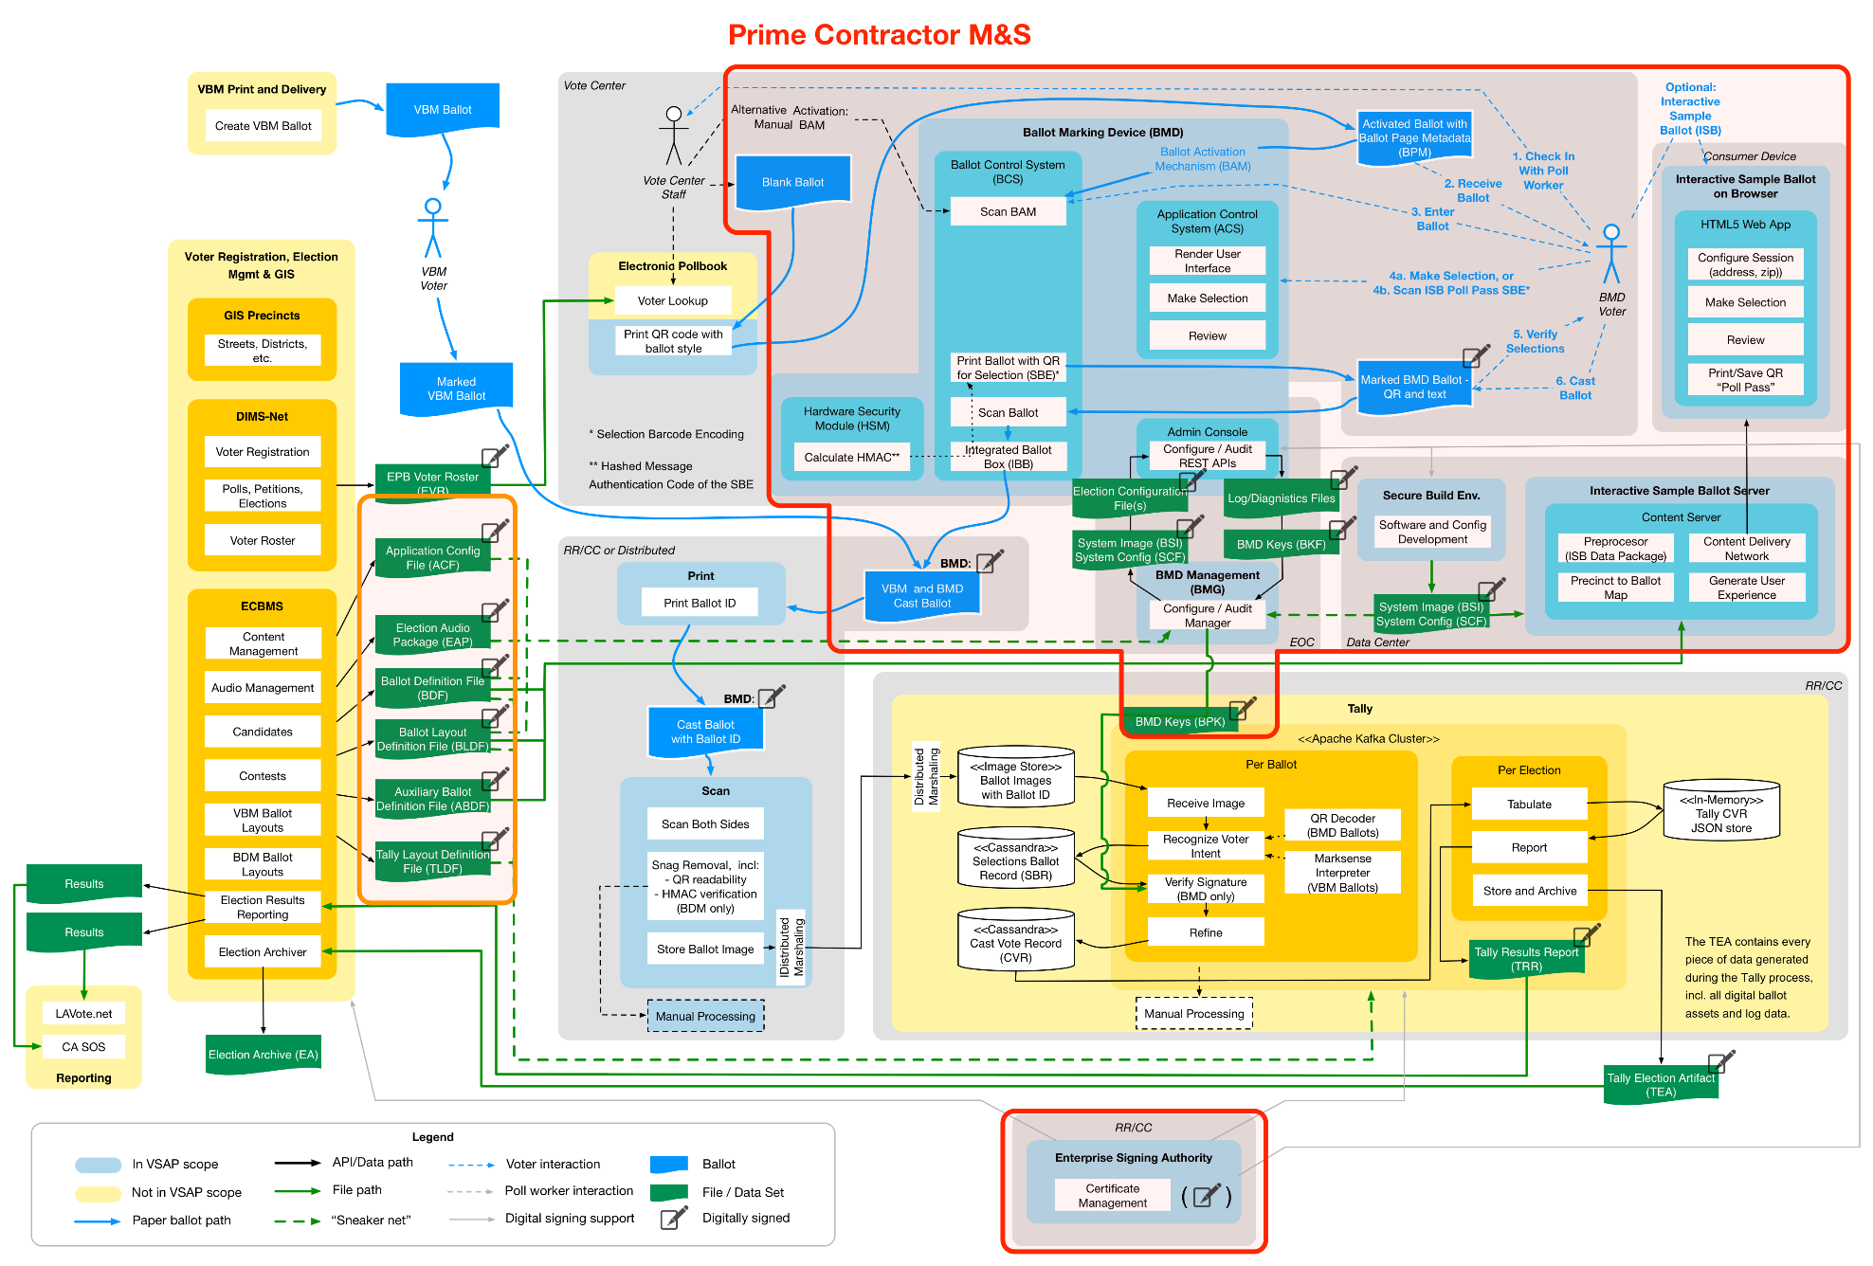

    - Third-Party Sub-Components
Third-party sub-components will include IOTS hardware as well as software tools, operating systems, etc., used in the development of the components. Further, there may be third-party sub-components in the BMD, the BMG or ISB (either hardware or software) which the Contractor will deliver as part of its committed deliverables. The County expects such third-party sub-components will be delivered together with the manufacturers’ standard warranties and that the Contractor will manage and support these third-party sub-components as part of its Maintenance and Support responsibilities.
    - Coordination of Other Vendor VSAP Components
The Contractor will not be responsible for coordination with third-party vendors of other VSAP components during the M&S period, unless as specified through a negotiated work order.
  - M&S Terms
After completion of the Warranty period, County intends to retain the Contractor to provide M&S and the County will pay an annual fee for such services as determined in the Contract pursuant to selection and award to the winning Contractor.
The County contract for M&S services will be for a period of five (5) years after the Warranty period with the option, at County discretion, for three (3) 2-year extensions for a potential total of eleven (11) years after the Warranty period.
  - M&S Initiation
The M&S period for each Contractor In-Scope Component will begin upon close of the Warranty period of that component.
  - Comply with Applicable Election Law During M&S (Based on a Negotiated Work Order)
The Contractor will be required to comply with applicable provisions of the Elections Code and regulations under a negotiated Work Order (for Goods and Services). This would include re-certifications or any other changes required by the Elections Code and regulations. This would include de minimis change submissions or re-certifications or any other changes required by the Elections Code and regulations.
The deliverable will be determined based on a negotiated work order.
PROPOSER RESPONSE TO: Task 5.4 Comply with Applicable Election Law During M&S
Will the Proposer complete the task as described above?
___ Yes
___ Yes, with modifications
___ No
Explain your approach to completing the task as described above:
  - Provide On-Site Support Services
The Contractor will be required to provide on-site support (up to 60 days prior to an election) at agreed upon M&S pricing throughout the M&S period. On-site support personnel technically competent to fully support and repair the BMD units and other Contractor In-Scope Components shall be provided to County during all support periods for up to sixteen (16) hours per day (such that the support period covers all election operational hours).
PROPOSER RESPONSE TO: Task 5.5 Provide On-Site Support Services
Will the Proposer complete the task as described above?
___ Yes
___ Yes, with modifications
___ No
Explain your approach to completing the task as described above:
  - Other Services to be Provided During M&S
During the M&S period, Contractor shall provide the following services and deliverables as specified in Section 3.0 Implementation.
Deliverable | Update or Ongoing as Needed
3.5 End-to-End Security Plan | Update
3.5.1 Continuity Plan | Update
3.9 VSAP Solution Use Procedures | Update
3.13.1 Repair and Replacement of BMDs | Ongoing
3.13.2 Contractor In-Scope Component Recall and Update Services | Ongoing
3.13.3 Preventative Maintenance Schedule | Update
3.13.4 Preventative Maintenance on BMDs | Ongoing
3.13.5 BMD Hardware Lifecycle and Bill of Materials Report | Ongoing
3.14 Report of Software Maintenance | Ongoing
3.15 Report of Third-Party Sub-component Maintenance | Ongoing
3.16.1 Configuration Management Report | Ongoing
3.16.2.1 Unit Test Scripts and Unit Test Results | Ongoing
3.16.2.2 System Test Cases and System Test Results | Ongoing
3.16.2.3 Integration Test Cases and Integration Test Results | Ongoing
3.16.2.4 User Acceptance Test Cases and Test Results | Ongoing
3.16.2.5 Regression Test Cases and Test Results | Ongoing
3.16.2.6 Volume/Stress Test Cases and Volume/Stress Test Results | Ongoing
3.16.2.7 Security Test Cases and Security Test Results | Ongoing
3.16.4 Contractor System Documentation | Ongoing
3.17.1 Training and Knowledge Transfer Plan | Update
3.17.2 Training Materials | Update
3.17.3 Report of Training Metrics | Update
3.17.4 User Guide Documentation | Ongoing
3.19.4 Contractor In-Scope Component Help Desk Services Report | Ongoing
3.19.5 Contractor In-Scope Component Problem Log Report | Ongoing
3.20 Contractor Service Level Report | Ongoing

- Other Services Provided During Maintenance and Support
PROPOSER RESPONSE TO: Task 5.6 Other Services to be Provided During M&S and Associated Deliverables
Will the Proposer complete the deliverables and related tasks as described above?
___ Yes
___ Yes, with modifications
___ No
Explain your approach to completing the deliverables and related tasks as described above:
  - M&S Closeout
The M&S period will end after the term of M&S is reached or when all County approved extensions have expired (“M&S Closeout”). Upon the completion of the Warranty and M&S periods and any extensions of the M&S period, the Contractor shall perform all activities necessary to close out M&S. This includes updating and transferring all system documentation to County and performing formal contract closure.
    - M&S Closeout Checklist
The Contractor shall provide an M&S Closeout Checklist that shall, at a minimum, include a list of deliverables, documentations accepted, outstanding issues with a related plan for remediation and final acceptance by the County. The M&S Closeout Checklist shall be in the form and format agreed to by the VSAP Project Team.
The Closeout Checklist shall confirm that all tasks have been completed, all deliverables have been accepted and all activities that need to be completed to officially close the M&S period have been completed.
Deliverable 5.7.1 M&S Closeout Checklist
Delivery Timing | Submitted for approval no less than 60 calendar days prior to Contract end date
Delivery Frequency | Once
Description | The Contractor shall deliver an M&S Closeout Checklist as described in Section 5.7.1.

PROPOSER RESPONSE TO: Deliverable 5.7.1 M&S Closeout Check-List
Will the Proposer complete the deliverables and related tasks as described above?
___ Yes
___ Yes, with modifications
___ No
Explain your approach to completing the deliverables and related tasks as described above:
    - Disposition of County Intellectual Property After M&S
The Contractor shall identify any of the VSAP Project’s proprietary documentation and return it to the County. Any electronic copies of the VSAP Project proprietary information (such as any County IP) stored on the Contractor equipment shall be transferred back to the County and/or destroyed.
The Contractor shall also transfer all agreed to, and finalized, documentation to the VSAP Project Team. The format and the medium of transfer shall be at the discretion of the VSAP Project Team.
Deliverable 5.7.2 Disposition of County Intellectual Property Report
Delivery Timing | Submitted for approval no later than 5 calendar days following M&S closeout or as required by the NDA, whichever is sooner
Delivery Frequency | Once
Description | The Contractor shall deliver a Disposition of County Intellectual Property Report as described in Section 5.7.2. The Disposition of County Intellectual Property Report, at minimum, shall include:  - An attestation that proprietary information has been transferred back to the County and/or destroyed  - All agreed to, and finalized, documentation has been transferred to the County
PROPOSER RESPONSE TO: Deliverable 5.7.2 Disposition of County Intellectual Property Report
Will the Proposer complete the deliverables and related tasks as described above?
___ Yes
___ Yes, with modifications
___ No
Explain your approach to completing the deliverables and related tasks as described above:
    - System Documentation Updates
The Contractor shall make updates to relevant system documentation (operations, training, security, design, requirements, use procedures, etc.) to reflect any changes that have occurred during Warranty or M&S periods.
    - Transfer of Materials
At M&S Closeout, the Contractor shall conduct a review with the VSAP Project Team and identify any documentation that shall be updated because of changes during the Warranty or M&S periods. The Contractor shall be required to update the documentation and provide it to VSAP Project Team for review and final acceptance.
The Contractor shall identify any County proprietary documentation and return it to County. Any electronic copies of County proprietary information stored on the Contractor’s equipment shall be destroyed and/or transferred back to County. This section is not meant to replace or supersede any requirement in the NDA, which the Contractor must comply with in all respects.
The Contractor shall release the source code for all interfaces developed during the M&S period, specifically for VSAP, to County with a complete set of documented source code for them. As part of the transfer of source code, the Contractor shall conduct a detailed workshop with the VSAP Project Team explaining the structure of the source code and how to navigate and find key aspects of the system functionality within the code.
Deliverable 5.7.4a Updated System Documentation at M&S Closeout
Delivery Timing | Submitted for approval no less than 20 calendar days prior to Contract end date
Delivery Frequency | Once
Description | The Contractor shall provide updated system documentation at M&S Closeout as described in Section 5.7.4.

PROPOSER RESPONSE TO: Deliverable 5.7.4a Updated System Documentation at M&S Closeout
Will the Proposer complete the deliverables and related tasks as described above?
___ Yes
___ Yes, with modifications
___ No
Explain your approach to completing the deliverables and related tasks as described above:

Deliverable 5.7.4b Transfer Source Code
Delivery Timing | Transfer Source Code: Submitted no less than 20 calendar days prior to Contract end date  Transfer Source Code Workshop: Conducted no less than 20 calendar days prior to Contract end date
Delivery Frequency | Once
Description | The Contractor shall transfer source code developed during the M&S period to the County and conduct a workshop as described in Section 5.7.4.

PROPOSER RESPONSE TO: Deliverable 5.7.4b Transfer Source Code
Will the Proposer complete the deliverables and related tasks as described above?
___ Yes
___ Yes, with modifications
___ No
Explain your approach to completing the deliverables and related tasks as described above:

- Additional Services
  - Provide Additional Goods and Services (Based on a Negotiated Work Order)
Additional Goods & Services will allow County flexibility to use the Contract to have the Contractor perform tasks not anticipated at the time of contract execution but identified later. This could include enhancements or re-certification support services (especially for de minimis items). A pool of dollars will be set aside in the contract and used via fee-based negotiated work orders. The order of Additional BMDs during the M&S period is one example of possible Additional Goods and Services.
The deliverable will be determined based on a negotiated work order.
PROPOSER RESPONSE TO: Task 6.1 Provide Additional Goods and Services
Will the Proposer complete the task as described above?
___ Yes
___ Yes, with modifications
___ No
Explain your approach to completing the task as described above:
  - Provide Enhancements
    - Provide Enhancement Development (Based on a Negotiated Work Order)
Should it be necessary to develop enhancements (whether due to changes in the Elections Code and regulations or County request) beyond those in the accepted design of the BMDs, BMG and ISB during Implementation, Warranty or M&S periods, the Contractor will be expected to provide these enhancements for a negotiated work order fee.
If the County determines that system enhancements are required for Contractor In-Scope Components, it shall submit a request for those modifications to the Contractor. The Contractor shall analyze the changes and provide constructive feedback on the request along with a cost estimate for performing those changes to the County. These cost estimates shall be negotiated based on rates proposed and agreed to in the Cost Proposal. The County can then decide whether it wishes to move forward with the requested enhancements, which shall be incorporated as a change order to the contract.
The deliverable will be determined based on a negotiated work order.
PROPOSER RESPONSE TO: Task 6.2.1 Provide Enhancement Development
Will the Proposer complete the task as described above?
___ Yes
___ Yes, with modifications
___ No
Explain your approach to completing the task as described above:
    - Provide Enhancement Certification (Based on a Negotiated Work Order)
Should it be necessary to re-certify or provide a request for a de minimis ruling by the California Secretary of State on enhancements made during Implementation, Warranty or M&S periods, the Contractor will be required to provide re-certification support services for these enhancements for a negotiated work order fee.
All system enhancement requests (changes requiring 200 or more hours of effort) that occur during any period shall be documented and communicated with the County within a reasonable, agreed upon timeframe, on a regular basis. The Enhancement Certification shall contain the description of the enhancement request, progress and the test results and outcome of each request.
The deliverable will be determined based on a negotiated work order.
PROPOSER RESPONSE TO: Task 6.2.2 Provide Enhancement Certification
Will the Proposer complete the task as described above?
___ Yes
___ Yes, with modifications
___ No
Explain your approach to completing the task as described above:

7.0 Assumptions
The Contractor shall document its assumptions for its response to this SOW. No cost information shall be included in this Technical Proposal. All financial assumptions shall be included in the Cost Proposal.
Instructions: Document the assumptions related to the Proposer’s approach to provide required services outlined in this SOW. Add rows as necessary. Do not include any assumptions related to costs. Do not change any of the pre-populated sections. Any changes to the pre-populated sections could lead to the disqualification of the Proposal.

- Assumptions to the Proposer’s Approach to Provide Required Services
Item # | Reference  (Section, Page, Paragraph) | Description | Rationale
1.
2.
3.

The BMD units produced are expected to be used for Full Rollout and thus are not in addition to the estimated quantity of 31,100 BMDs.
Applicable time for Countywide and UDEL Elections is Election Day minus 120 days through completion of official canvass or recounts. For Special Elections, the applicable time is E-60 (or three weeks after notification of special Election date by County) through completion of official canvass or recounts.
The Diagnosis Timeframe for a reported issue will be met when the Contractor provides a substantive response to the issue. A substantive response includes, at a minimum, a clearly worded description of the issue and an estimate of what will be done to resolve the issue within the associated Resolution Timeframe. Response times for Resolution Timeframe and Diagnosis Timeframe purposes shall each be measured from the time of the County’s report of the issue to the Contractor.
The allotted time periods for allowable Diagnosis Timeframe and Resolution Timeframe on any reported issue in accordance with this Table 3 shall begin at the time of first attempt to reach Contractor regarding the condition reported, if by phone, by email or fax sent during the Business Day, or by email sent at any time during an Important Election Work Period or Critical Election Work Period.

